CSYE 7280 User Experience Design and Testing

**FINAL UX REPORT**



**CareConnect+**

*“Connecting careseekers and caregivers”*

| **NU ID** | **Team Member Name** |
| --- | --- |
| 002713929 | Habeebuddin Mir |
| 002778147 | Maseerah Khatoon |
| 002796856 | Shaiz Akhtar |

**Supervisor – Prof. Svetlena Taneva Metzger, PhD**

Master of Science in Information Systems

College of Engineering

Northeastern University, Toronto

**TABLE OF CONTENTS**

| SL NO | TITLE | PAGE NO. |
| --- | --- | --- |
| 1 | Executive Summary | 2-5 |
| 2 | Introduction  2.1 The Problem  2.2 Approach adopted  2.3 Competition Comparison  2.4 Functional Architecture  2.5 User Interface | 6-9 |
| 3 | Methodology  3.1 User needs Assessment  3.2 Cognitive Walkthrough  3.3 Heuristic Evaluation  3.4 Usability Testing | 10-32 |
| 4 | Findings  4.1 Low Fidelity Prototype  4.2 Medium Fidelity Prototype  4.3 High Fidelity Prototype | 33-54 |
| 5 | Discussion  5.1 Issues Found and Issues Addressed  5.2 Performance, Perception and Result Limitations  5.3 Final Summary  5.4 Future Work | 55-56 |
| 6 | Appendices  6.1 User Needs Assessment  6.2 Low Fidelity Prototype  6.3 Usability Testing  6.4 Final Prototype After Usability Testing  6.5 Class Presentation | 57-100 |

1. **EXECUTIVE SUMMARY**

Everyone needs a seamless experience when engaging with businesses online, especially patients worried that they might be sick. It’s essential for people to have easy access to detailed information about doctors, including their specialties, credentials, and patient reviews. Traditional methods of booking appointments, such as calling clinics, can be time-consuming and frustrating. We designed an app that can streamline the booking process, allowing users to see available time slots and choose the one that suits them best.

Standard industry processes were followed in order to achieve our goal of creating a user centric doctor’s appointment booking application. This included initially preparing a proposal and participant action plan that detailed out our proposed functionalities, target demographics and the methodologies to be followed. This initial planning was followed by the User Needs Assessment to identify the needs and establish requirements for user tasks through in-person observations, combined with netnography, interviews, focus groups, and questionnaires. The data was then analyzed and user needs were extracted for each task. Next we developed 3 low fidelity prototypes based on cards/post-it notes/basic wireframes to represent the structure/interactions of the tasks and layout of screens for the tasks, incorporating the insights from the user needs and requirements.

The low fidelity prototypes were then evaluated by collecting feedback from target users through the cognitive walkthrough methodology and counterbalancing. The feedback gained helped us finalize the basis of our advanced prototype. This time we moved towards a more sophisticated, higher- fidelity, and digital version of the prototype, with simulated interactions. Next came the heuristic evaluation based on the industry principles which helped us redesign the prototype. Finally high fidelity usability testing sessions were conducted which led to our final prototype submission.

In the final task completion data collection, there were a number of useful conclusions and insights drawn from user performance and feedback: Almost all the existing features and functionalities worked well and as expected. A few people from user group 2 were confused regarding their actions and the terminology used on buttons, which resulted in 1 error and twice a need for guidance. Feedback was taken and confirmation screens and appropriate language was integrated.

All issues unearthed during the last round of user testing involving existing functionalities were promptly rectified and none are left. Although there were numerous additional new functionalities suggested that can be taken into account in future scope of the project. Suggestions included need for online consultations through video, audio or text and integration of app data with third party apps like Calendar and Health monitoring. At last it was noted that a doctor's or a healthcare’s side of interface where they can deal with patients will make this app a complete doctor’s appointment booking app.

Attached below in this section are the supporting final prototype screenshots and the user task completion data gathered during the last round of user testing sessions.

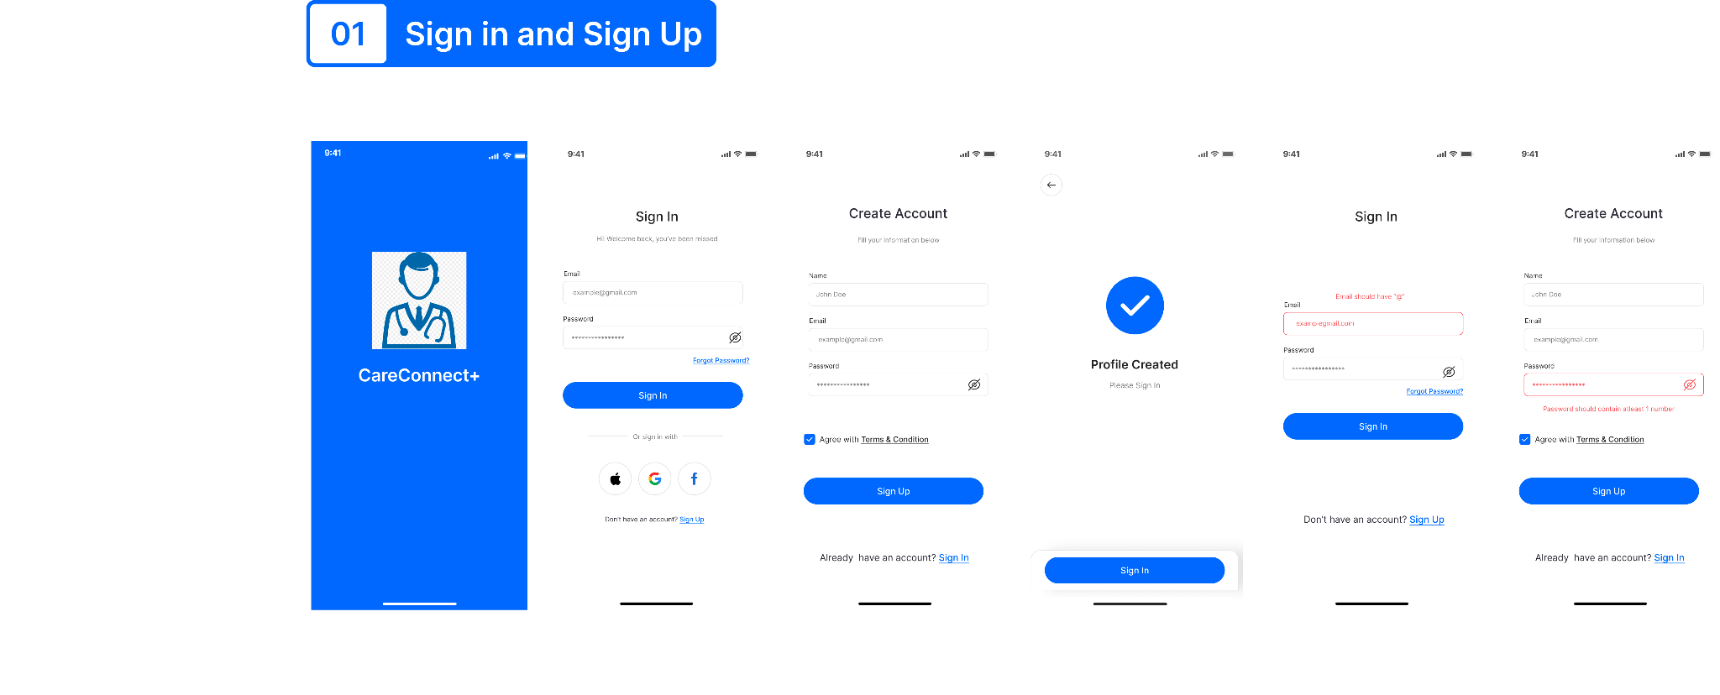

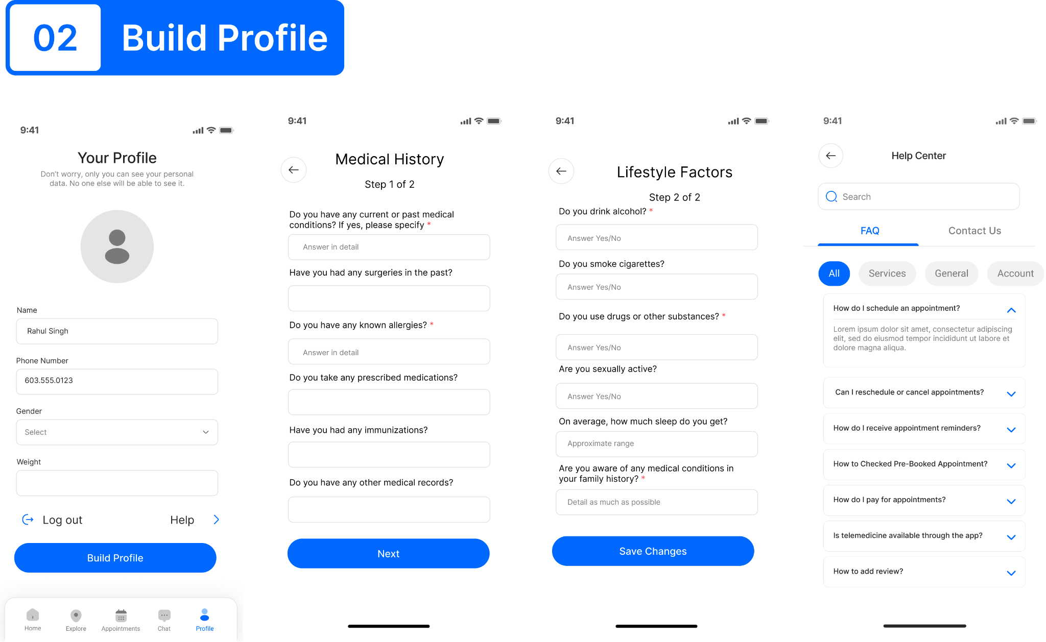

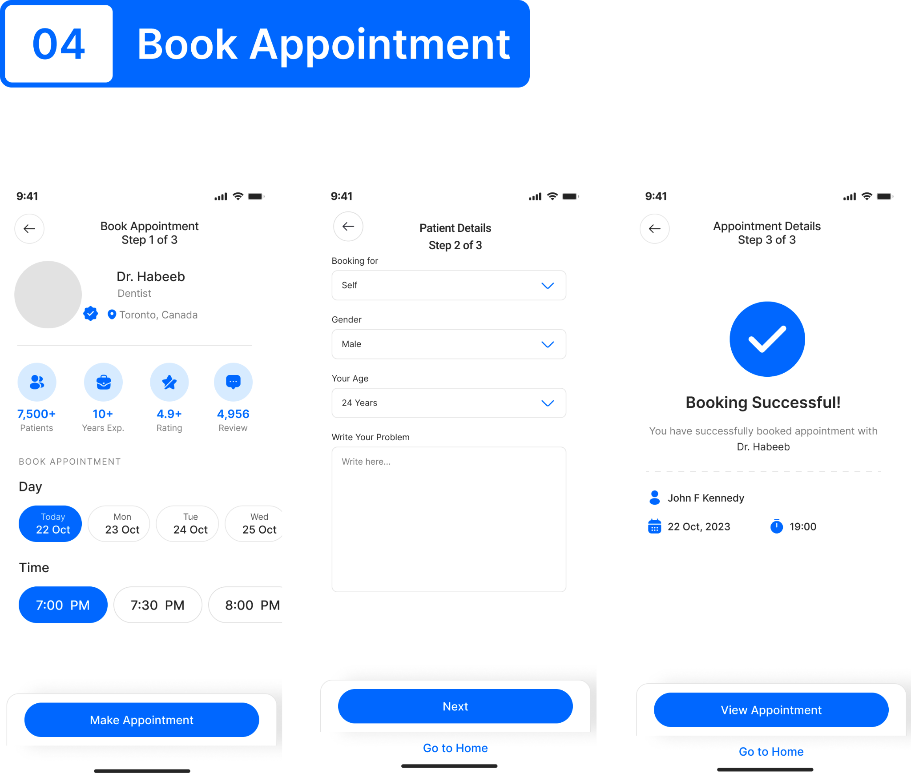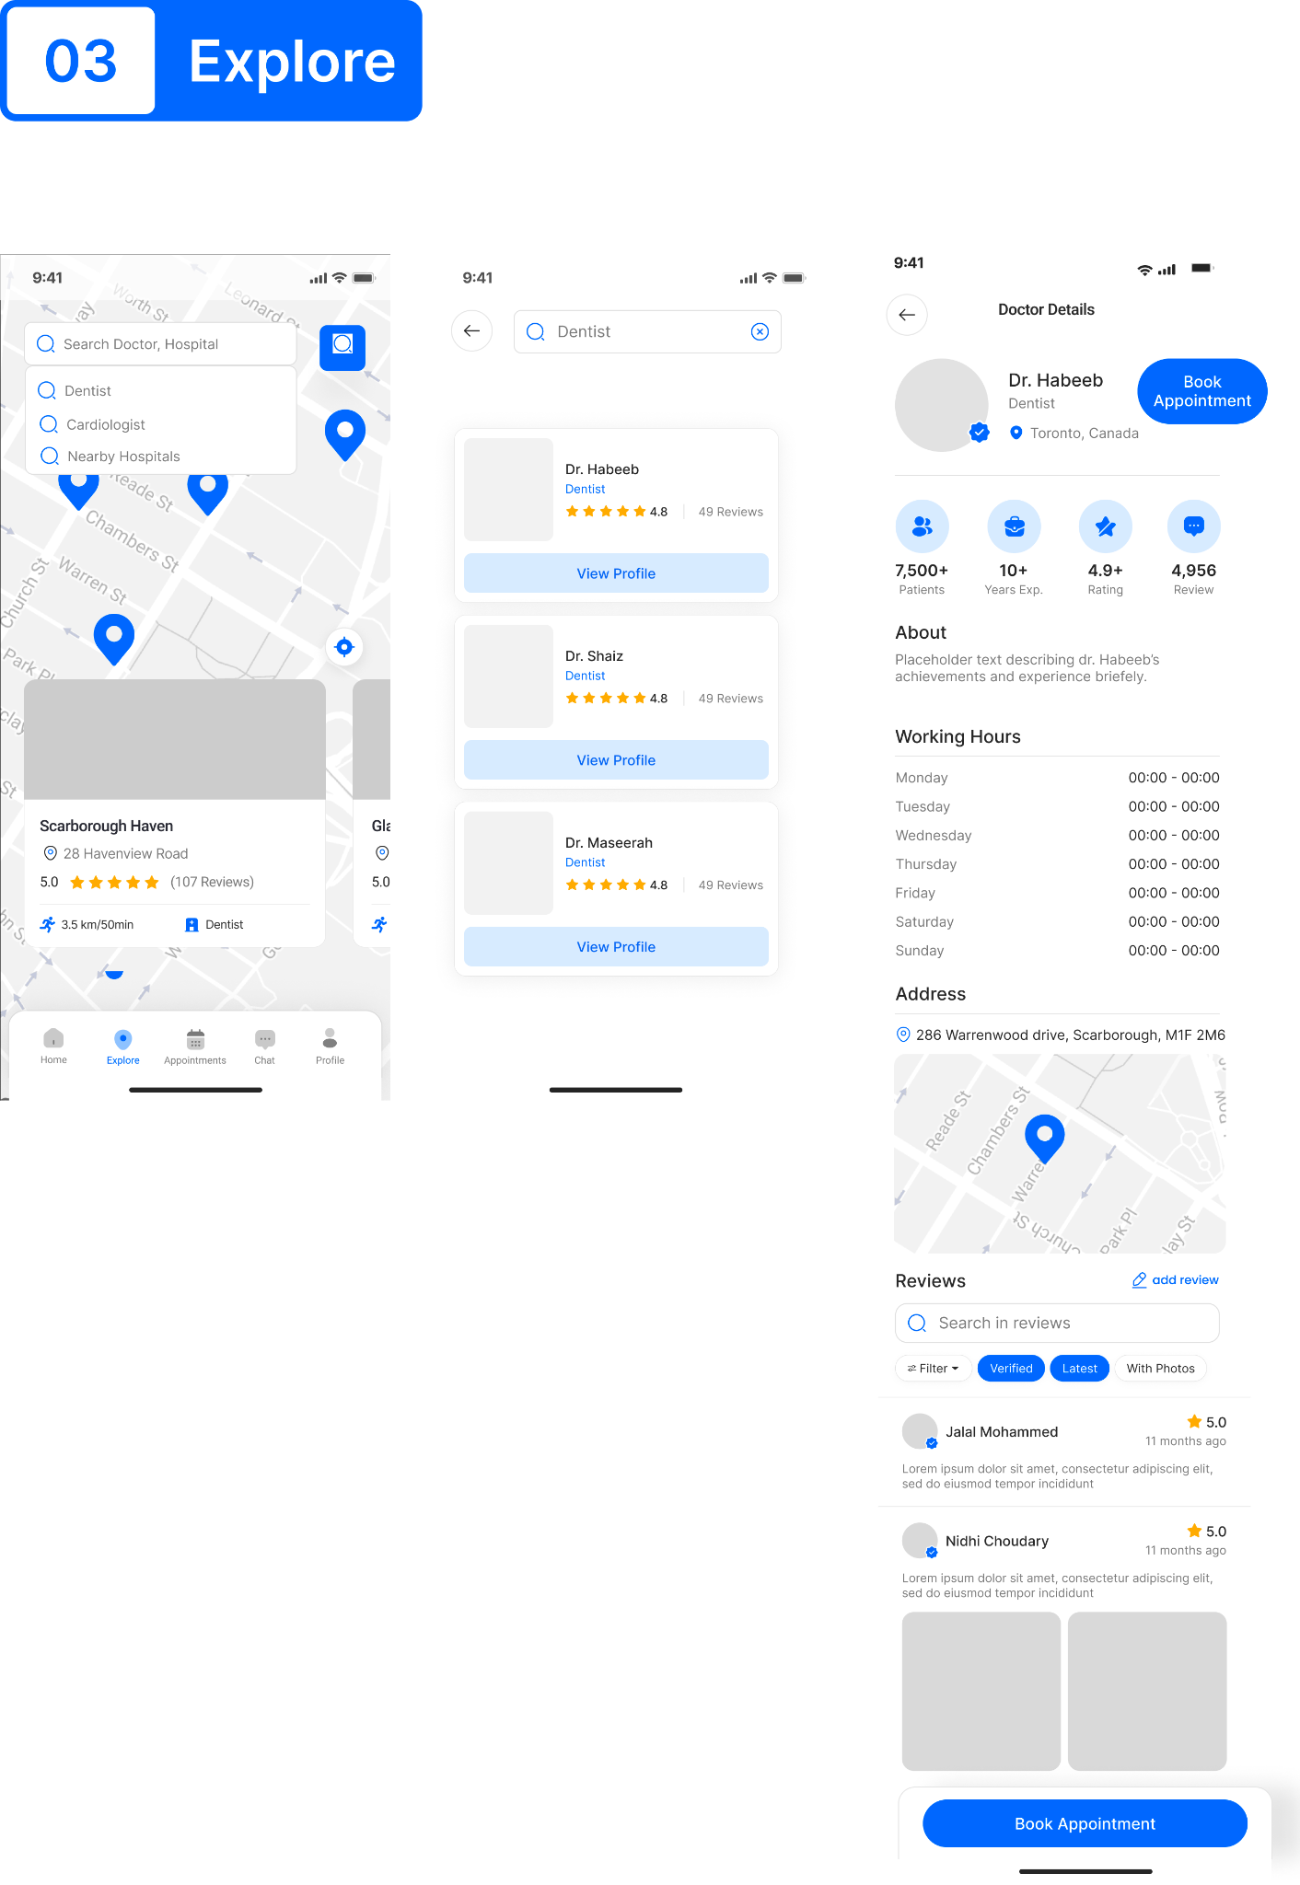

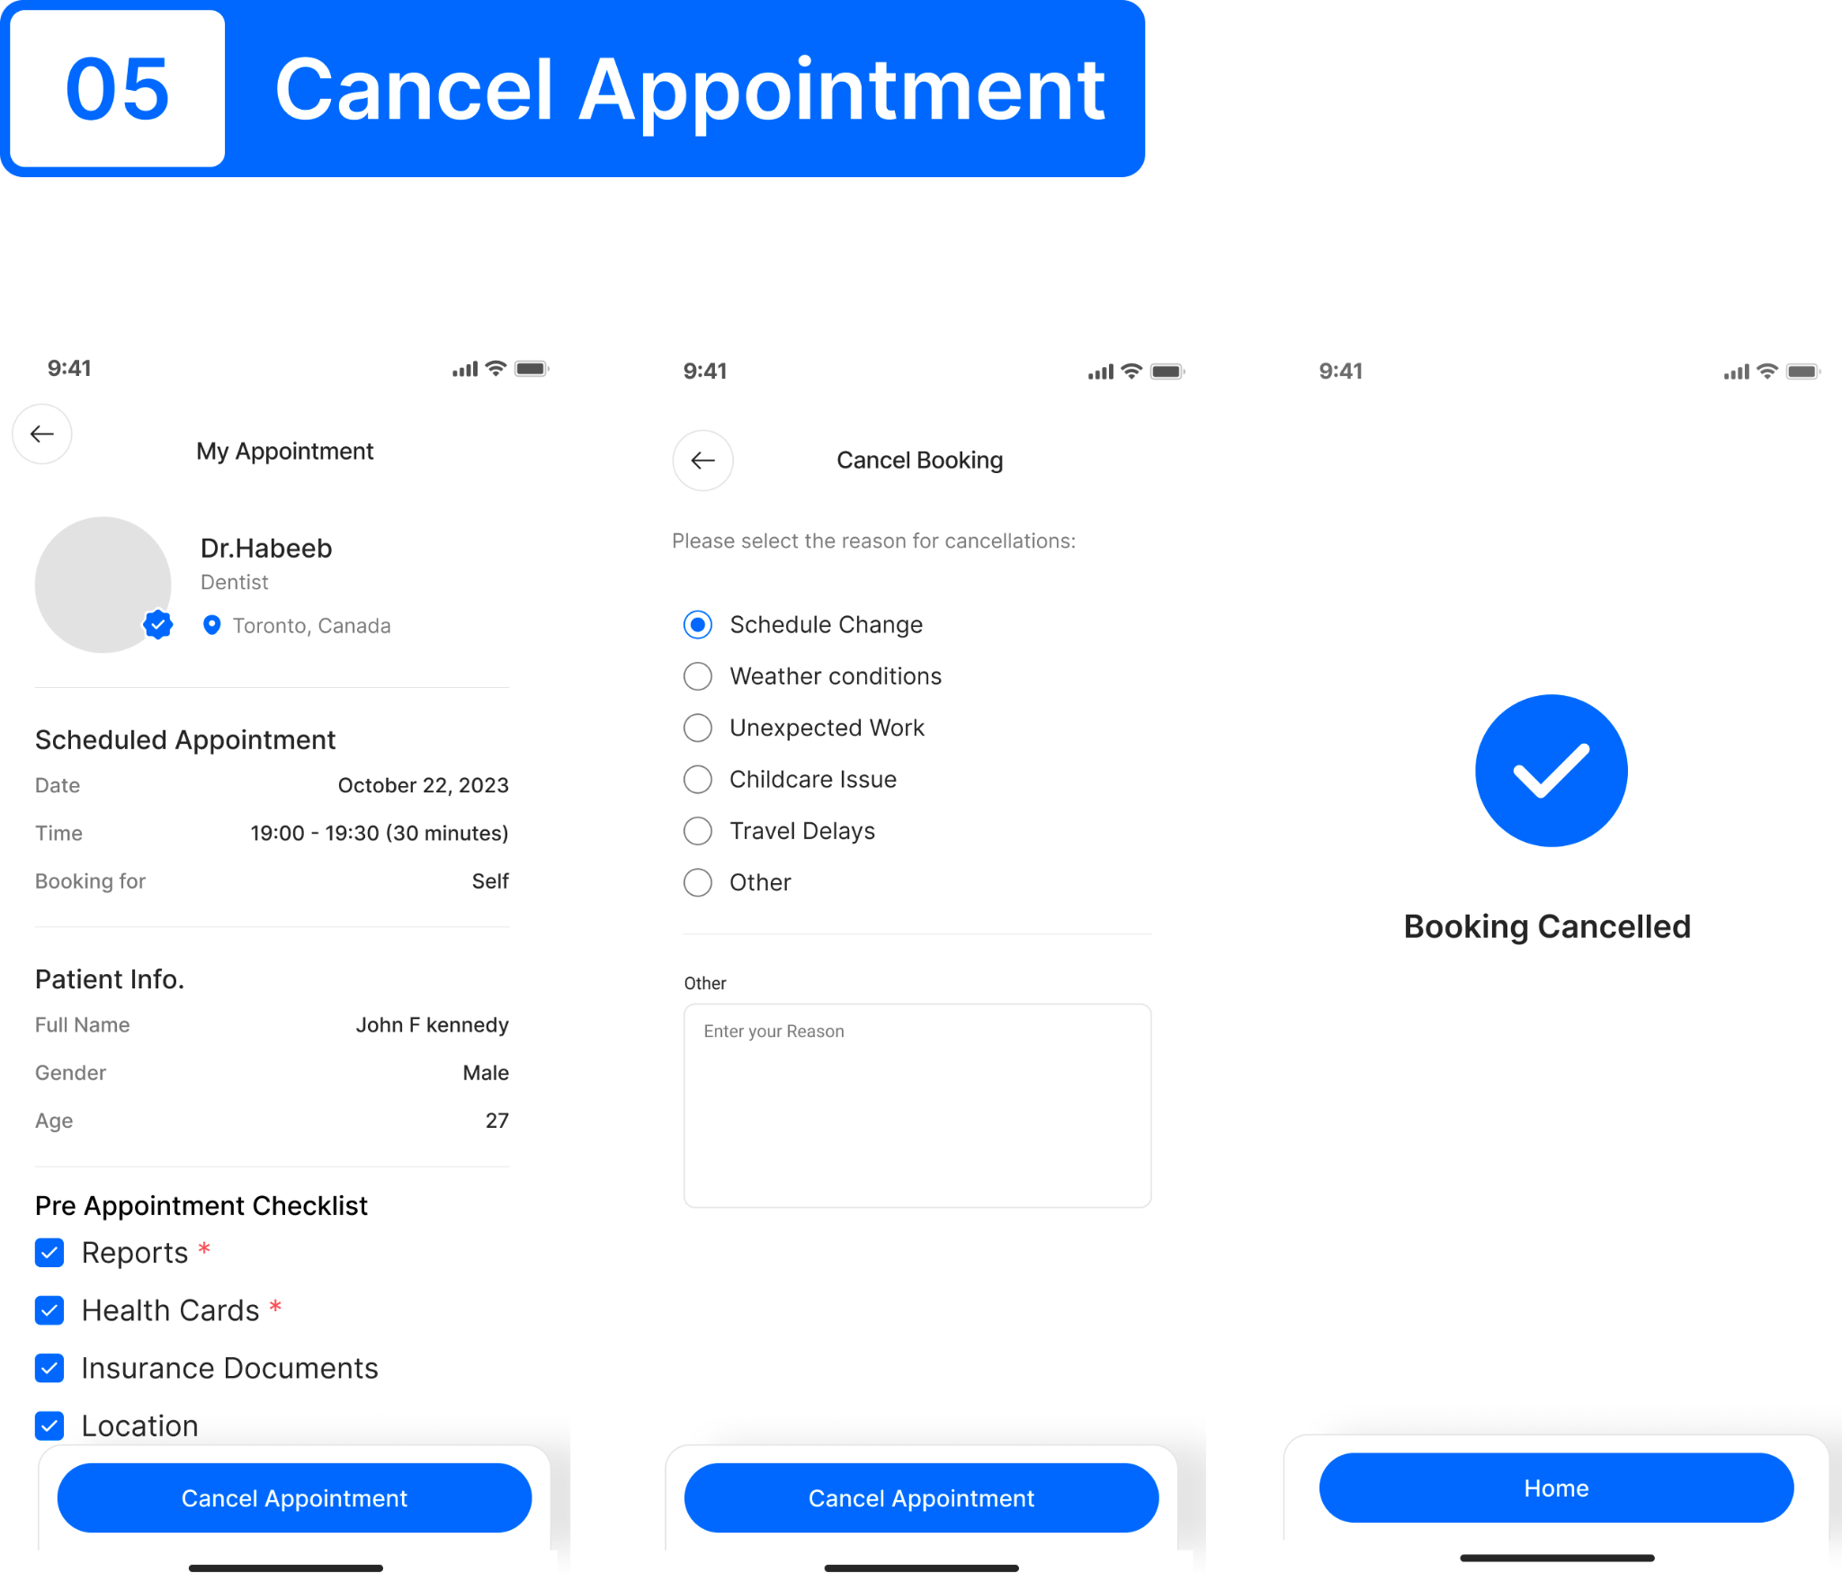

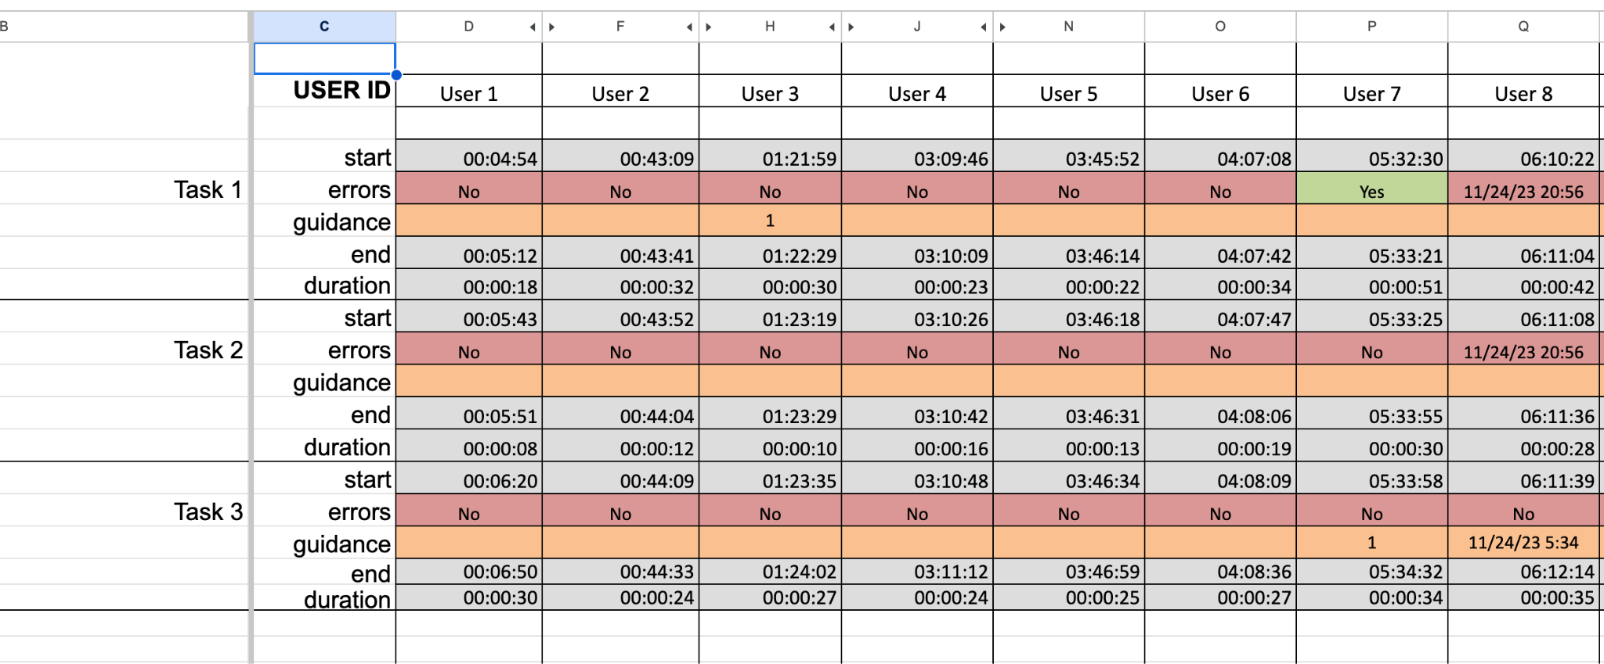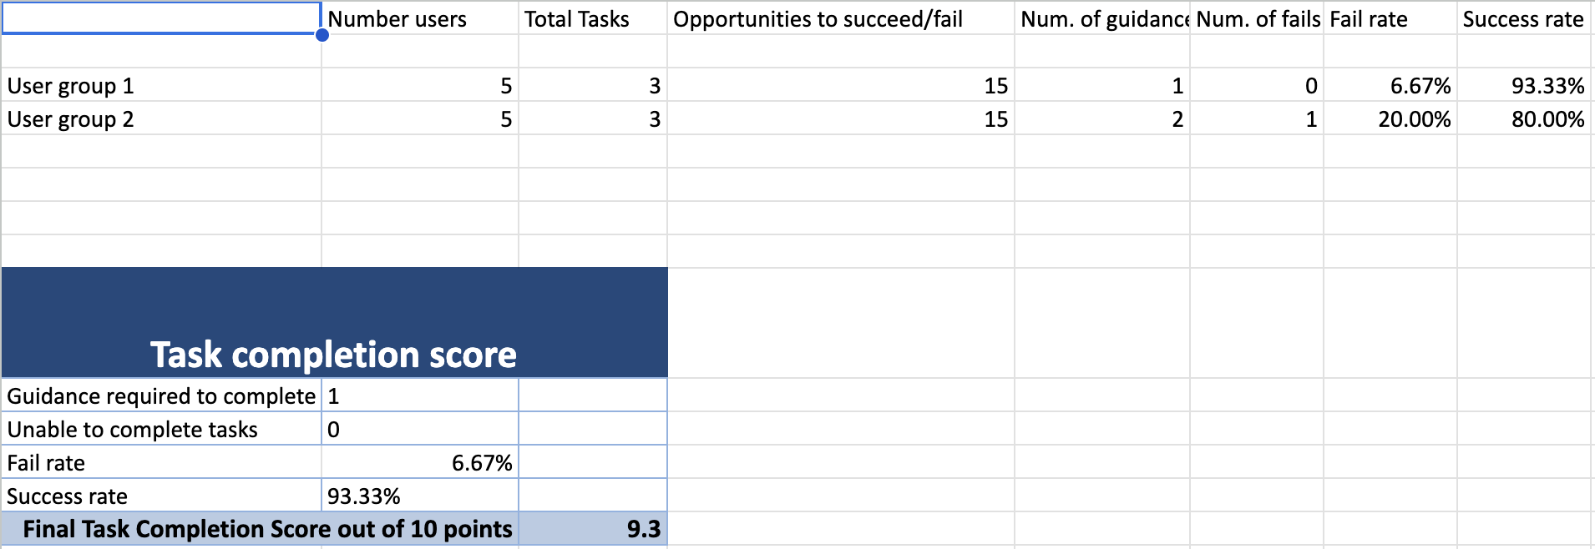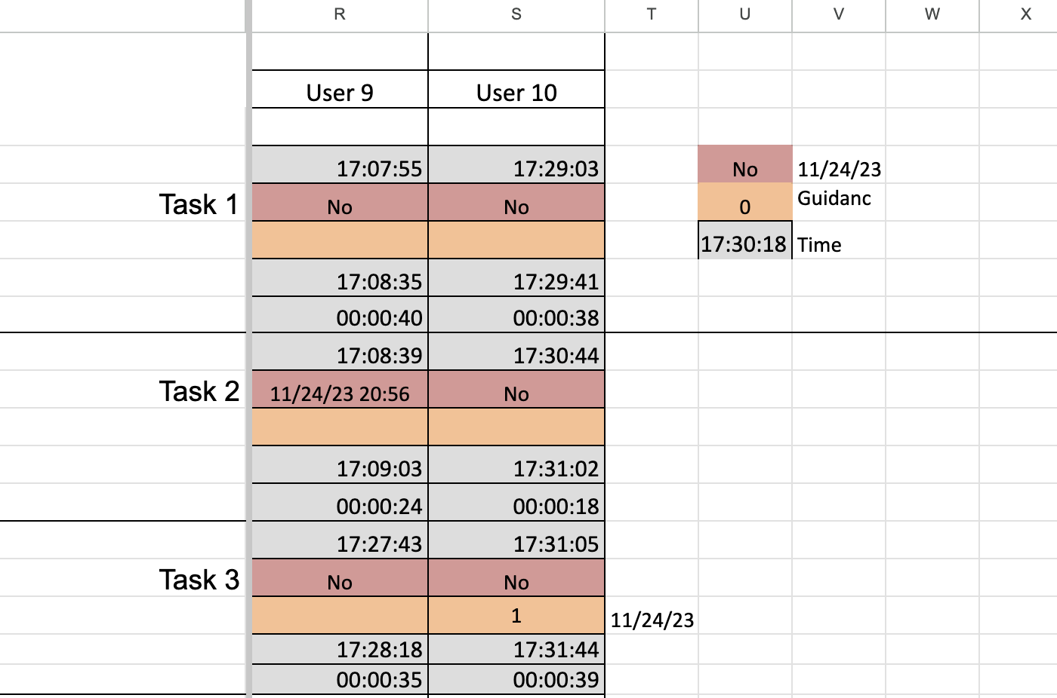

1. **INTRODUCTION**

CareConnect+ is a comprehensive doctor’s appointment booking mobile application that offers three major and multiple minor functionalities. The major functionalities include the ability to sign up and build a relevant medical and lifestyle factored profile, the option to access detailed and well structured doctor’s profiles and obviously the feature to schedule an appointment at your convenience. Many other helpful features like reset passwords, access to help documents, add reviews, cancel appointments and such are included. Every screen and every UI element is designed keeping user experience at focus.

2.1 The Problem

When two different people are asked how they would book a doctor’s appointment, more often than not, the answers we receive would be completely different. Some might prefer contacting healthcare facilities directly, and others would experiment with a non widely used booking app like Maple or Practo. While all of them get the job done, which is to get a doctor’s appointment, they may not necessarily be efficient and seamless for an everyday user. So the problem we identify is an app that is highly efficient and useful without compromising on a user’s experience.

2.2 Approach adopted

The approach we adopted was quite simple yet meticulous and time consuming to get the best possible results: a User-Centered research and study that involved multiple rounds of prototype development. Our goal was to pick a diverse set of participants, conduct studies using industry adopted and time-proven methodologies and to always prioritize user experience and efficiency. It involved high level data analysis involving both quantitative and qualitative analysis.

2.3 Competition Comparison

| Competition | Pros | Cons |
| --- | --- | --- |
| Hospital Websites | -Provides detailed information about the hospital's services, facilities, and healthcare providers. -Some allow direct appointment booking with healthcare providers.  -Often include information about specialized departments and | -May present a biased view of their own services, limiting comparisons. -Quality and user-friendliness can vary. -Not all offer online appointment booking, requiring phone calls.  -Often lacks patient reviews, limiting insights into the patient experience. |
| Maple | -Device adaptive UI elements  -Offers online consultations  -User friendly terminology | -Has their own doctors. Does not offer doctors working in other hospitals  -Tedious sign up process  -No physical clinics |
| Practo | -Hosts a wide range of doctors from multiple specialties  -Detailed doctor profiles and reviews | -Data not up to date  -UI works well on desktop but elements don't adjust well on mobile devices  -No online consultations |

All of the above pros were integrated and cons were addressed in CareConnect+, making it stand out from the rest not only in functionality but also user experience.

2.4 Functional Architecture

CareConnect+ is a mobile application with a robust functional architecture designed for efficient doctor's appointment management. The system comprises modules for user authentication and profile management, allowing users to register and maintain comprehensive medical and lifestyle profiles. Accessible doctor profiles include detailed information and reviews for informed decision-making. The appointment booking feature enables users to schedule appointments conveniently. Additional functionalities cover password reset, access to help documents, and user reviews. The user-centric interface prioritizes a positive experience, emphasizing intuitive navigation and secure authentication. The architecture also incorporates a notification system for appointment reminders and a review management system for user feedback. Overall, CareConnect+ is structured to ensure a seamless and secure interaction between patients and healthcare providers.

2.5 UI

2.5.1 User Needs Identified

Following is a table listing out the user needs that were identified during the initial phases of the research:

| Task name | User Need description | User Requirement description | Type of req. |
| --- | --- | --- | --- |
| Find a doctor | Get detailed information and reviews of a doctor | Comprehensive doctor's profile displaying past reviews, experience, specialties,  achievements and updated availability | Functional and  Informational |
| Find a doctor | Need better filters and sorting | Ability to filter search results based on speciality, ratings, distance, availability and mode of appointment | Functional |
| Book an appointment | App needs to store data from the previous  appointment and autofill. Like payment and address. | App needs to store data from the previous appointment and offer suggestive fill | Functional and  Informational |
| Book an appointment | Have the option of choosing an appointment type like chat, video or in-person. Option to opt for recurring appointments | Display different modes of appointment the doctor offers along with the availability of each | Functional |
| Communicate | Ability to track appointments, cancel or  reschedule and share health records | A "My Bookings" tab that displays completed, upcoming and canceled appointments. | Functional |
| Communicate | Ability to add reviews and follow up | Prompt users at the end of an appointment to add reviews and ratings. A chat window to  communicate with the doctor | Functional |
| Build a profile | Easy to understand questionnaire that will  build a profile | When a user signs up, they need to go through a simple questionnaire to create a basic profile with and preferences | Functional |
| Book regular  appointments | Ability to get visual-audio prompts and suggestions to help book an appointment | Ever user input should have a an option like "Learn More" that explains what kind of response is expected and explanatory prompts | Functional and  Informational |
| Book regular  appointments | Get confirmations, reminders and checklists to prepare before an appointment. Hopital/  Clinic maps showing where the doctor's office is located | A very informative post-booking page with a checklist of all the helpful materials. Notifications of last date of cancellations and appointments | Functional and  Informational |
| Online appointments | Ability to include family members into online appointments remotely | Ability to invite different pre-approved emergency contacts onto online vide appointments | Functional |

2.5.2 UI Issues encountered in existing apps

Maple and Practo were two major competitions identified that came close to what we wished to design. Testing it ourselves and going through online reviews of other patients gave us a comprehensive overview of the common basic UI issues frequently identified. For instance in maple, there were two issues we came across. The first one was that the users frequently experienced appointment rejections and cancellations without appropriate feedback and explanation, leaving users confused and clueless. Another common issue was it’s confusing navigation that we found. There was no clear indication of the path the user has moved through in the app. Practo too had some basic UI issues. The website was designed to be suitable to be viewed on a desktop. When it is opened in other devices like a mobile phone or tablet, the UI elements go all over the screen.

2.5.2 How CareConnect addressed issues

CareConnect was designed with the aim of addressing issues identified in the existing systems. Feedback and clear communication was prioritized. Every action the user completed and was coupled with an appropriate acknowledgement. We added error messages when incorrect inputs were provided. Confirmation screens were added when a user books or cancels an appointment. Finally we invested a lot of time in testing and prototyping multiple navigation systems to come up with the most clear and easy to understand one. That was accomplished with appropriate next and back buttons and accessible navigation bars at the bottom of the screen.

2.5.2 Use Cases/Tasks for Prototypes

All the levels of prototypes developed, highlighted the following tasks to be focussed during user testing sessions:

1. Build a Profile

a. Enter Basic Data

b. Fill out Medical History

c. Fill out Lifestyle factors

d. Hit Save button

1. Search Doctors

a. Enter search query

b. Set filters

c. Access list of doctors

d. View doctor’s profiles

1. Book appointment

a. Select date

b. Select time slot

c. Choose appointment mode

d. Review pre-appointment checklist

1. **METHODOLOGY**

3.1 User Characteristics

After pre-screening multiple candidates, we shortlisted a pool of 10 participants making it a very diverse and forthcoming people from varied demographics. This good mix increases the chances of getting different perspectives fulfilling the purpose of the research.

Six of our participants consist of young adults aged 18-30. This group of people are often considered as tech savvy and usually do not require too frequent medical care. The rest of the pool consists of people aged 41+. This group of people may or may not be highly proficient in using technology and some of them suffer from chronic diseases requiring them to regularly visit the doctor. Our survey was dominated by women constituting 70% and the rest 30% identified as men.

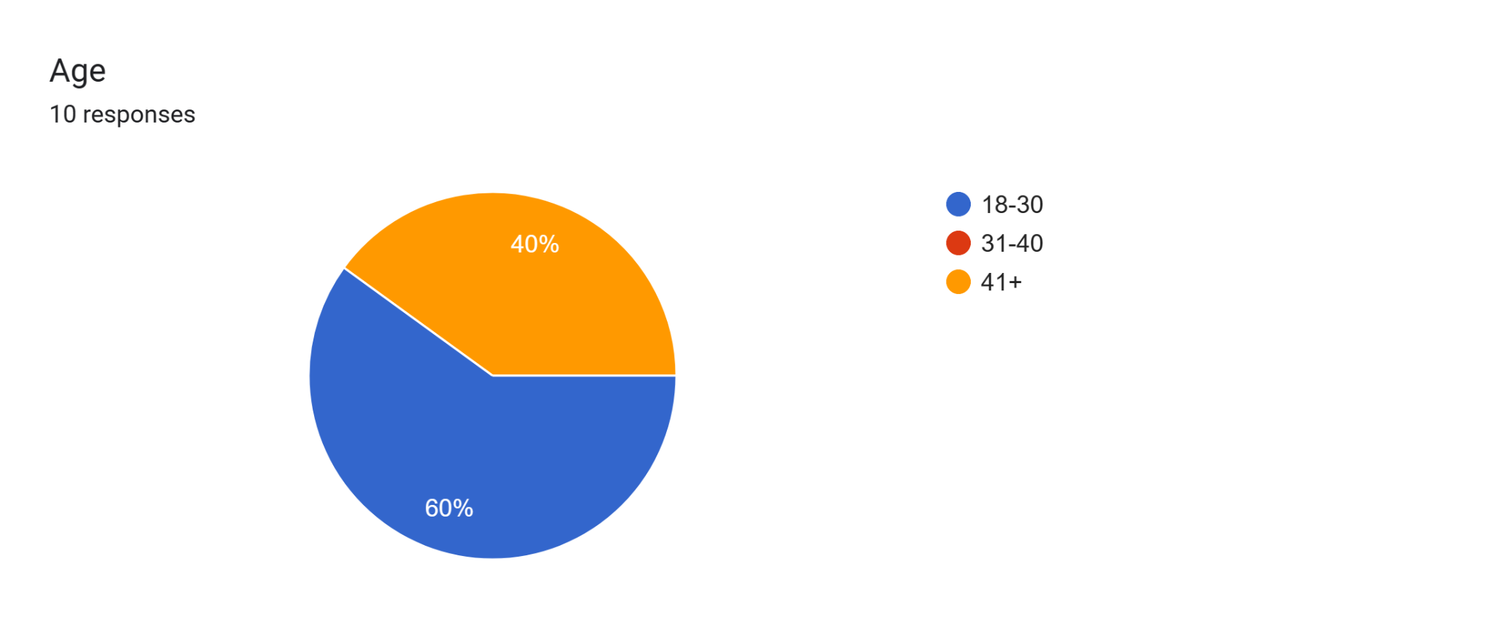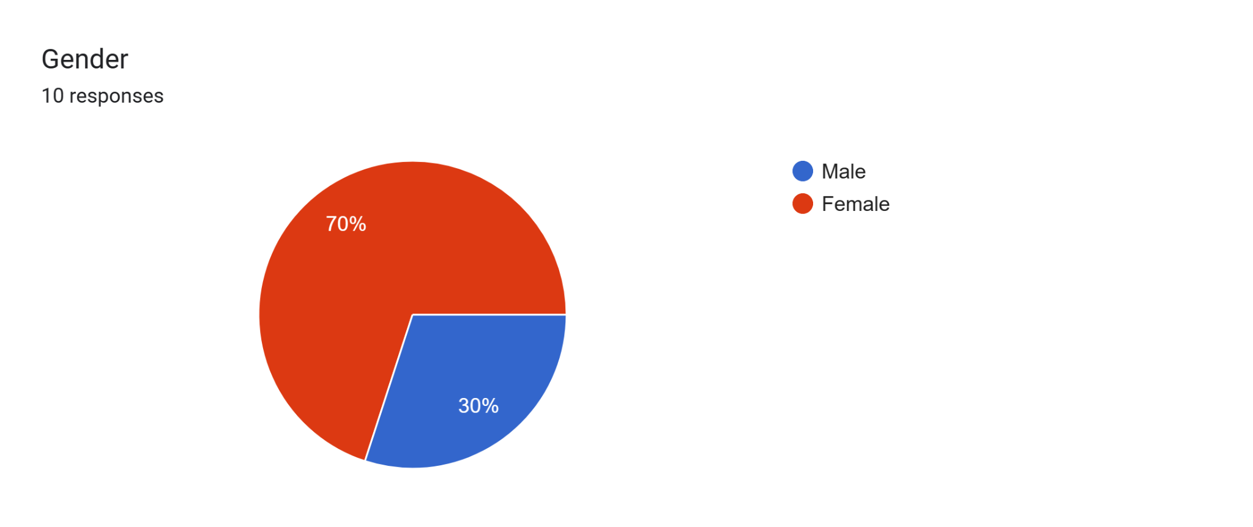

Different regional markets are dominated by different web apps and platforms used to book doctor’s appointments. So it was essential for us to pick people from countries having systems that varied from others to get universal feedback. For example people in India either preferred web apps like Practo or hospital websites to secure a visit. While north american countries preferred apps like Maple or contact the doctor’s office directly for a specialized appointment.

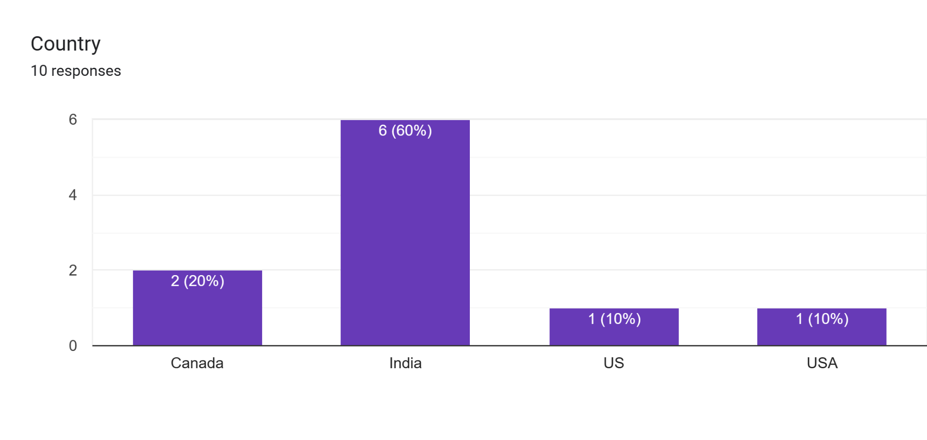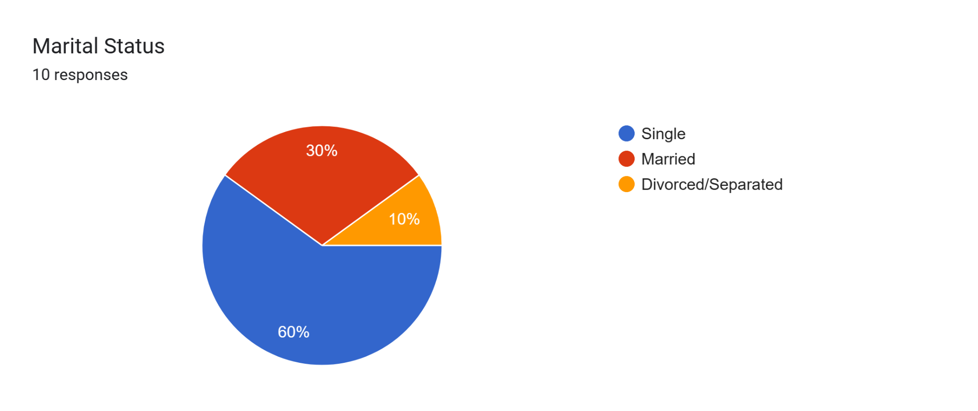

Our pool of participants had people from different walks of life. Half of them were employed, one of them retired and 4 identified as students or home makers. This speaks to us about how busy people’s lives are and the importance of an easy to use hassle free booking software. Technical proficiencies also varied making us focus on understanding the need for a right balance between appealing and simplicity in UX designs.

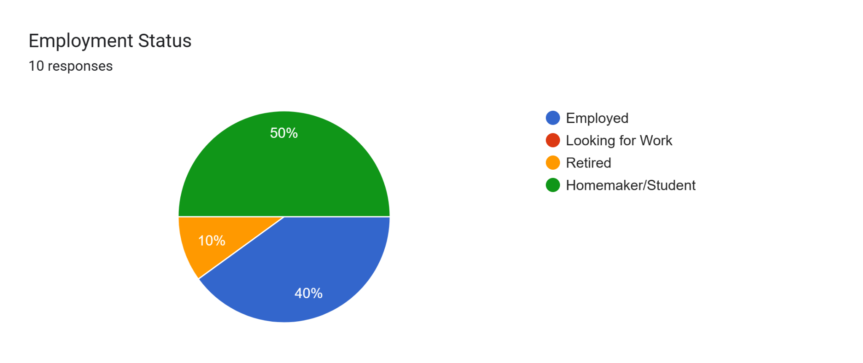 3.2 User Needs Assessment

After initial planning and participant action protocols were developed, we put to use our research into conducting a ‘User Needs Assessment’. A User Needs Assessment is a systematic process aimed at understanding the requirements and preferences of users regarding a product, service, or system. It involves identifying key stakeholders, selecting appropriate assessment methods such as surveys or interviews, collecting and analyzing data, and creating user personas. The insights gained guide the development or improvement of the offering, fostering a user-centric approach and ensuring that the final product aligns effectively with user needs and expectations.

The user needs and requirements survey sessions can be broadly divided into 3 parts:

1. **Pre-Survey**

In order to shortlist 10 promising participants, we will send out a questionnaire prepared using google forms that will help us get to know about our participants’ demographics like age, gender, country, marital and employment status and their comfortableness with technology. We also get to know how often they require medical care so that we can group them into user groups accordingly. This helps us pick a diverse pool of candidates that could potentially give a wide range of ideas and feedback.

1. **Primary Survey**

Our pool of participants will consist of people from Toronto as well as multiple other countries. Due to this, we plan to conduct our sessions both online using Zoom and offline in person. Each session will be hosted by 2 members of our team with one of them asking questions and the other making notes and observations. We encourage our participants to speak out loud as they perform the given tasks.

Our pool of participants will be divided into two user groups. Refer “User needs assessment requirements” file for more details. Each user group is assigned a set of 3 tasks listed out in the file mentioned. The following are the questions to be asked during the sessions:

1. What are your preferred methods of searching for doctors and booking appointments? Please walk us through how you go about doing that.
2. Why do you prefer using the method you mentioned over others? Is it faster, more simple or reliable?
3. How do you prefer to consult with healthcare professionals?
4. Do you have any specific accessibility needs, such as larger text, voice commands, or screen reader support?
5. Do you feel booking an appointment with a doctor is as easy as booking a movie ticket?
6. Why do you think so? Try comparing the both and see which part is as easy or hard compared to the other?

As this is one of the initial set of sessions, we will aim to keep pre conceived questions to a minimum and focus on observing user behavior and basing questions on the same. The observations will focus on Workflows of the users : How, when and users complete their tasks; High priority tasks, information and decisions; How information flows; Tools and technologies that are used.

All online and in person interviews will be recorded and carefully studied later to complete user needs and requirements reports.

**3. Post Survey Feedback**

After the completion of live interviews, will we send out surveys asking users about their thoughts on their experience performing the tasks. There will also be questions asking them about their opinions and thoughts on how the UX functionalities can be improved upon. The aim of this last and final survey is to allow people to share their thoughts from the comfort of their own where they do not feel the pressure of being scrutinized.

**Data Collected:**

The following paragraphs describe the insights gathered from participants who engaged with healthcare apps, including Practo and Maple, web-based healthcare services and individual hospital/clinic websites. During the initial phase of our study, participants were assigned specific tasks within these applications, and their feedback provided valuable insights for enhancing the overall user experience. Key findings sorted task wise from their feedback include:

**Finding a Doctor and Booking appointment:**

During our research, we met a participant called Uday, who had been assigned with booking an appointment via the Maple app. When he opened the app, he was sent to another page, but locating the "Book Appointment" section proved challenging. Uday began exploring several options on the app, hoping to find the right button. After a few minutes , our researcher asked about his experience. "Why did you click the 'Ask a Question' button?". Uday said that he imagined there was a 'Book Appointment' option underneath it, or that it would take him to a page where he could request an appointment.

This finding emphasized the importance of user-friendly navigation as well as the need for visible and intuitive design elements in healthcare apps. Users like Uday may make assumptions about button functionality, underlining the significance of clear and simple appointment booking options.

During our interviews, participants emphasized the necessity of improved search filters and sorting options. They proposed filters based on specialization, ratings, location, availability, and appointment mode to increase the precision of doctor searches. The importance of comprehensive physician profiles was underlined. When choosing a healthcare practitioner, users underlined the value of past evaluations, professional experience, specialties, and noteworthy accomplishments. While some platforms had this, they weren’t very easy to interpret. These tons of information needs to be efficiently summarized using aggregators and highlighting icons.

**Communication:**

Participants suggested adding functions that would let users book, postpone, and cancel appointments as well as safely transmit vital health information.Users recommended adding a chat window to enable direct connection with medical professionals in addition to these features. In order to increase accountability and transparency, they also want to be able to rate and evaluate appointments.

**Building a Profile:**

Building a resourceful profile can be tedious and medical terms can be difficult to understand for everyday users. We found users of Maple and Practor asking us what some of the user input fields meant while filling up their data. They also tried looking up medical terms online. We asked them if helpful prompts like a question mark icon or a “Learn More” next to the input field could have been more helpful and everyone agreed. We also observed most people skipping important profile fields because the questionnaire was too long. We realized dividing the questionnaire to build profiles into mandatory fields and optionals would help.

Senior participants during their interviews expressed desire for less fancy text styles and more simple clear text styles accompanied with audio and visual aids would help them navigate through the app seamlessly.

**Managing Chronic Conditions:**

After booking an appointment through hospital websites most participants met with short single line confirmation emails or notes. Most first time users weren’t exactly sure of the need for any other steps that could help them. In order to improve the post-appointment process's efficiency and informational value, participants requested post-booking sites that included checklists, cancellation alerts, and unambiguous instructions to the doctor's office.

Users also asked for the ability to add family members and pre-approved emergency contacts to online appointments, which would be especially helpful in an emergency. None of the platforms had this option.

These participants' input will be a great source of information for improving the functionality and general usability of healthcare applications. The goal of these enhancements is to increase the apps' usability and efficacy in catering to the various demands of healthcare users. Apps like Practor or Maple did not offer the option of recurring appointments.

**Graphs**:

The following are the graphs obtained through post interview surveys:

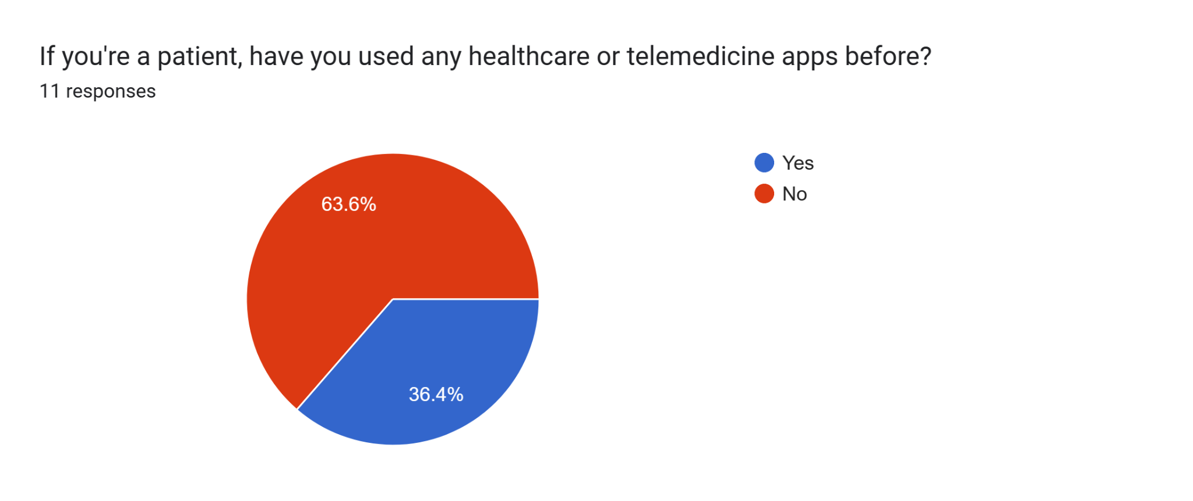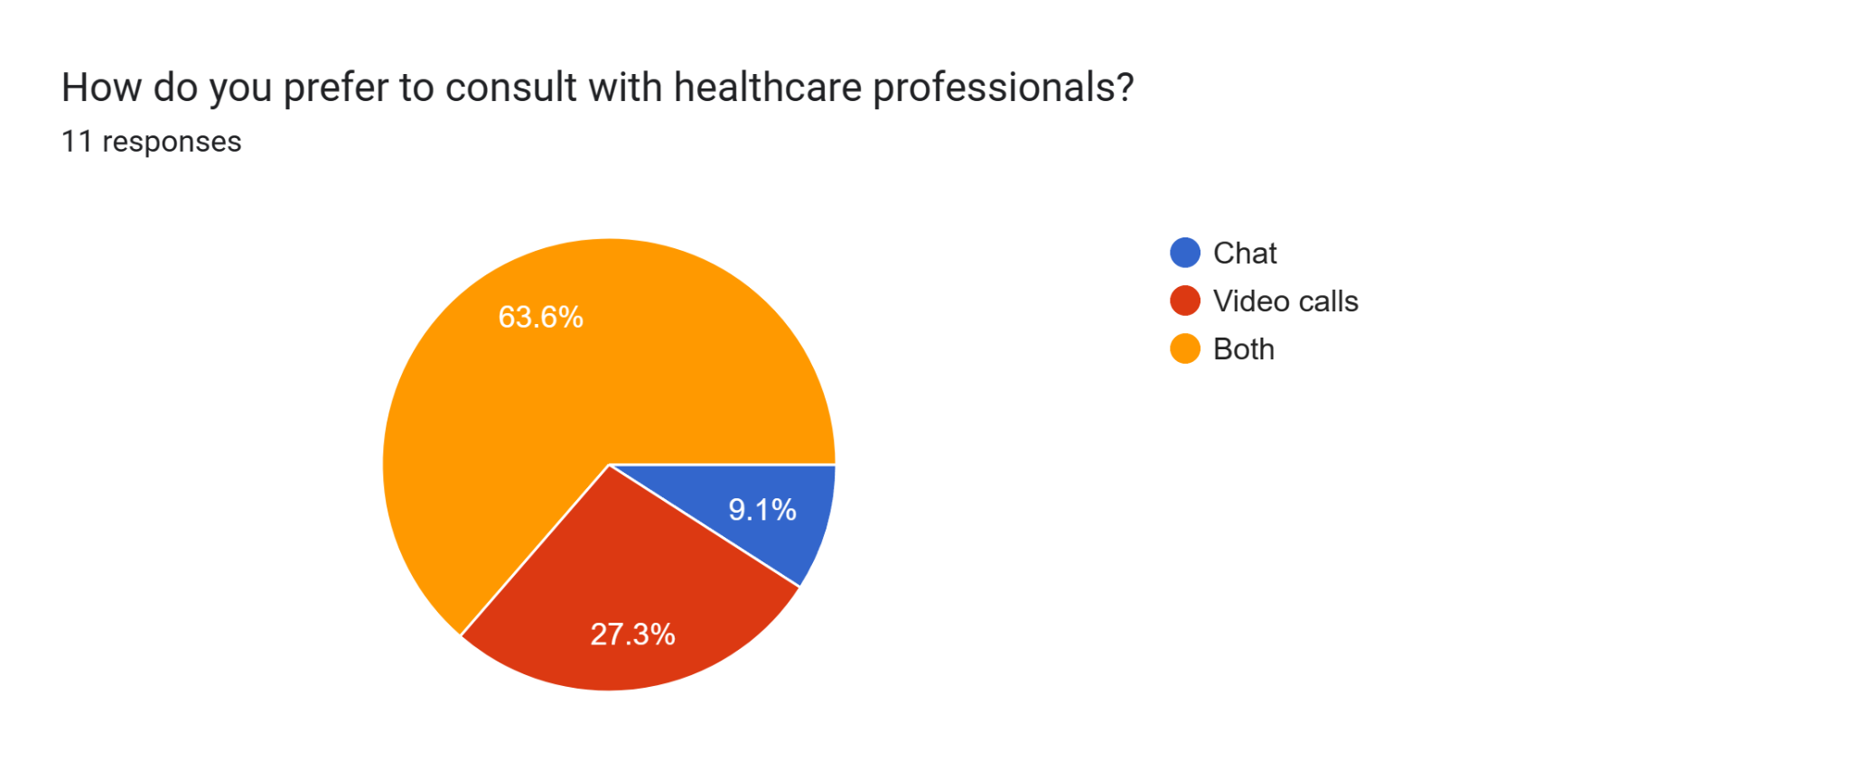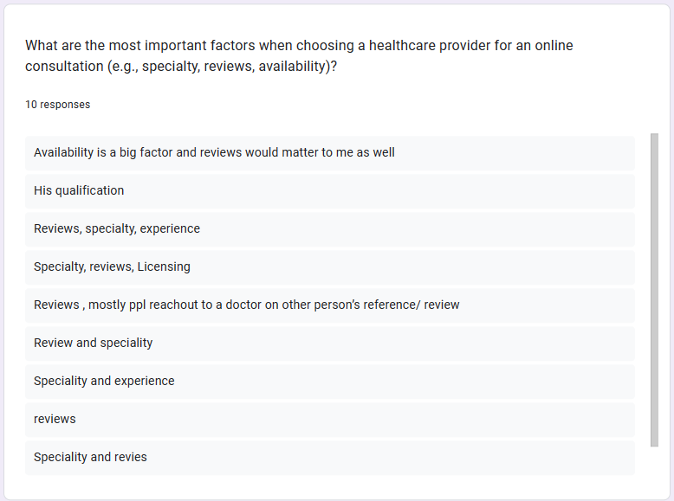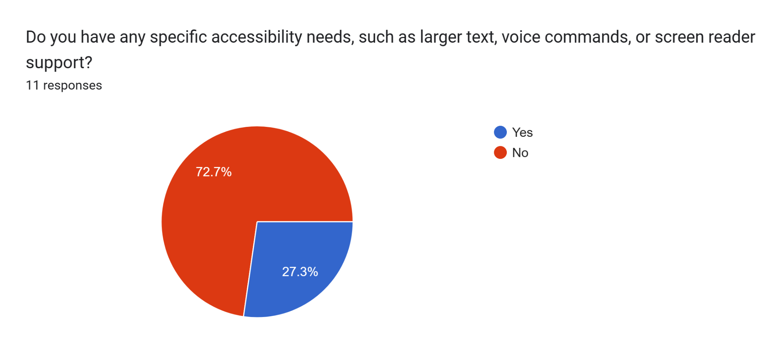

In summary, the following were the user needs and requirements identified:

| Task name | User Need description | User Requirement description | Type of req. |
| --- | --- | --- | --- |
| Find a doctor | Get detailed information and reviews of a doctor | Comprehensive doctor's profile displaying past reviews, experience, specialties,  achievements and updated availability | Functional and  Informational |
| Find a doctor | Need better filters and sorting | Ability to filter search results based on speciality, ratings, distance, availability and mode of appointment | Functional |
| Book an appointment | App needs to store data from the previous  appointment and autofill. Like payment and address. | App needs to store data from the previous appointment and offer suggestive fill | Functional and  Informational |
| Book an appointment | Have the option of choosing an appointment type like chat, video or in-person. Option to opt for recurring appointments | Display different modes of appointment the doctor offers along with the availability of each | Functional |
| Communicate | Ability to track appointments, cancel or  reschedule and share health records | A "My Bookings" tab that displays completed, upcoming and canceled appointments. | Functional |
| Communicate | Ability to add reviews and follow up | Prompt users at the end of an appointment to add reviews and ratings. A chat window to  communicate with the doctor | Functional |
| Build a profile | Easy to understand questionnaire that will  build a profile | When a user signs up, they need to go through a simple questionnaire to create a basic profile with and preferences | Functional |
| Book regular  appointments | Ability to get visual-audio prompts and suggestions to help book an appointment | Ever user input should have a an option like "Learn More" that explains what kind of response is expected and explanatory prompts | Functional and  Informational |
| Book regular  appointments | Get confirmations, reminders and checklists to prepare before an appointment. Hopital/  Clinic maps showing where the doctor's office is located | A very informative post-booking page with a checklist of all the helpful materials. Notifications of last date of cancellations and appointments | Functional and  Informational |
| Online appointments | Ability to include family members into online appointments remotely | Ability to invite different pre-approved emergency contacts onto online vide appointments | Functional |

**Prototype Development**:

The insights gained through User Needs Assessments led us to develop three low fidelity prototypes. Low-fidelity prototypes are basic, quick representations of designs, often created with simple tools like sketches or wireframes. They help test and communicate concepts early in the design process before investing in more detailed prototypes. We utilized placeholders and other elements for this version. The prototypes are listed below:

**Prototype I**

Description: This low fidelity prototype is made based on extensive evaluation

on the feedback received during the user needs and assessment sessions.

It accomplishes critical tasks required to search for doctors and book an appointment

**Build Your Profile**

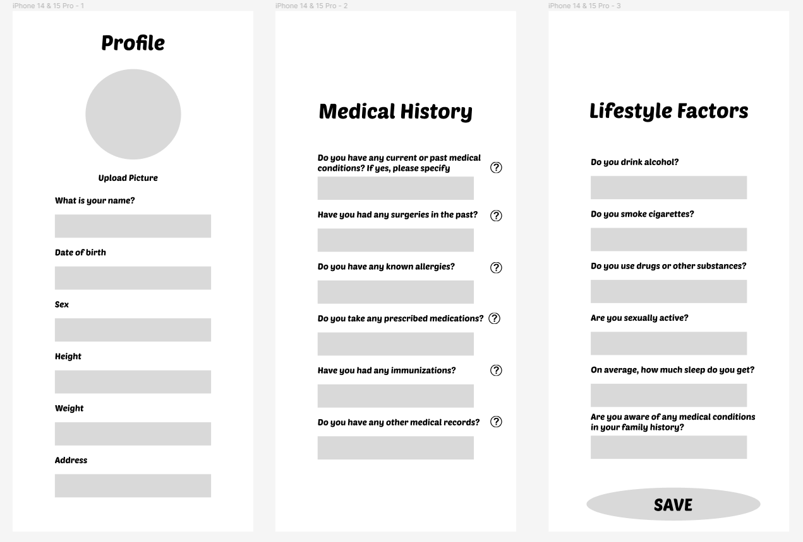

**Search Doctors**

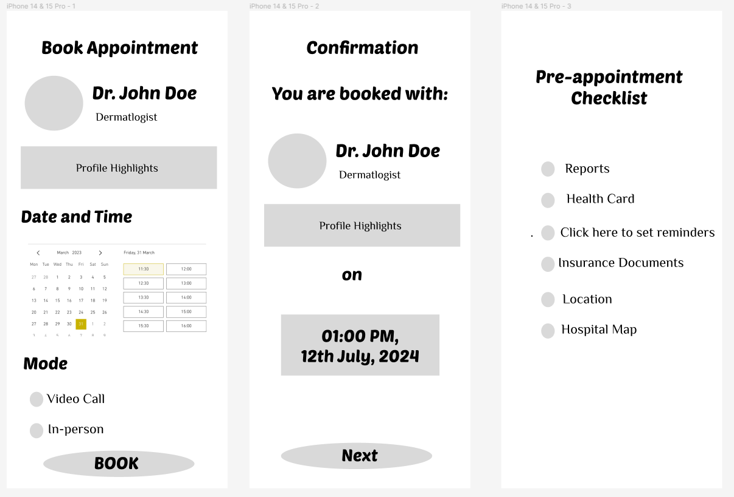

**Book Appointment**

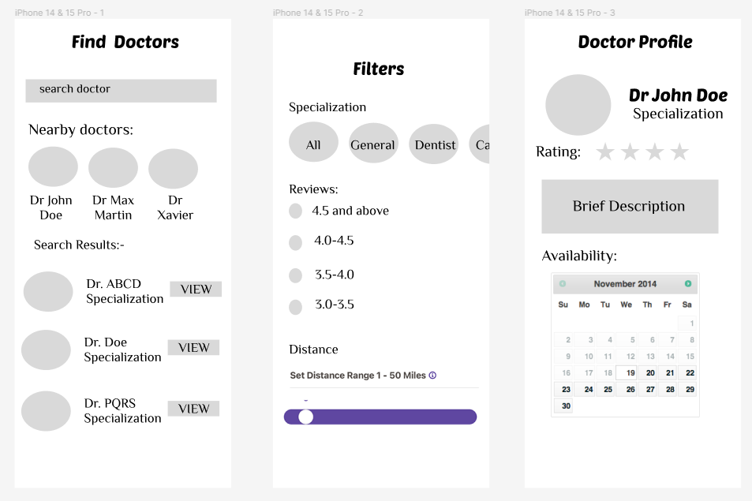

**Prototype II**

Description: The design prototypes below are of low fidelity nature to be presented to users

for testing multiple tasks including building a profile, searching for doctors using

helpful filters and finally booking appointments.

**Sign Up and View Services**

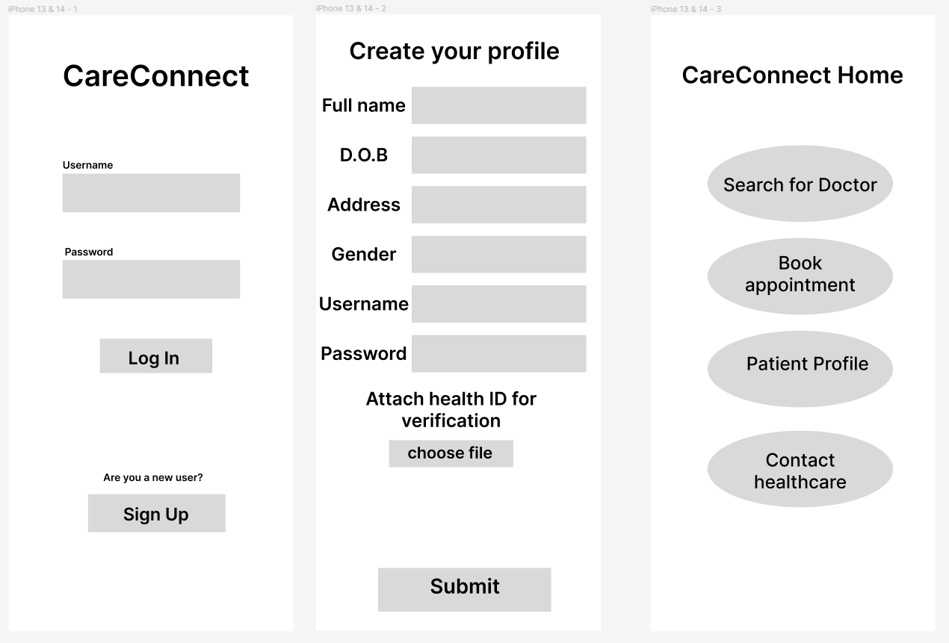

**Search for Doctors and book appointment**

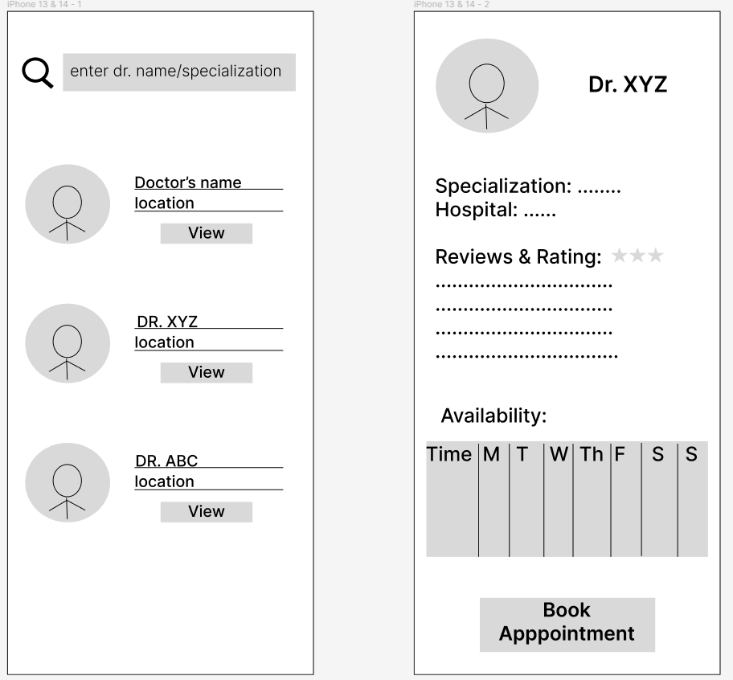 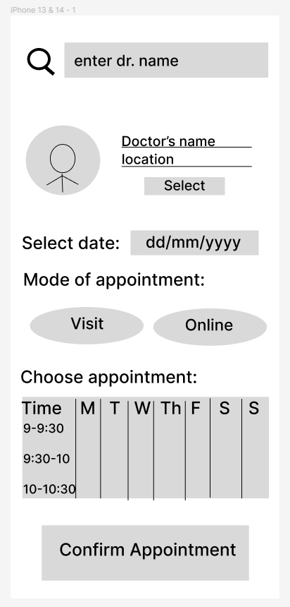

**View and Update Profile**

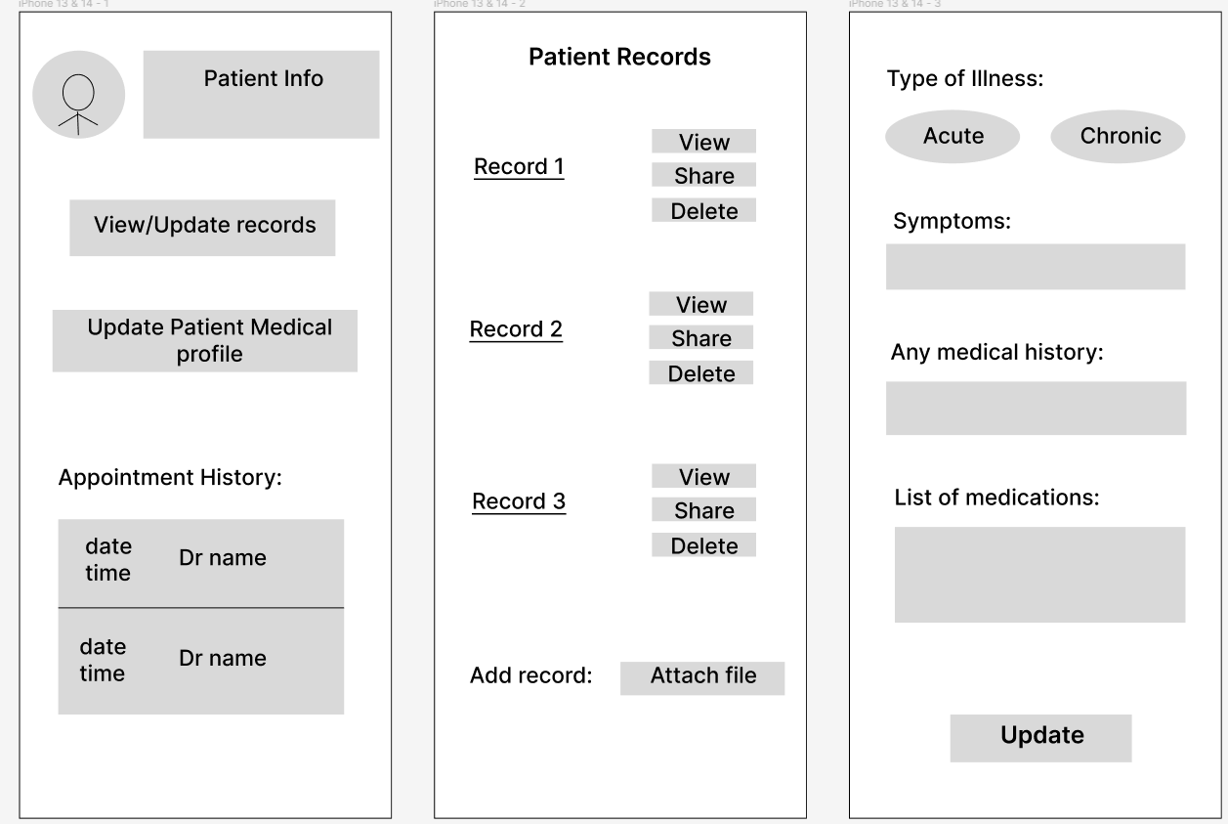

**Prototype: III**

**Description**: A digital prototype of Care Connect health application made using Figma based on the tasks and user needs assessed by the survey carried out for user groups including young adults, adults and senior citizens.

**Start point:**

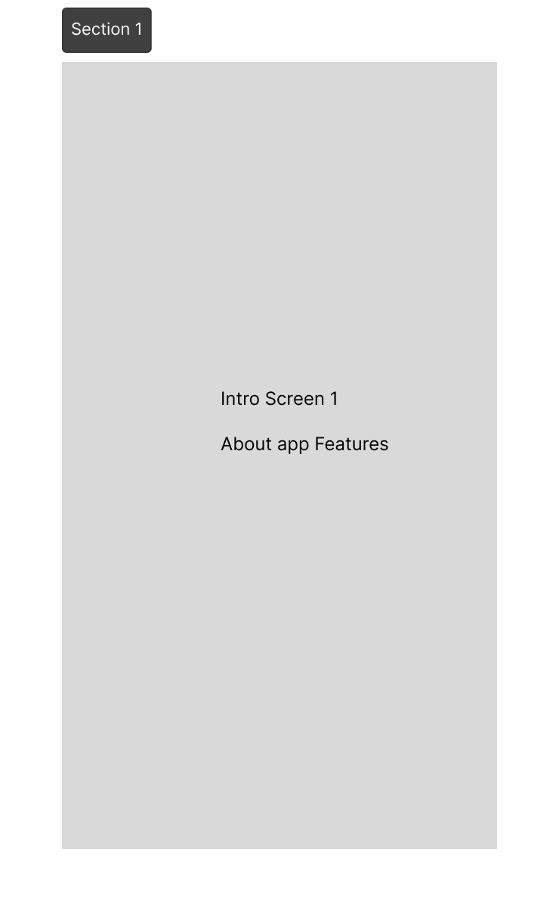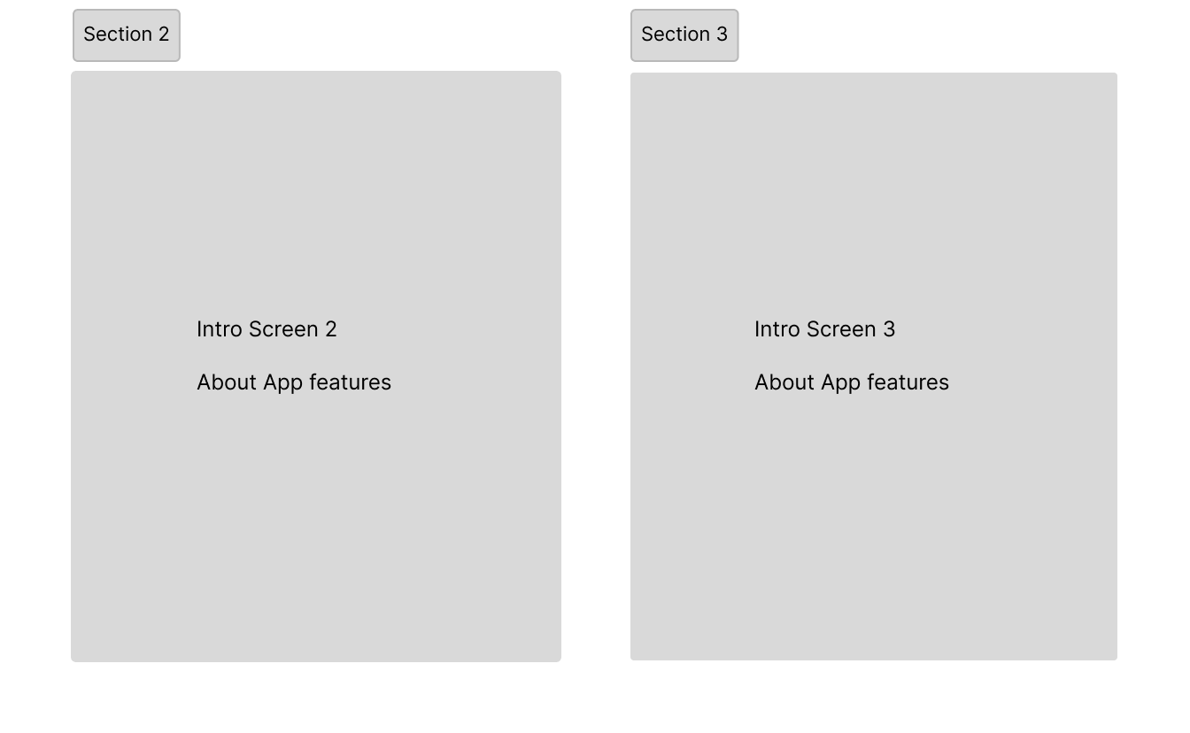

**Build Profile and Login:**

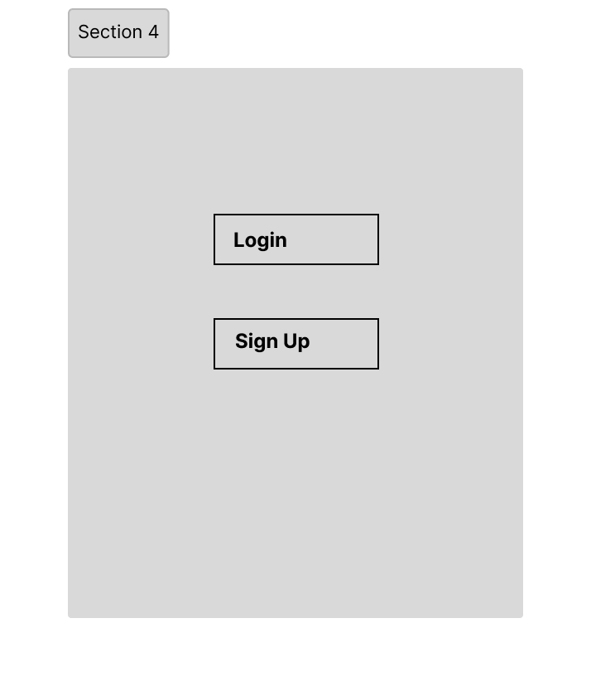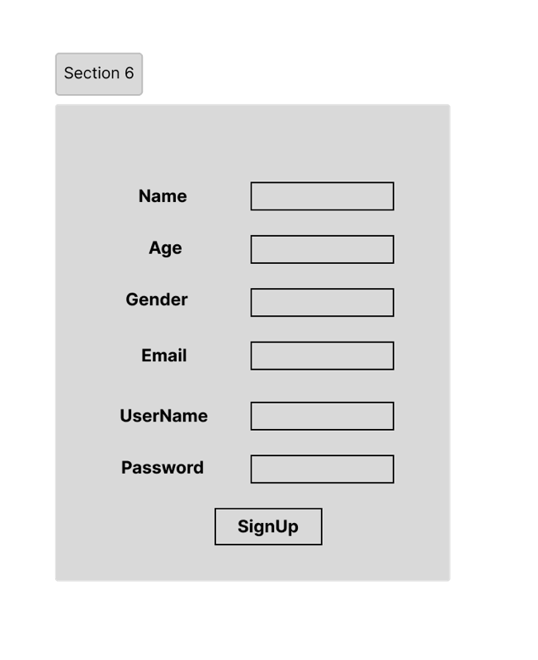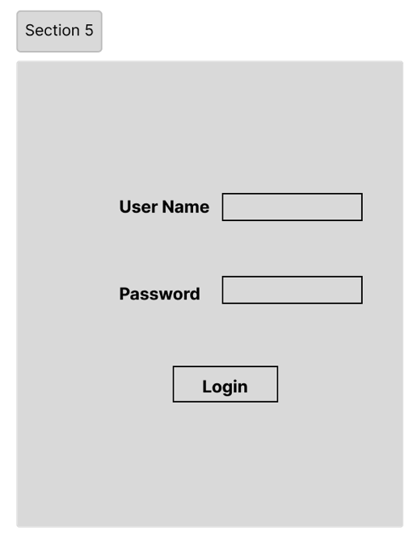

**Book Appointment and My Appointment screen:**

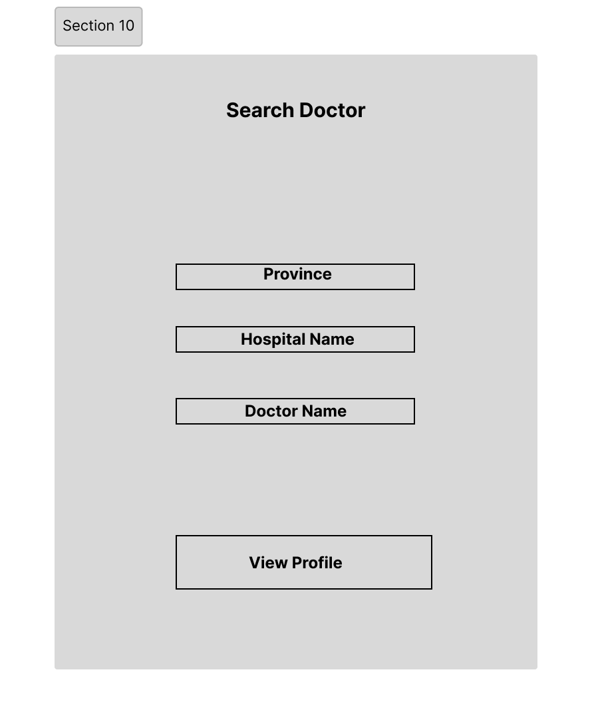

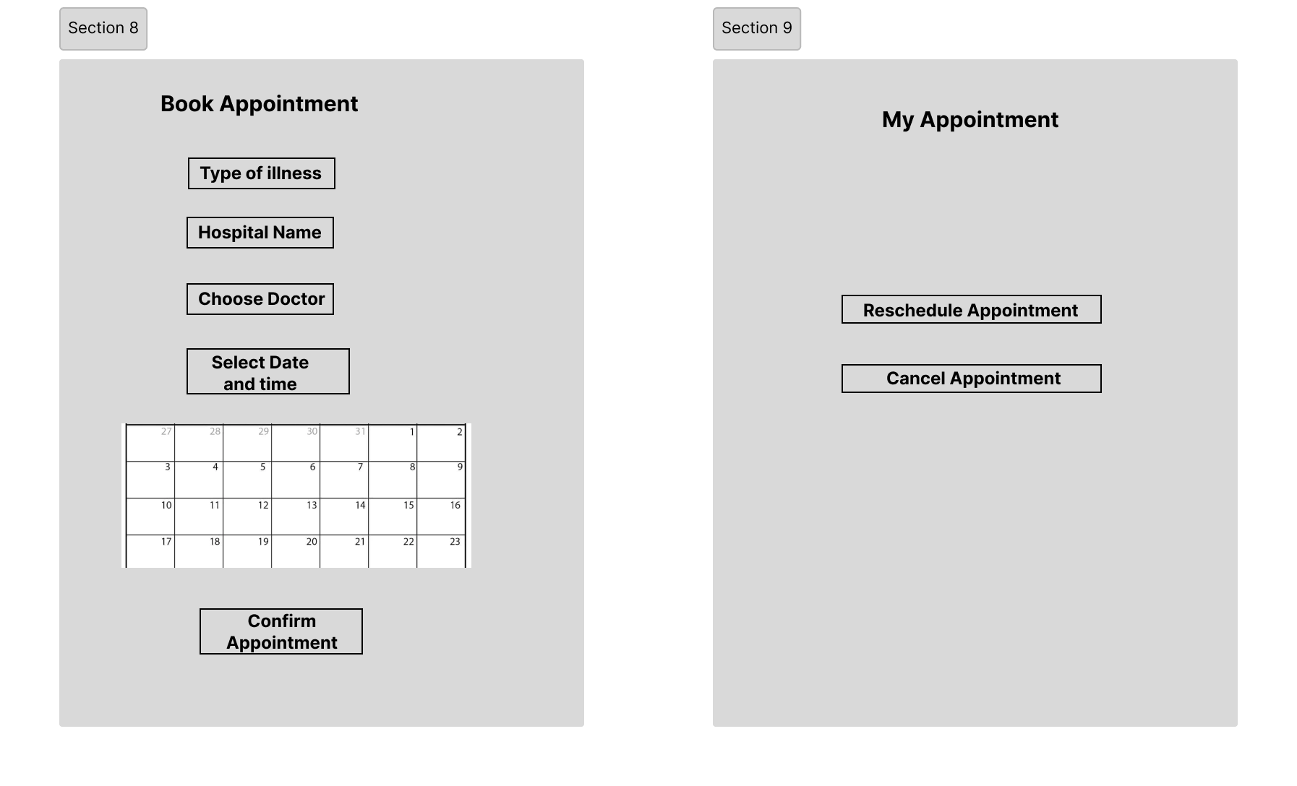

3.3 Cognitive Walkthrough

The low fidelity prototypes developed initially gave us an essential starting point to start shaping and testing our design and ideas. Continuing with the same participants we evaluated the low fidelity prototype to get feedback that could help us develop a medium priority prototype.

The session protocol used to test and survey the low fidelity prototypes is as follows:

1. Pre Survey: A questionnaire prepared using google forms that will help us get to know about our participants’ demographics like age, gender, country, marital and employment status and their comfortableness with technology. We also get to know how often they require medical care so that we can group them into user groups accordingly.
2. Cognitive Walkthrough: A cognitive walkthrough(ref 6.2.3) involves a complete team effort to develop questions to be asked to the participants. It’s essential to keep the number of questions to an optimal level and focus on observing and asking questions based on user actions. Counterbalancing(ref 6.2.5) is also implemented by mixing up prototypes and tasks presented to the participants.
3. Note taking: We follow a tabular approach to record our observations during sessions. This pre-made table attached in the appendix has appropriate columns for user actions and behaviors to be recorded. Following this over narration paragraphs or transcripts helps us focus on key points in a readable format.
4. Post Survey Questionnaire: Another questionnaire prepared using google forms(ref 6.2.4) to get user votes and feedback on the prototypes they preferred and their insights behind their preferences.
5. Conclusions: The last step in our protocol is the brain storming session where participants of our team sit and review all session recordings and notes to conclude our key findings and finalize the prototype to build further.

**3.3.1 The role each team member played in the assignment**

| **Team Member** | **Role** | **No. of User-interviews conducted** |
| --- | --- | --- |
| Habeebuddin Mir | Facilitator, observer, note-taker | 3 |
| Maseerah Khatoon | Facilitator, observer, note-taker | 3 |
| Shaiz Akhtar | Facilitator, observer, note-taker | 4 |

**3.3.2 Semi-structured Script**

1. How was your booking experience through this prototype compared to the traditional way of booking?
2. Were there any difficulties or challenges you encountered during the booking process?
3. Did you find all the necessary information about the doctor (e.g., name, specialty, location) easily accessible and clear?
4. Were you able to understand the available appointment slots and choose a suitable one?
5. How was your experience setting up and managing your user profile within the app?
6. Did you feel comfortable sharing personal information for the booking process?
7. Were the fonts, buttons, and icons easy to read and interact with?
8. Were you able to easily find doctors based on their specialty, location, or availability?
9. Were you provided with a clear confirmation of your appointment after booking?
10. Did you receive any follow-up information or instructions?
11. On a scale of 1 to 10, how satisfied are you with your experience using this app, and why?
12. Are there any features or functionalities you think should be added or removed?

**3.3.3 Scenarios and User Prompts**

Scenario 1: Build a Profile

In this scenario, a user, assumed to be signing up for the first time, is asked to build a profile. Building a profile includes multiple sub-tasks listed below requiring the user to navigate through multiple screens.

Task 1: Enter Basic Data

Task 2: Fill out Medical History

Task 3: Fill out Lifestyle factors

Task 4: Hit Save button

Scenario 2: Search Doctors

The next scenario involves searching for a doctor. In this scenario, the user uses a search bar to enter their query like a doctor’s name or location to get results when the search button is hit. The user also has the option of setting filters in this scenario. Successful completion should result in the display of a list of appropriate doctors.

Task 1: Enter search query

Task 2: Set filters

Task 3: Access list of doctors

Task 4: View doctor’s profiles

Scenario 3: Book appointment

One of the most critical scenarios for a user of CareConnect is to book an appointment. From the list of search results achieved in the last scenario, the user selects ‘View Profile’ of a doctor. On the profile page the user will have to choose a date, timeslot and mode to activate the ‘Book Now’ button. Upon clicking the button, the user should be able to view a confirmation screen with a checklist of pre-appointment necessities.

Task 1: Select date

Task 2: Select time slot

Task 3: Choose appointment mode

Task 4: Review pre-appointment checklist

**3.3.4 Prototype Development**

After a comprehensive evaluation and study of the low fidelity prototypes, we developed this advanced prototype that leverages the feedback and learnings from the user interviews and feedback. This version of the prototype enhances prototype Charlie by incorporating the best of prototype Alpha and Bravo while retaining the original design that proved to be useful.

Continuing the previous task goals, we focus on the 4 major features:

1. Login and Sign Up
2. Build Profile
3. Search and View Doctor profiles
4. Book appointments

Following pages will discuss each modified task screen and the reasoning behind the changes.

1. **Login and Sign Up Screens:**

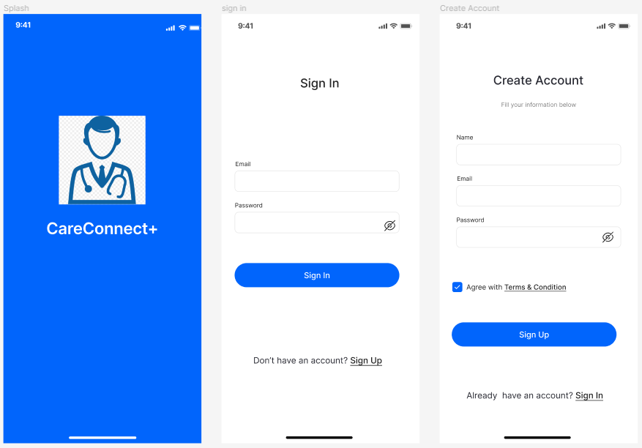

We start off with the launch screen of the app that leads to a sign in screen where the user is asked for their credentials. In case a new user launches the app, they are directed to create an account with their email and a password. Once a user hits sign in after entering correct credentials, the screen is populated with the home screen of the app.

Previously when a new user wished to sign up, we had more fields to fill in by the user. But as users’ suggested, we reduced the number of screens they need to go through before moving to the main screen. In this prototype, we have designed these screens to be quite clear and simple to start with the app as per the users preference so that they are not overwhelmed right at the start.

In the initial prototypes, we had missed creating a login page too, assuming everyone to be new users, but a login page has now been added after users requested one in the last session.

1. **Build Profile:**

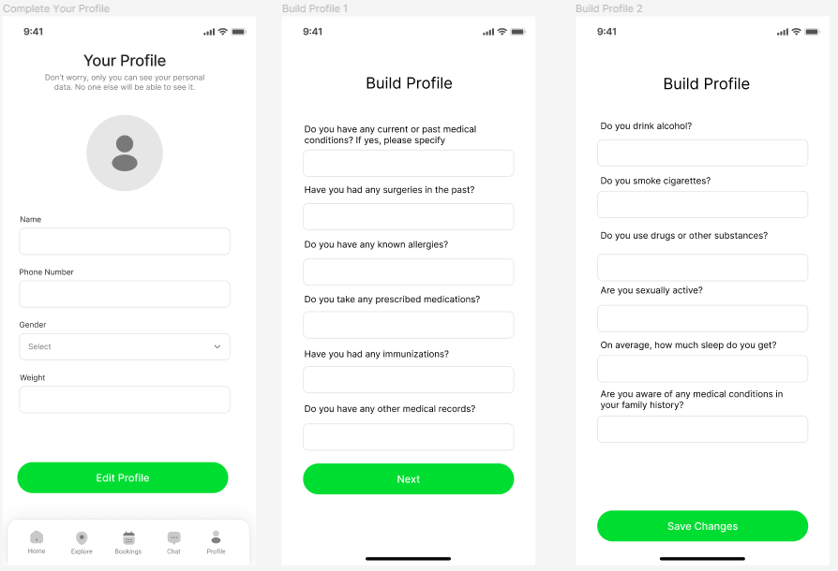

As mentioned in the previous screen description, users preferred making the sign up process shorter, which led us to create the build your profile separately. It was also pointed out that the language used was either too technical or vague, which prompted us to go with more user friendly terms. A right balance between the number of questions and the number of screens were also considered a lot. We ended up with a substantial number of questions perfectly fit onto 3 screens. While this section may not be perfect, it qualifies well as a medium fidelity prototype.

1. **Search for a Doctor**

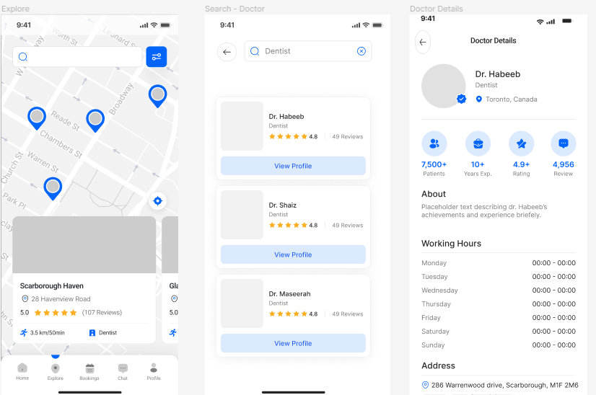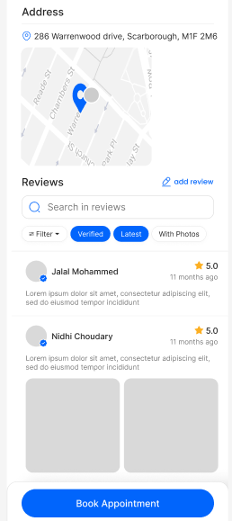

Apart from the evident addition of colors and graphics, we added the much sought out navigation bar to the main screen. We also added a map along with close by location suggestions which makes our search screen more dynamic. After searching up a speciality, users are given a list of doctor profiles in a card format that highlights the speciality and ratings of the doctor. It also provides users an action button to view a detailed profile of a doctor that they might be interested in.

Clicking on the ‘View Profile’ button directs the users to a comprehensive page that displays out all the essential information of a doctor one might possibly need. The information is not only aesthetically presented but also well structured highlighting critical content and summaries. The icons highlight achievements and experience of a doctor in an easy to grasp graphical way. After the user has gone through the profile, they will encounter a ‘Book Appointment’ action button that redirects them to the screens discussed next.

1. **Book Appointment**

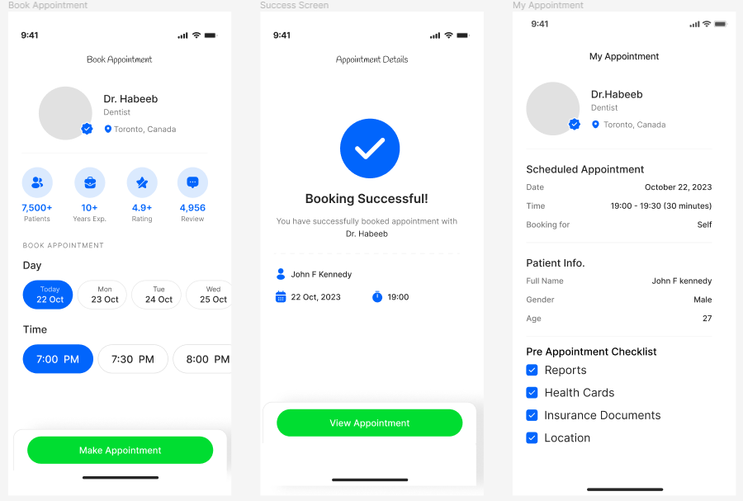

When a user decides to book an appointment with a doctor the above screen is shown up which allows the user to select a date and time for the appointment. Once the user taps the “Make Appointment” button a confirmation screen comes up with the appointment details.

During our evaluations with the earlier prototype, we had received feedback for the addition of a confirmation page which has been added here. Once an appointment is confirmed, the users can easily view the booked appointment under their bookings feature which gives a summary of their appointment and also we have included a checklist of documents or information that the user might need to share before their consultation.

Another critical aspect users pointed out was the need for fewer and more simpler steps during booking. That was considered into our design planning, making it the reason behind the button groups that can be seen for choosing date and times. We have designed the booking process to be convenient and easy to follow according to the users’ insights we concluded with our evaluations earlier.

3.4 Heuristic Evaluation

The medium fidelity prototype was then evaluated by the team members against the 10 Heuristic principles. Heuristic evaluation is a usability evaluation method in which one or more evaluators assess the user interface of a system based on a set of established heuristics or principles. These heuristics are general guidelines or rules of thumb that help identify usability problems and areas for improvement in a user interface.

The 10 heuristic principles commonly used in heuristic evaluation were originally introduced by Jakob Nielsen and Rolf Molich. These principles are:

1. Visibility of system status:

- Keep users informed about what is happening through appropriate feedback within a reasonable time.

2. Match between system and the real world:

- Use language and concepts familiar to users; follow real-world conventions, making information appear in a natural and logical order.

3. User control and freedom:

- Allow users to easily undo actions, exit undesirable states, and navigate through the system without feeling trapped.

4. Consistency and standards:

- Follow platform conventions and use consistent terminology, layout, and design across the system to reduce cognitive load.

5.Error prevention:

- Design the system to minimize the occurrence of errors by providing clear instructions, warnings, and confirmation dialogs.

6. Recognition rather than recall:

- Minimize the user's memory load by making objects, actions, and options visible and easily retrievable.

7. Flexibility and efficiency of use:

- Design for both novice and expert users, allowing shortcuts and efficient ways to accomplish tasks for experienced users without hindering beginners.

8. Aesthetic and minimalist design:

- Strive for simplicity and clarity in design, avoiding unnecessary elements that do not contribute to the user's understanding or task completion.

9. Help users recognize, diagnose, and recover from errors:

- Clearly communicate error messages, provide suggestions for recovery, and assist users in resolving issues.

10. Help and documentation:

- Provide easily accessible and context-sensitive help and documentation to assist users in understanding the system and completing tasks.

Keeping in mind these heuristic principles, each team member identified around 15 components of the app that violated one or more of the listed principles. A total of 11 high, 9 medium and 7 low priority issues were identified that will be discussed in section 4.2 of this report. Addressing all those issues helped us coming up with the following high fidelity prototype:









3.5 Usability Testing

The following is the protocol followed in the final usability testing and performance measurement:

1. **Objective:**

To conduct high fidelity testing of CareConnect and identify areas of improvement.

1. **Participants:**

U1: 5 from ‘Young aged (18-39) and high technical proficiency’

U2: 5 from ‘Old aged (40+) and low technical proficiency’

1. **Facilitators:**

| **NU ID** | **Team Member Name** | **Contribution** |
| --- | --- | --- |
| 002713929 | Habeebuddin Mir | 3x Facilitator, 4x observer and note-taker |
| 002778147 | Maseerah Khatoon | 3x Facilitator, 3x observer and note-taker |
| 002796856 | Shaiz Akhtar | 4x Facilitator, 3x observer and note-taker |

1. **Tools and Methodology:**

i) Data Collection Excel Sheet to record Metrics

ii) Free form notes to record observational notes

iii) Multiple cameras to record sessions

iv) Figma application to redesign and test prototype

1. **Task Scenarios:**

**Task 1:** You are signing up for the first time on a Healthcare App. You need an email id and password. After the sign up, you have to sign in, navigate to the Build profile section, and answer a series of questions to build your medical and lifestyle profile.

**Task 2:** Once a user is signed in, they navigate to the explore section, to search for either a doctor or a speciality. Once they find a suitable match, they can view the doctor’s profile in detail.

**Task 3:** When a user finds a doctor’s profile satisfactory, they can find the ‘Book Appointment’ button which leads them to the booking screens. After completing a series of steps, which involves choosing their desired dates and time, a user is able to secure an appointment. They should then try canceling the appointment.

1. **Session Overview:**

**i) Informational Briefing-** Provide a brief overview of the session. Introducing the CareConnect application. Explain the purpose of the usability test and emphasize that the focus is on the product, not the participant's abilities.

**ii) Demographic Survey-** Present users with an online form to collect their demographic data and their technical proficiencies.

**iii) Prototype Testing-** At this stage, users are presented with the CareConnect prototype and asked to complete a series of tasks defined in section 5. This session involves recording performance of users in controlled settings. Users are observed and timed. Data is recorded on video, and observations are made in free form notes(ref 6.3.2). The data is used to calculate performance times and to identify and explain errors and guidances a user might have required during the session.

**iv) Debrief and Post-Test Questionnaire-** Discuss any challenges or surprises encountered during the session. Gather feedback on the overall experience. Ask about specific pain points and areas of satisfaction.

1. **Post Session Task:**

i) Compile notes and observations

ii) Analyze data to identify common themes and issues

iii) Generate a usability report outlining findings and recommendations

iv) Redesign Prototype based on usability report conclusion

This final round of usability testing identified areas of improvement which led to the development of our final prototype:









1. **FINDINGS**

4.1 Low Fidelity Prototype (Cognitive Walkthrough)

**Issues with Chosen Prototype (Charlie):**

In our evaluation of three low-fidelity prototypes Alpha, Bravo, and Charlie we focused on addressing usability concerns and identifying the most user-friendly prototype. After a thorough analysis, we zeroed in on Prototype Charlie based on its overall positive performance. However our cognitive walkthrough identified specific issues with Prototype Charlie that need to be fixed and improved. Below is a detailed description of the issues encountered, along with the number of instances and users affected:

**Issue 1: Navigation Complexity**

Statement of the Issue:Within Prototype Charlie, users highlighted a desire for a more streamlined navigation experience, emphasizing the need for fewer panels to transition between different options from their present screen.

a. Number of Instances: 2

b. Number of Users Affected: 3



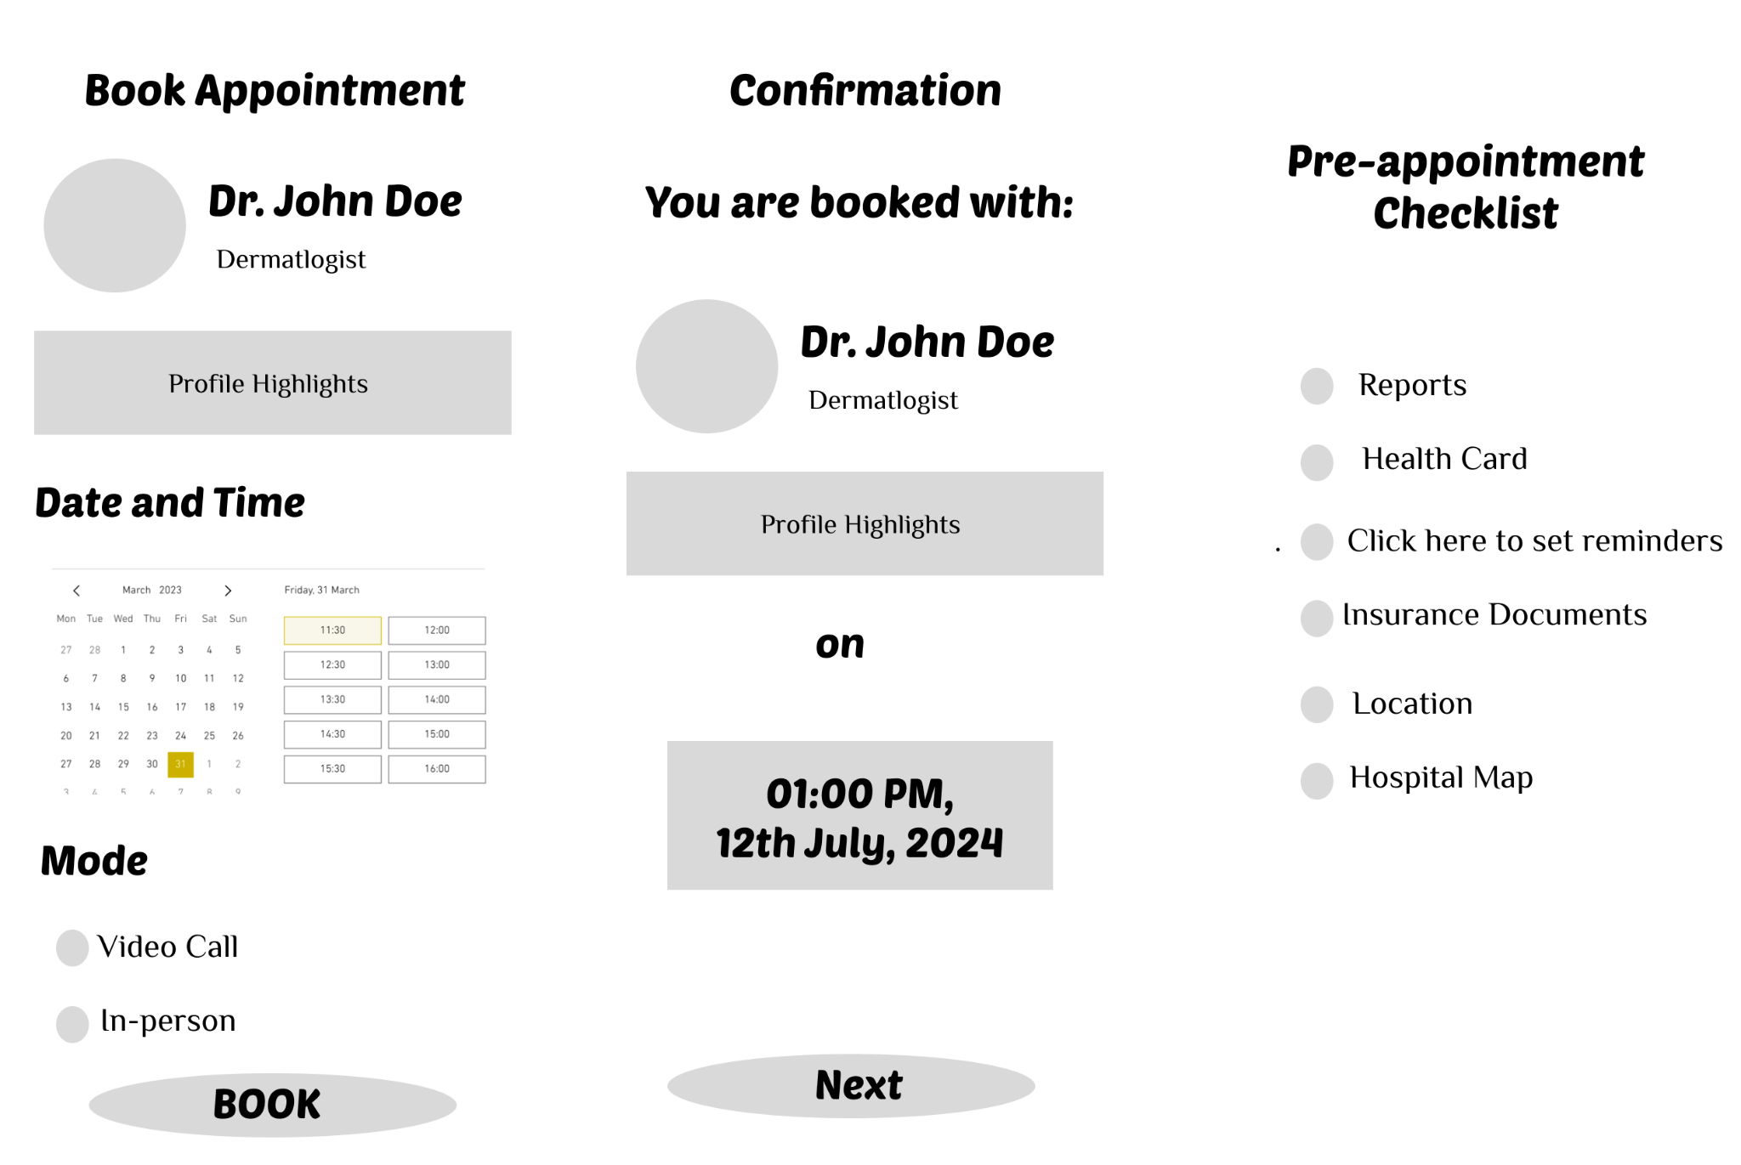

**Issue 2: Security Concerns**

Statement of the Issue: Users were hesitant to share information within Prototype Charlie because of perceived security concerns, highlighting the need for stronger security procedures.

a. Number of Instances: 2

b. Number of Users Affected: 1

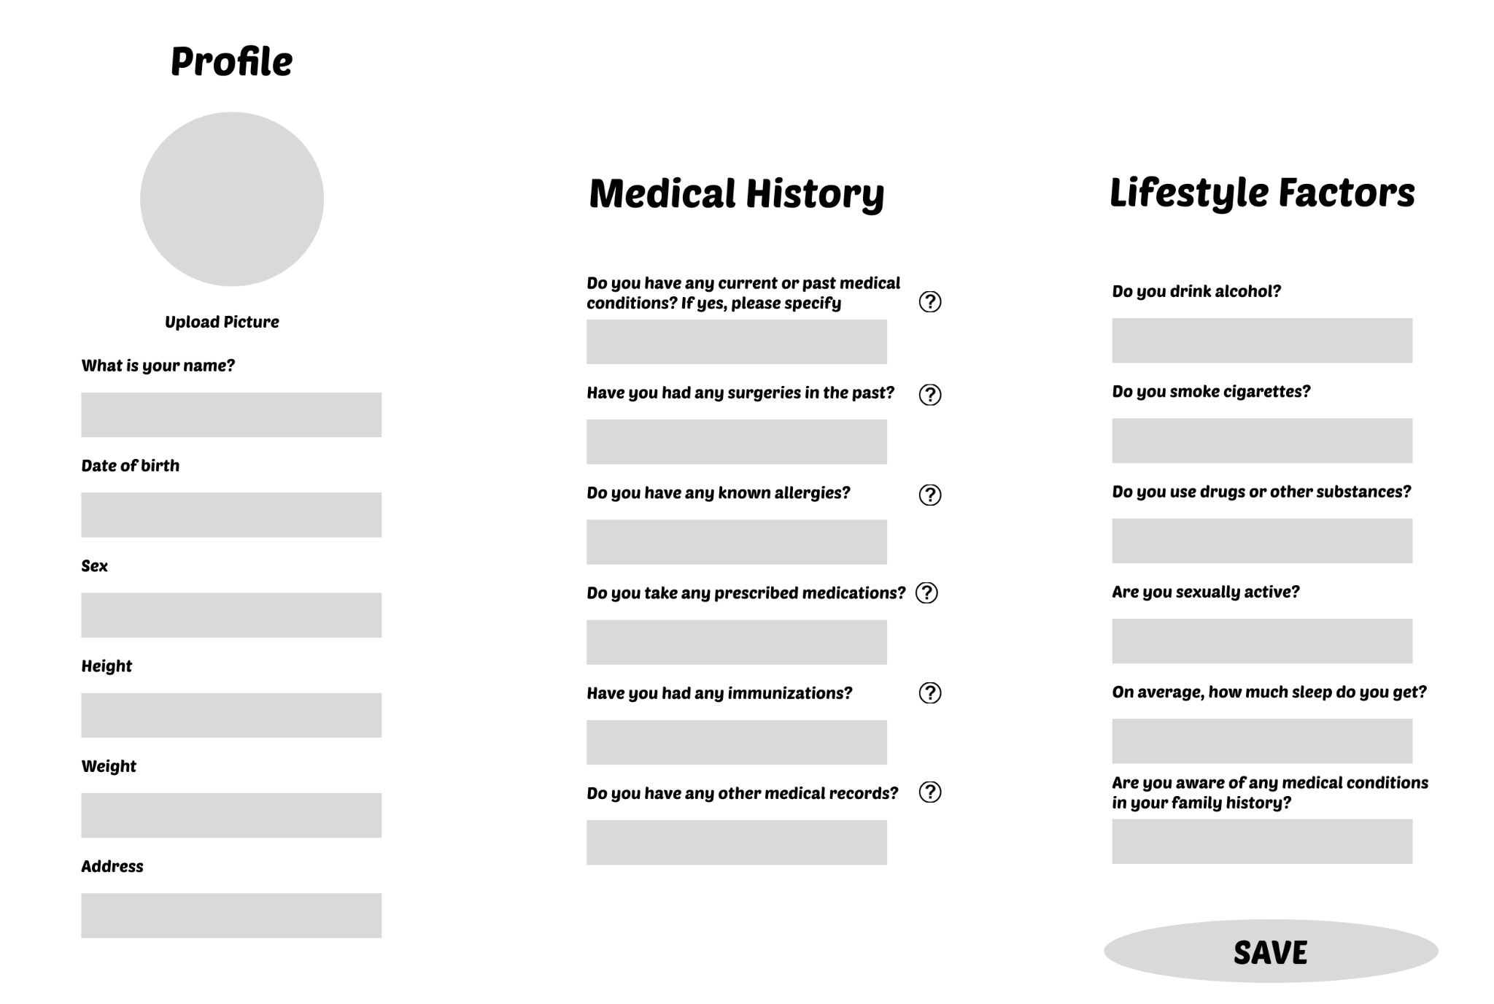

**Participants' Subjective Feedback:**

* A better navigation between pages and the home screen would help.
* UX of booking where users have liberty to choose relevant medical records.
* Lacks a home screen.

**Conclusion**:

These findings are crucial in understanding user expectations and areas that can be improved within Prototype Charlie. Despite these identified issues, Prototype Charlie emerged as the preferred option in the overall evaluation, with participants favoring its user-friendly attributes. Moving forward, addressing these concerns will contribute to a more refined and optimal user experience within Prototype Charlie.

4.2 Medium Fidelity Prototype (Heuristic Evaluation)

We identified and resolved a total of *9 high priority* and *11 medium priority* issues that are discussed in this document. Quite a few *low priority* issues were also redesigned and are listed down towards the end.

Issue #1: HIGH - Forgot Password

| – A standard ‘Forgot password’ feature is missing from the sign up page. This could potentially lock users out of their profiles when they forget their passwords leaving them with no option of retrieval.  – Heuristics violated:  User Control and Freedom  Flexibility & Efficiency of use |  |
| --- | --- |
| – The ‘Forgot Password’ feature was added to the screen by strategically placing it just below the password input screen. It is also in blue and underlined, indicating that it is a hyperlink that could possibly redirect users to a password reset screen. |  |

Issue #2: HIGH - Sign Up Hyperlink

| – The sign in and sign up hyperlinks use the same font color as the rest, making them look like a footnote rather than a helpful function. It is essential to highlight these links using different font colors.  – Heuristics violated:  Consistency & standards |  |
| --- | --- |
| - The ‘Sign Up’ and ‘Sign In’ hyperlink were highlighted using the blue color, commonly used for hyperlinks. This sets them apart from the rest of text and brings user’s focus to the link when needed. |  |

Issue #3: HIGH - Suggestive Search

| – There are two things lacking here in the search feature: One is a placeholder in the search bar that could guide users on what type of query is expected. And the other is dynamic suggestions while typing.  – Heuristics violated:  Recognition rather than recall  Error Prevention |  |
| --- | --- |
| – A standard suggestive search and autocomplete hints bar is provided when the user starts typing and helps users complete their search appropriately. It suggests multiple possible search phrases. |  |

Issue #4: HIGH - Navigation Bar Highlight in Explore

| – A user may not be able to identify on which screen of the app they are on. The navigation bar should be able to highlight it so that it is more visible.  – Heuristics violated:  Visibility of system status |  |
| --- | --- |
| — Keeping in mind the color theme and highlighting method used throughout, the ‘Explore’ screen icon located in the navigation bar is highlighted by changing its color to blue, setting it apart from the rest of the gray icons. This helps users identify where they are currently in the application. |  |

Issue #5: HIGH - Back Buttons in Search Doctor

| – In any of the ‘Search for a doctor’ steps, a user is unable to go back to the previous screens in order to edit queries or look up a different profile.  – Heuristics violated:  User control and freedom |  |
| --- | --- |
| — Small black arrows with gray circles are conveniently placed at the top left of the screen for users to navigate back to the previous screen. It is intuitive and natural for all users to locate. |  |

Issue #6: HIGH - Navigation Bar Highlight in Profile

| – A user may not be able to identify on which screen of the app they are on. The navigation bar should be able to highlight it so that it is more visible.  – Heuristics violated:  Visibility of system status |  |
| --- | --- |
| — Just like for the Explore screen, and maintaining the consistency, the ‘Profile’ screen icon located in the navigation bar is highlighted by changing its color to blue, setting it apart from the rest of the gray icons. This helps users identify where they are currently in the application. |  |

Issue #7: HIGH - Back button in Book Appointment

| – In any of the ‘Book an Appointment’ steps, a user is unable to go back to the previous screens in order to edit queries or pick a different date and time.  – Heuristics violated:  User control and freedom |  |
| --- | --- |
| — In line with the Search for a Doctor screens, small black arrows with gray circles are conveniently placed at the top left of the screen for users of the book appointment feature to navigate back to the previous screen. It is intuitive and natural for all users to locate. |  |

Issue #8: HIGH - Emergency Exit in Book Appointment

| – Booking appointment procedure lacks emergency exit feature where if a user wishes to abort can go back to the home screen.  – Heuristics violated:  User control and freedom |  |
| --- | --- |
| – For emergency exit, a ‘Go To Home’ link was created and clubbed with the navigation button located on the bottom center of the screen. Instead of a button like ‘Next’, this looks more like a redirection link so that users do not get confused and mistakenly quit the process. |  |

Issue #9: HIGH - Cancel Appointment

| – One of the most essential features of booking is to be able to cancel the booking. This feature is missing from the My Appointment screen.  – Heuristics violated:  User control and freedom |  |
| --- | --- |
| – Cancel appointment button was added at the bottom center of the screen keeping up with the rest of the screen buttons. Clicking on that button leads users to a new screen where they can add the reason for cancellation and submit cancel the appointment. |  |

Issue #10: MEDIUM - Input Validation in Sign In/Sign Up

| – Users are not made aware of any improper input immediately after entering, rather they have to wait till they hit the button  – Heuristics violated:  Visibility of system status |  |
| --- | --- |
| – When a user completes typing an input field incorrectly and moves on to the next input field, the previous one is highlighted in red, accompanied along with a short descriptive error message suggesting users to correct their input before moving forward. |  |

Issue #11: MEDIUM - Confirmation in Sign Up/Sign In

| – When a user successfully signs up, there is no feedback or confirmation of the action.  – Heuristics violated:  Visibility of system status |  |
| --- | --- |
| – A new confirmation screen has been added and shows up when a user successfully signs up. It uses clear words and icons to indicate that the user has successfully signed it. It also has a button that indicates the user to sign in using the newly created credentials. |  |

Issue #12: MEDIUM - Help Center and Logout

| – Two essential features that are missing but could be very useful are the ability for a user to logout and a way to reach the help section in the app.  – Heuristics violated:  User control and freedom  Error prevention |  |
| --- | --- |
| – For log out and help redirection, new links have been created on the bottom of the profile page. The logout button logs a user out and the help redirects them to a new page. This new page is well-made for users to look up their queries and find an appropriate solution. |  |

Issue #13: MEDIUM - Descriptive Headings

| – Rather than having generic headings like Build Profile, the headings should be more descriptive, matching the grouping of the questions.  – Heuristics violated:  Match between system and real world |  |
| --- | --- |
| – The questions have been grouped into two sections, namely ‘Medical History’ and ‘Lifestyle Factors’. The names are self explanatory and consist of questions related to a user’s medical encounters and general lifestyle factors that may affect one’s health respectively. |  |

Issue #14: MEDIUM - Number of Steps

| – Users unable to articulate how long the profile building process could be due to lack of indicators like the number of steps remaining.  – Heuristics violated:  Visibility of system status |  |
| --- | --- |
| – The number of steps left in the completion of the process is conveniently placed on the top center just below the page name. It indicates the step the user is on and the total number of steps. |  |

Issue #15: MEDIUM - Placeholders/Default Values

| – Input fields lack helpful placeholder/default texts that could potentially guide users in the right direction when providing inputs  – Heuristics violated:  Error Prevention  Recognition rather than recall |  |
| --- | --- |
| – Helpful placeholders are now present in each mandatory and most of the optional text fields that sets out the expectations for the users. |  |

Issue #16: MEDIUM - Mandatory and Optional Fields

| – In a case like this, where there are multiple questions are to be answered by users, it is helpful to have some indications on questions that are mandatory and the ones that are optional  – Heuristics violated:  Error Prevention  Flexibility & efficiency of use |  |
| --- | --- |
| – Standard design practice is implemented in the form of red stars next to the questions to indicate to users which of the inputs are mandatory and which one’s are optional. |  |

Issue #17: MEDIUM - Number of Steps

| – Users unable to articulate how long the appointment booking process could be due to lack of indicators like the number of steps remaining.  – Heuristics violated:  Visibility of system status |  |
| --- | --- |
| – The number of steps left in the completion of the process is conveniently placed on the top center just below the page name. It indicates the step the user is on and the total number of steps. |  |

Issue #18: MEDIUM - Add notes for Doctors

| – An essential and very useful feature to have would be the ability for users to add a note while booking the appointment. It could provide important context to a doctor.  – Heuristics violated:  User control and freedom |  |
| --- | --- |
| – An additional step is created just before the final step of appointment booking. This page has appropriate input fields where users get the freedom of choosing whom they want to book an appointment for and also add notes describing the problem they are facing. |  |

Issue #19: MEDIUM - Mandatory and Optional Checklist

| – In a case like this, where there are multiple requirements expected to be fulfilled by users, it is helpful to have some indications on questions that are mandatory and the ones that are optional  – Heuristics violated:  Error Prevention  Flexibility & efficiency of use |  |
| --- | --- |
| – Standard design practice is implemented in the form of red stars next to the checklist items to indicate to users which of the items are mandatory and which one’s are optional to complete. |  |

Issue #20: MEDIUM -Book Appointment button position

| – A user has to scroll to the bottom of the screen to view the book appointment button. A shortcut somewhere more accessible would be helpful.  – Heuristics violated:  Flexibility & efficiency of use |  |
| --- | --- |
| – In addition to the ‘Book Appointment’ button at the bottom of the screen, another one on the top right has been added for users looking for a shortcut. |  |

**Low Priority Issues:**

| –Needs audio/visual aids for questions  –Heuristics violated:  Error prevention |  |
| --- | --- |
| –The doctor cards could be more descriptive  –Heuristics violated:  Flexibility & efficiency of use |  |
| –Button colors inconsistent  –Heuristics violated:  Consistency & standards |  |
| –Book appointment shortcut  –Heuristics violated:  Flexibility & efficiency of use |  |
| –Inconsistent button placement  –Heuristics violated:  Consistency & standards |  |
| –Add an option to set reminders for appointment and a button to share the appointment details with personal contacts  –Heuristics violated:  User control and Freedom |  |
| –Keep necessary appointment details and keywords highlighted so they can be focussed on  –Heuristics violated:  Visibility |  |

4.3 High Fidelity Prototype **(Usability testing performance)**:

**4.3.1 Description of Quantitative Metrics**

Quantitative metrics in user testing are measurable data points that provide numerical insights into user behavior, preferences, and interactions with a product or system. These metrics help evaluate the performance, usability, and overall effectiveness of a design. Here are the quantitative metrics recorded in user testing:

1. Task Completion Rate:

- Definition: The percentage of successfully completed tasks by users.

- Calculation: (Number of successfully completed tasks / Total number of tasks) * 100.

2. Time to complete Task:

- Definition: The average time it takes for users to complete a specific task.

- Calculation: Total time spent on tasks / Number of tasks.

3. Error Rate:

- Definition: The percentage of tasks that include errors or mistakes.

- Calculation: (Number of errors / Total number of tasks) * 100.

4. Completion Rate:

- Definition: The percentage of users who successfully complete a given set of tasks.

- Calculation: (Number of users who completed tasks / Total number of users) * 100.

5. Usability Satisfaction:

- Definition: Users' self-reported satisfaction with the usability of the product.

- Measurement: Obtained through post-task or post-test questionnaires.

6. Impact of Errors:

- Definition: Assigning severity levels to identified errors, ranging from minor inconveniences to critical usability issues.

7. Number of Requests for Help / Help Lookups:

- Definition: The number of times users seek assistance or refer to help resources during their interaction with the product.

- Calculation: Count of help requests or lookups.

Collecting and analyzing these quantitative metrics alongside qualitative insights from user testing can provide a comprehensive understanding of the user experience and help guide improvements in design and functionality.

**4.3.2 Task Completion Summary:**

**Task Completion Score:**

Guidance Required to Complete Task: 2 instances

Unable to Complete Tasks: 1 instances

Fail Rate: 16.67%

Success Rate: 83.33%

Final Task Completion Score out of 10 points: 8.3

**User Group 1 (Young and High Tech)**

Task 1: Sign Up - Sign In - Build Profile

Success Rate: 100%

All participants in this group successfully completed the task without encountering any issues.

Task 2: Search and View Doctor Profiles

Success Rate: 100%

All participants successfully navigated and interacted with the search and view features as expected.

Task 3: Book and Cancel Appointment

Success Rate: 100%

All participants were able to book and cancel appointments without any difficulties.

**User Group 2 (Old aged and low Tech proficiency)**

Task 1: Build Profile

Success Rate: 80%

One participant encountered issues in finding the 'Build Profile' option. The failure rate for this task was 20%.

Task 2: Search and Explore

Success Rate: 100%

All participants in this group successfully completed the task of searching and exploring doctor profiles.

Task 3: Book Appointment

Success Rate: 80%

One participant expressed uncertainty about whether the appointment was canceled, indicating a need for a confirmation screen. The failure rate for this task was 20%.

**4.3.3 Detailed Description of Issues Found:**

| **Severity** | **Description** | **Screenshot** |
| --- | --- | --- |
| High | **Task 1:** Build Profile  **Issue:** One user (User 7) could not find the 'Build Profile' option and suggested changing 'Edit' to 'Build'.  **Instances:** 1 user.  **User Feedback:** "Could not find 'Build Profile' option,  needs to change 'Edit' to 'Build'." |  |
| **Medium** | **Task 3:** Book Appointment  **Issue:** User 7 and User 10 were unsure if the appointment was canceled. Lack of confirmation screen.  **Instances:** 2 users.  **User Feedback:** "Not sure if the appointment was  canceled, needs a confirmation screen." |  |
| **Low** | No low priority issues found | NA |

**Participants' Subjective Feedback:**

User 7 (Mohammed):

"Could not find 'Build Profile' option, needs to change 'Edit' to 'Build'. Not sure if the appointment was canceled; needs a confirmation screen."

User 9 (Alam):

"Took more time than others, spent extra time thinking of answers during the sign-up. Everything else went smoothly."

User 10 (Mike):

"Comparatively quicker than others in their age group. Noted uncertainty about the appointment cancellation; suggested adding a confirmation screen."

**4.3.4 User Feedback**

The exit questionnaire gathered valuable feedback from users regarding their experiences with the high-fidelity final prototype. Here is a summary of the common themes and specific responses:

**Overall Satisfaction:**

Users generally expressed satisfaction with the prototype.

Positive comments highlighted smooth task execution and ease of navigation.

**Time Efficiency:**

Varied completion times were noted, with some users completing tasks quicker than others.

**Task-Specific Feedback:**

**Task 1:** Sign Up - Sign In - Build Profile

**Positive Feedback:**

Users appreciated the smooth sign-up process.

Some participants, like Victoria and Omar, found the process quick and efficient.

**Areas for Improvement:**

Aisha took the longest time during sign-up, suggesting a potential usability concern.

Mohammed encountered issues finding the 'Build Profile' option and recommended a change to improve clarity.

**Task 2:** Search and View Doctor Profiles

**Positive Feedback:**

Users like Victoria, Aisha, Omar, Jason, and Mike reported that the search and view features worked as expected.

No major issues or challenges were mentioned by the majority of users during this task.

**Areas of Improvement:**

No Negative comments as such

**Task 3:** Book and Cancel Appointment

**Positive Feedback:**

Overall, users found booking and canceling appointments straightforward.

**Areas for Improvement:**

Mohammed and Mike expressed uncertainty about appointment cancellations, suggesting the need for a confirmation screen.

**Common Themes and Suggestions:**

**Visibility of Features:**

Several users highlighted the importance of improving the visibility and clarity of certain features, particularly the 'Build Profile' option.

**Confirmation Screens:**

Users, especially Mohammed and Mike, emphasized the need for confirmation screens, particularly during appointment cancellations.

**Time Considerations:**

Some users, like Aisha and Alam, mentioned taking more time during specific tasks, indicating potential areas for streamlining.

**Conclusion:**

The exit questionnaire provides valuable insights into both the strengths and areas for improvement in the high-fidelity prototype. Users' feedback emphasizes the importance of clear navigation, efficient task completion, and considerations for user confidence through confirmation screens. Implementing these suggestions can enhance the overall user experience and contribute to the prototype's usability.

1. **DISCUSSION**

5.1 Issues Found and Issues Addressed

There were broadly four iterations that we went through to land up with our final prototype presented. Each iteration presented a unique set of issues identified by both the users and researchers through quantitative and qualitative data analysis methodologies. While the ideal result out of each iteration was to address every issue identified in that particular round, that wasn’t always the case. This was due to multiple reasons including infeasibility, or that the issue was of a low priority and it wasn’t efficient to invest time and resources into addressing it, and then came some issues that completely fell out of the scope of the research and timelines. Issues like the need for multi-factor authorisations, third party app syncing, healthcare professionals’ interface and online appointments were a few that came under the umbrella of issues that were never addressed.

On the other hand, numerous high, medium and low priority issues like the need for better navigation interface, multiple sign in options, reset password, better terminologies, intuitive UI element placements and consistent user action feedback were addressed throughout the research and development of this project.

5.2 Performance, Perception and Result Limitations

For the most part, performance and perception, i.e. the quantitative usability testing data and subjective user feedback aligned with each other almost perfectly. For instance when users spend more time on a task than usual and request for guidance, it translates into the feedback received for the need for more appropriate terminologies and user action feedback. But there were cases where the data was ideal and expected, and users completed the tasks but it turned out that they just happened to complete the tasks while not actually meaning to. The quantitative data suggested everything went smoothly, but the user feedback suggested that the users were not very sure what the Build Profile button but when they tried it anyways, they realized it was a button to edit Profile, something they were searching for anyways.

All our results and work was critically evaluated by the team members themselves as well as the professor and teaching assistant. It all started right from the beginning when sufficient background research and competition study was not conducted. But identifying that shortcoming early helped us prevent undesired results. Another major factor that might have negatively impacted our presence of (unintentional) biased participants. Most of our participants were people that we knew personally, they may or may not have been neutral and unbiased. Also due to a small group of participants and not a perfectly ideal diverse pool, we could have not addressed every user's needs and requirements. To finish off, time mismanagement, lack of precise and advanced data collection tools and novice approach to advanced methodologies prevented us from preparing an industry ready application design.

5.3 Final Summary

The major takeaways from this user research and development is summarized as follows:

1. User-Centered Design is Critical: Prioritizing the needs and preferences of users is fundamental to creating successful and effective products.

2. Iterative Design Leads to Improvement: The design process should be iterative, incorporating feedback and making continuous improvements based on user insights.

3. Usability is Key: Products should be designed with a focus on usability, ensuring that users can easily and efficiently accomplish their tasks.

4. Accessibility is a Priority: Designing for accessibility ensures that products are usable by individuals with diverse abilities, contributing to a more inclusive user experience.

5. Data Should Inform Design: Data-driven decision-making, including quantitative and qualitative data, is essential for making informed design choices.

6. User Personas Guide Design: User personas serve as a foundation for design decisions, helping to create solutions that resonate with the target audience.

7. Competitive Analysis Provides Context: Understanding the competitive landscape provides context for design decisions and helps identify areas for improvement.

8. Documentation is Essential: Documenting research findings, design decisions, and iterations creates a knowledge base that informs future work and ensures consistency.

9. Prioritization is Key: Prioritizing enhancements based on impact and feasibility ensures that resources are allocated effectively to address the most critical issues.

By embracing these general learnings, teams can create a user-centric design process that continually evolves and improves, resulting in products that not only meet user expectations but also contribute to the success of the business or organization.

5.4 Future Work

All issues unearthed during the last round of user testing involving existing functionalities were promptly rectified and none are left. Although there were numerous additional new functionalities suggested that can be taken into account in future scope of the project. Suggestions included need for online consultations through video, audio or text and integration of app data with third party apps like Calendar and Health monitoring. At last it was noted that a doctor's or a healthcare’s side of interface where they can deal with patients will make this app a complete doctor’s appointment booking app.

1. **APPENDICES**

**6.1 USER NEEDS ASSESSMENT**

**6.1.1 USER PROFILES**

| Name | Age Group |
| --- | --- |
| Ahmad Shah | 18-30 |
| Syed Fiza | 18-30 |
| Yishtavi | 18-30 |
| Fouziya Sultana | 18-30 |
| Arjumand | 18-30 |
| Humaira siddiqua | 31 - 50 |
| Amarra | 18-30 |
| Vishnu Sajai | 31 - 50 |
| Ali | 18-30 |
| Moen Shaik | 51+ |
| Prudhvi Kanth Munagala | 18-30 |

**6.1.2 USER NEEDS ASSESSMENT PARTICIPANT SUMMARY**

After pre-screening multiple candidates, we shortlisted a pool of 10 participants making it a very diverse and forthcoming people from varied demographics. This good mix increases the chances of getting different perspectives fulfilling the purpose of the research.

Six of our participants consist of young adults aged 18-30. This group of people are often considered as tech savvy and usually do not require too frequent medical care. The rest of the pool consists of people aged 41+. This group of people may or may not be highly proficient in using technology and some of them suffer from chronic diseases requiring them to regularly visit the doctor. Our survey was dominated by women constituting 70% and the rest 30% identified as men.



Different regional markets are dominated by different web apps and platforms used to book doctor’s appointments. So it was essential for us to pick people from countries having systems that varied from others to get universal feedback. For example people in India either preferred web apps like Practo or hospital websites to secure a visit. While north american countries preferred apps like Maple or contact the doctor’s office directly for a specialized appointment.



Our pool of participants had people from different walks of life. Half of them were employed, one of them retired and 4 identified as students or home makers. This speaks to us about how busy people’s lives are and the importance of an easy to use hassle free booking software. Technical proficiencies also varied making us focus on understanding the need for a right balance between appealing and simplicity in UX designs.

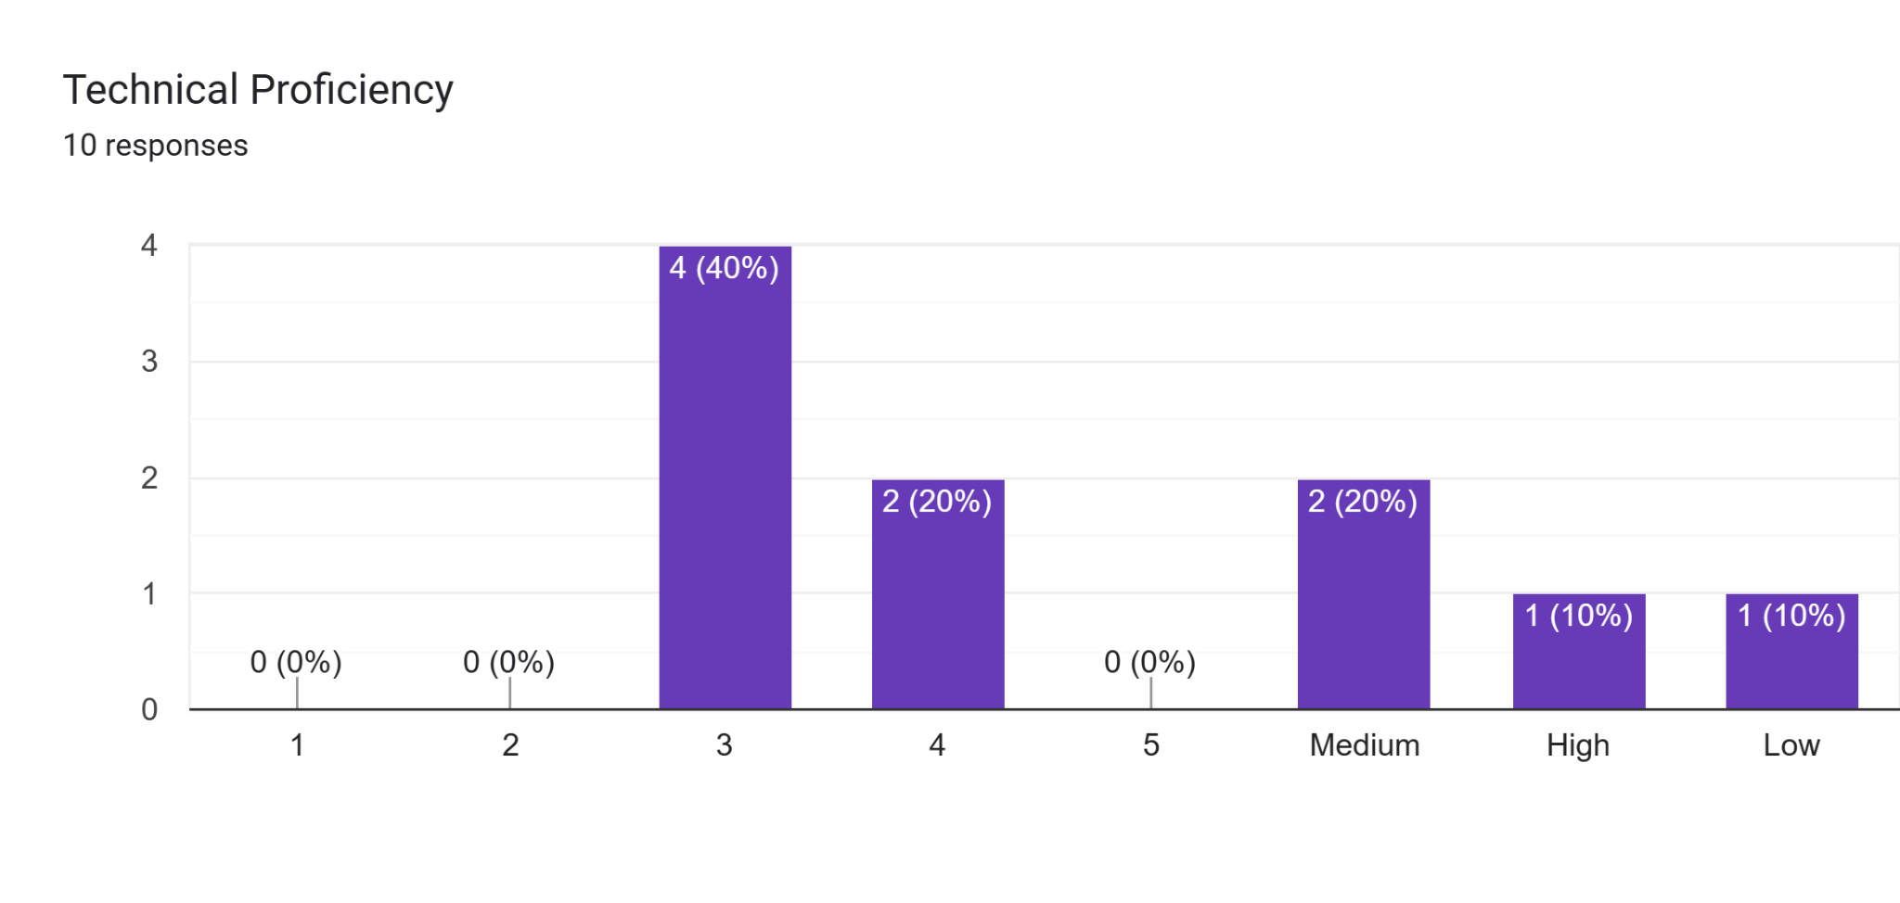

**6.1.3 USER NEEDS ASSESSMENT DATA COLLECTED**

This comprehensive overview represents the insights gathered from participants who engaged with healthcare apps, including Practo and Maple, web-based healthcare services and individual hospital/clinic websites. During the initial phase of our study, participants were assigned specific tasks within these applications, and their feedback provided valuable insights for enhancing the overall user experience. Key findings sorted task wise from their feedback include:

**Finding a Doctor and Booking appointment:**

During our research, we met a participant called Uday, who had been assigned with booking an appointment via the Maple app. When he opened the app, he was sent to another page, but locating the "Book Appointment" section proved challenging. Uday began exploring several options on the app, hoping to find the right button. After a few minutes , our researcher asked about his experience. "Why did you click the 'Ask a Question' button?". Uday said that he imagined there was a 'Book Appointment' option underneath it, or that it would take him to a page where he could request an appointment. This finding emphasized the importance of user-friendly navigation as well as the need for visible and intuitive design elements in healthcare apps. Users like Uday may make assumptions about button functionality, underlining the significance of clear and simple appointment booking options.

During our interviews, participants emphasized the necessity of improved search filters and sorting options. They proposed filters based on specialization, ratings, location, availability, and appointment mode to increase the precision of doctor searches. The importance of comprehensive physician profiles was underlined. When choosing a healthcare practitioner, users underlined the value of past evaluations, professional experience, specialties, and noteworthy accomplishments. While some platforms had this, they weren’t very easy to interpret. These tons of information needs to be efficiently summarized using aggregators and highlighting icons.

**Communication:**

Participants suggested adding functions that would let users book, postpone, and cancel appointments as well as safely transmit vital health information.

Users recommended adding a chat window to enable direct connection with medical professionals in addition to these features. In order to increase accountability and transparency, they also want to be able to rate and evaluate appointments.

**Building a Profile:**

Building a resourceful profile can be tedious and medical terms can be difficult to understand for everyday users. We found users of Maple and Practor asking us what some of the user input fields meant while filling up their data. They also tried looking up medical terms online. We asked them if helpful prompts like a question mark icon or a “Learn More” next to the input field could have been more helpful and everyone agreed. We also observed most people skipping important profile fields because the questionnaire was too long. We realized dividing the questionnaire to build profiles into mandatory fields and optionals would help.

Senior participants during their interviews expressed desire for less fancy text styles and more simple clear text styles accompanied with audio and visual aids would help them navigate through the app seamlessly.

**Managing Chronic Conditions:**

After booking an appointment through hospital websites most participants met with short single line confirmation emails or notes. Most first time users weren’t exactly sure of the need for any other steps that could help them. In order to improve the post-appointment process's efficiency and informational value, participants requested post-booking sites that included checklists, cancellation alerts, and unambiguous instructions to the doctor's office.

Users also asked for the ability to add family members and pre-approved emergency contacts to online appointments, which would be especially helpful in an emergency. None of the platforms had this option.

These participants' input will be a great source of information for improving the functionality and general usability of healthcare applications. The goal of these enhancements is to increase the apps' usability and efficacy in catering to the various demands of healthcare users.

Apps like Practor or Maple did not offer the option of recurring appointments.

**Graphs**:

The following are the graphs obtained through post interview surveys:



**6.1.4 USER NEEDS ASSESSMENT SESSION PROTOCOL**

The user needs and requirements survey sessions can be broadly divided into 3 parts:

1. **Pre-Survey**

In order to shortlist 10 promising participants, we will send out a questionnaire prepared using google forms that will help us get to know about our participants’ demographics like age, gender, country, marital and employment status and their comfortableness with technology. We also get to know how often they require medical care so that we can group them into user groups accordingly. This helps us pick a diverse pool of candidates that could potentially give a wide range of ideas and feedback.

1. **Primary Survey**

Our pool of participants will consist of people from Toronto as well as multiple other countries. Due to this, we plan to conduct our sessions both online using Zoom and offline in person. Each session will be hosted by 2 members of our team with one of them asking questions and the other making notes and observations. We encourage our participants to speak out loud as they perform the given tasks.

Our pool of participants will be divided into two user groups. Refer “User needs assessment requirements” file for more details. Each user group is assigned a set of 3 tasks listed out in the file mentioned. The following are the questions to be asked during the sessions:

1. What are your preferred methods of searching for doctors and booking appointments? Please walk us through how you go about doing that.
2. Why do you prefer using the method you mentioned over others? Is it faster, more simple or reliable?
3. How do you prefer to consult with healthcare professionals?
4. Do you have any specific accessibility needs, such as larger text, voice commands, or screen reader support?
5. Do you feel booking an appointment with a doctor is as easy as booking a movie ticket?
6. Why do you think so? Try comparing the both and see which part is as easy or hard compared to the other?

As this is one of the initial set of sessions, we will aim to keep pre conceived questions to a minimum and focus on observing user behavior and basing questions on the same. The observations will focus on Workflows of the users : How, when and users complete their tasks; High priority tasks, information and decisions; How information flows; Tools and technologies that are used.

All online and in person interviews will be recorded and carefully studied later to complete user needs and requirements reports.

**3. Post Survey Feedback**

After the completion of live interviews, will we send out surveys asking users about their thoughts on their experience performing the tasks. There will also be questions asking them about their opinions and thoughts on how the UX functionalities can be improved upon. The aim of this last and final survey is to allow people to share their thoughts from the comfort of their own where they do not feel the pressure of being scrutinized.

**6.1.5 USER NEEDS ASSESSMENT USE CASE DIAGRAM**

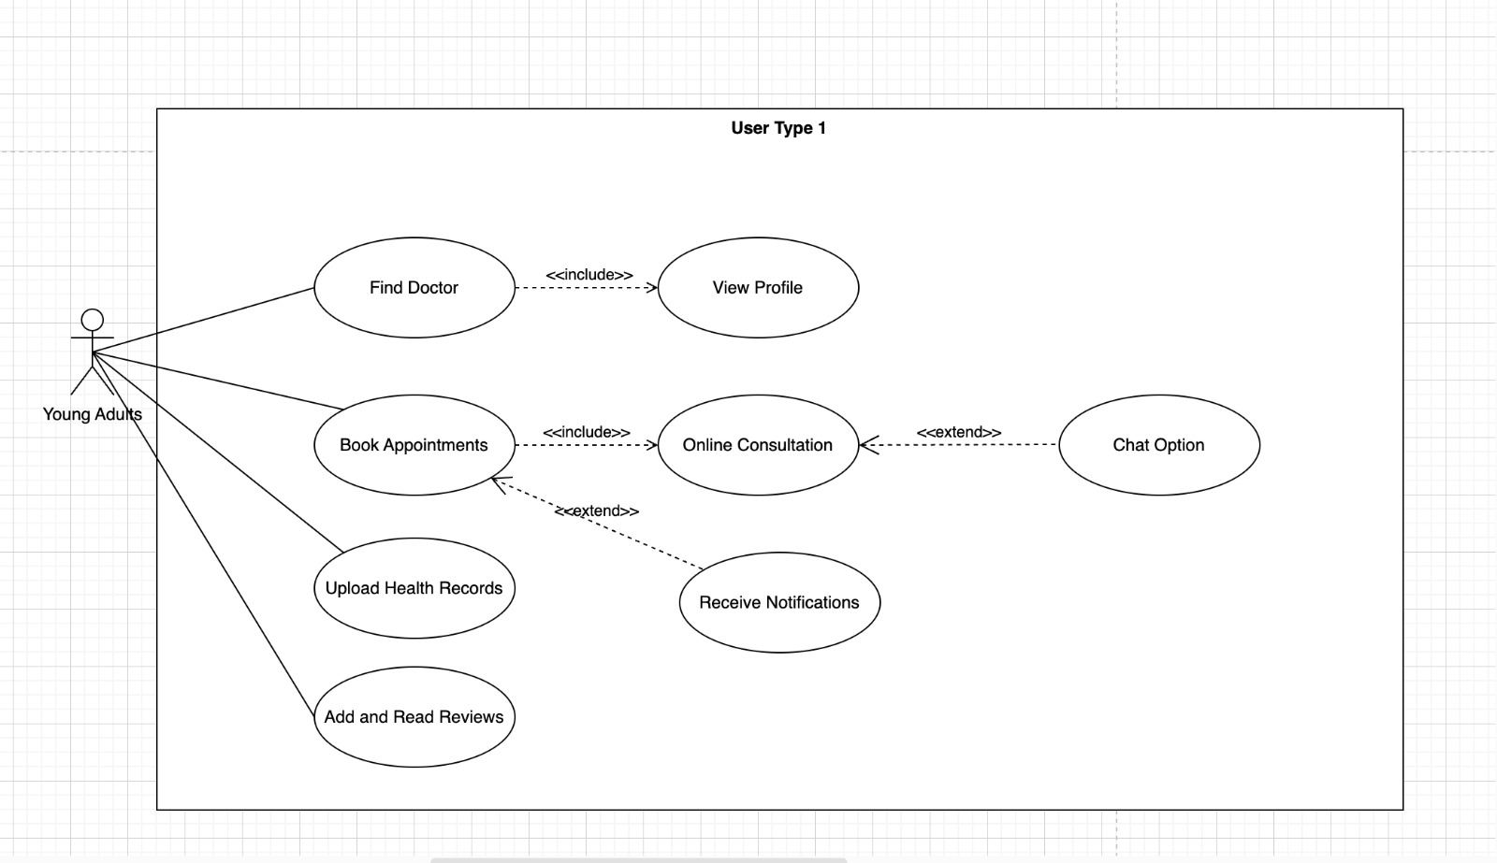

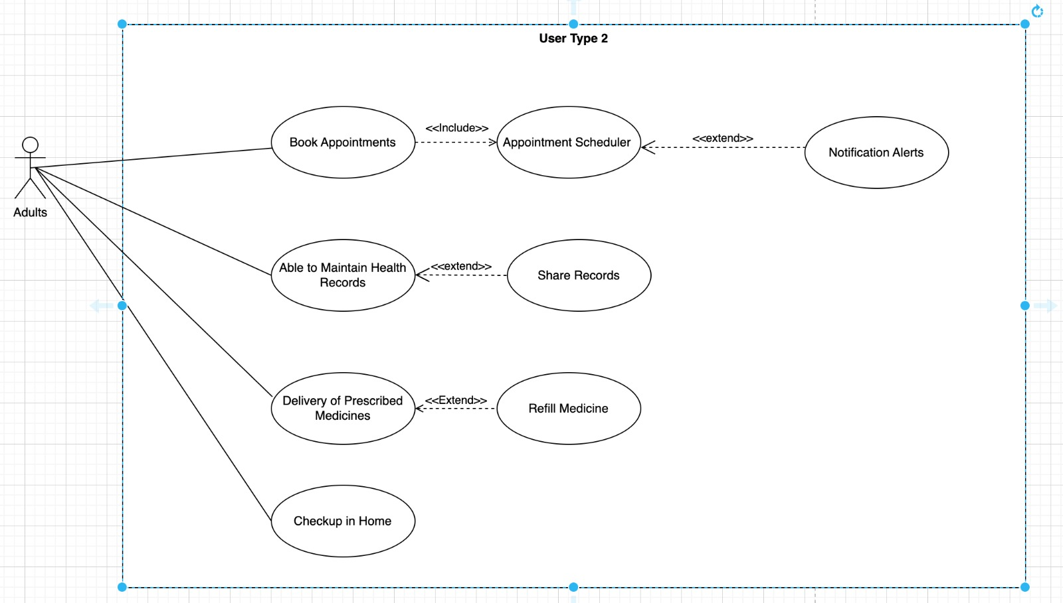

**6.2 LOW FIDELITY PROTOTYPE ANALYSIS**

**6.2.1 LOW FIDELITY PROTOTYPE ANALYSIS USER DEMOGRAPHICS**

After pre-screening multiple candidates, we shortlisted a pool of 10 participants making it a very diverse and forthcoming people from varied demographics. This good mix increases the chances of getting different perspectives fulfilling the purpose of the research.

Six of our participants consist of young adults aged 18-30. This group of people are often considered as tech savvy and usually do not require too frequent medical care. The rest of the pool consists of people aged 41+. This group of people may or may not be highly proficient in using technology and some of them suffer from chronic diseases requiring them to regularly visit the doctor. Our survey was dominated by women constituting 70% and the rest 30% identified as men.



Different regional markets are dominated by different web apps and platforms used to book doctor’s appointments. So it was essential for us to pick people from countries having systems that varied from others to get universal feedback. For example people in India either preferred web apps like Practo or hospital websites to secure a visit. While north american countries preferred apps like Maple or contact the doctor’s office directly for a specialized appointment.



Our pool of participants had people from different walks of life. Half of them were employed, one of them retired and 4 identified as students or home makers. This speaks to us about how busy people’s lives are and the importance of an easy to use hassle free booking software. Technical proficiencies also varied making us focus on understanding the need for a right balance between appealing and simplicity in UX designs.



**6.2.2 LOW FIDELITY PROTOTYPE ANALYSIS SESSION PROTOCOL**

The session protocol used to test and survey the low fidelity prototypes is as follows:

1. Pre Survey: A questionnaire prepared using google forms that will help us get to know about our participants’ demographics like age, gender, country, marital and employment status and their comfortableness with technology. We also get to know how often they require medical care so that we can group them into user groups accordingly.
2. Cognitive Walkthrough: A cognitive walkthrough involves a complete team effort to develop questions to be asked to the participants. It’s essential to keep the number of questions to an optimal level and focus on observing and asking questions based on user actions. Counterbalancing is also implemented by mixing up prototypes and tasks presented to the participants (refer: 5.7)
3. Note taking: We follow a tabular approach to record our observations during sessions. This pre-made table attached in the appendix has appropriate columns for user actions and behaviors to be recorded. Following this over narration paragraphs or transcripts helps us focus on key points in a readable format.
4. Post Survey Questionnaire: Another questionnaire prepared using google forms to get user votes and feedback on the prototypes they preferred and their insights behind their preferences.
5. Conclusions: The last step in our protocol is the brain storming session where participants of our team sit and review all session recordings and notes to conclude our key findings and finalize the prototype to build further.

**The role each team member played in the assignment**

| **Team Member** | **Role** | **No. of User-interviews conducted** |
| --- | --- | --- |
| Habeebuddin Mir | Facilitator, observer, note-taker | 3 |
| Maseerah Khatoon | Facilitator, observer, note-taker | 3 |
| Shaiz Akhtar | Facilitator, observer, note-taker | 4 |

**Semi-structured Script**

1. How was your booking experience through this prototype compared to the traditional way of booking?
2. Were there any difficulties or challenges you encountered during the booking process?
3. Did you find all the necessary information about the doctor (e.g., name, specialty, location) easily accessible and clear?
4. Were you able to understand the available appointment slots and choose a suitable one?
5. How was your experience setting up and managing your user profile within the app?
6. Did you feel comfortable sharing personal information for the booking process?
7. Were the fonts, buttons, and icons easy to read and interact with?
8. Were you able to easily find doctors based on their specialty, location, or availability?
9. Were you provided with a clear confirmation of your appointment after booking?
10. Did you receive any follow-up information or instructions?
11. On a scale of 1 to 10, how satisfied are you with your experience using this app, and why?
12. Are there any features or functionalities you think should be added or removed?

**Scenarios and User Prompts**

Scenario 1: Build a Profile

In this scenario, a user, assumed to be signing up for the first time, is asked to build a profile. Building a profile includes multiple sub-tasks listed below requiring the user to navigate through multiple screens.

Task 1: Enter Basic Data

Task 2: Fill out Medical History

Task 3: Fill out Lifestyle factors

Task 4: Hit Save button

Scenario 2: Search Doctors

The next scenario involves searching for a doctor. In this scenario, the user uses a search bar to enter their query like a doctor’s name or location to get results when the search button is hit. The user also has the option of setting filters in this scenario. Successful completion should result in the display of a list of appropriate doctors.

Task 1: Enter search query

Task 2: Set filters

Task 3: Access list of doctors

Task 4: View doctor’s profiles

Scenario 3: Book appointment

One of the most critical scenarios for a user of CareConnect is to book an appointment. From the list of search results achieved in the last scenario, the user selects ‘View Profile’ of a doctor. On the profile page the user will have to choose a date, timeslot and mode to activate the ‘Book Now’ button. Upon clicking the button, the user should be able to view a confirmation screen with a checklist of pre-appointment necessities.

Task 1: Select date

Task 2: Select time slot

Task 3: Choose appointment mode

Task 4: Review pre-appointment checklist

**Interview Recording Snippets**

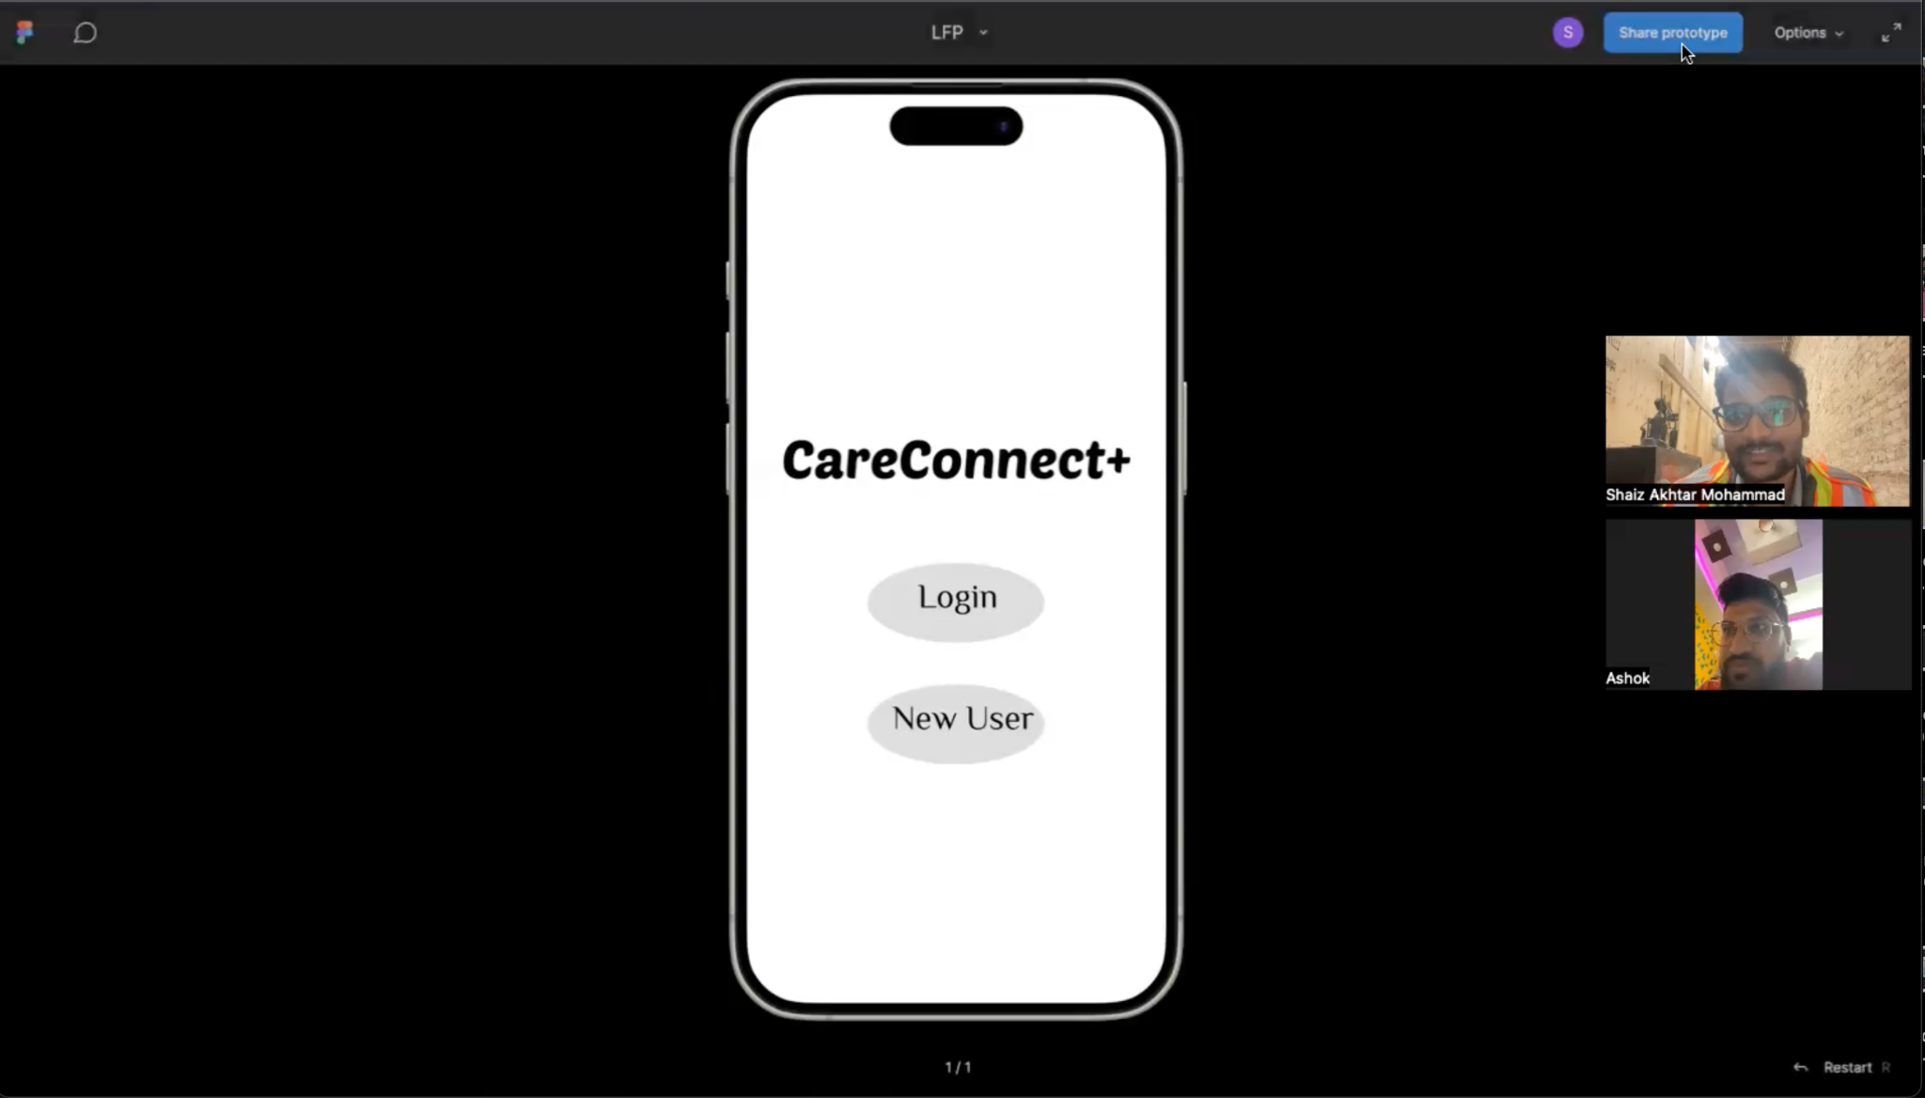

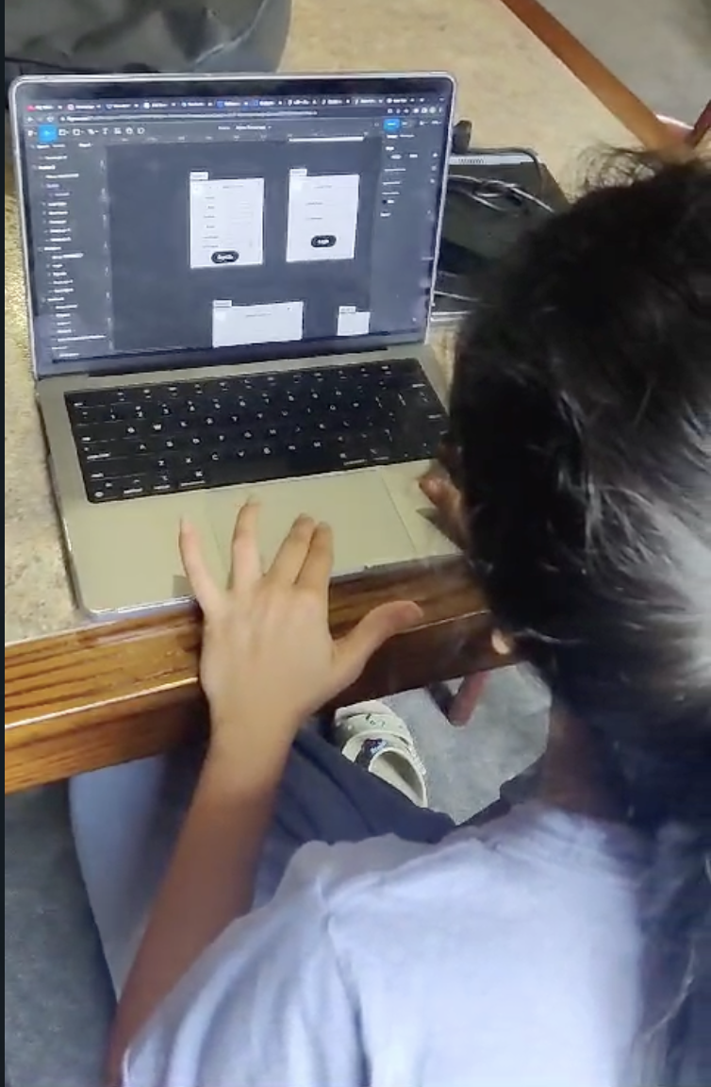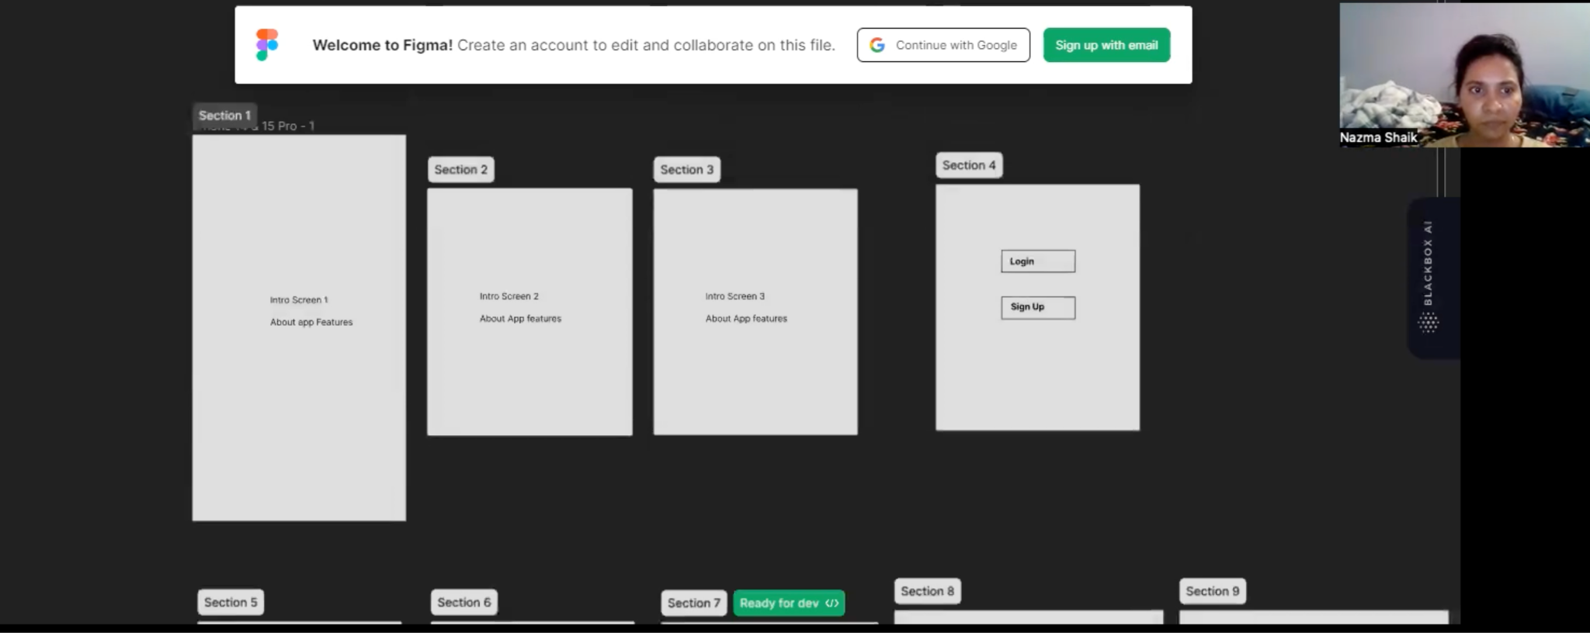

**6.2.3 LOW FIDELITY PROTOTYPE COGNITIVE WALK THROUGH NOTES**

1. Prototype Alpha:

| Task | Is the control for the action obvious? | Did the user complete all steps expected? | Was the user not sure what an action meant? | Was the user able to move to the next step? | Comments |
| --- | --- | --- | --- | --- | --- |
| Enter basic data for sign up | Yes | Yes | No | Yes | The process of entering basic data for sign-up was clear and straightforward |
| Fill out medical history | Yes | No | Yes | No | Users facing difficulty in building a profile.They are searching for medical history fields |
| Fill out lifestyle factors | No | No | Yes | No | Users were looking for these field |
| Hit save button and redirect | Yes | Yes | No | Yes | Straight Forward |
| Enter search query | Yes | Yes | No | Yes | Straight forward |
| Set filtering and sorting | Yes | Yes | No | Yes | User suggested to add search bar to filter |
| Hit search- see list of doctors | Yes | Yes | No | Yes | No comments |
| View doctor’s profile | Yes | Yes | No | Yes | Suggested to add book appointment button in this page too |
| Choose a date of appointment | Yes | Yes | No | Yes | No comments |
| Pick a time slot from available | Yes | Yes | No | Yes | No comments |
| Select mode of appointment | No | No | Yes | Yes | There is no mode in this prototype |
| Hit Book and view checklist | Yes | Yes | No | Yes | No comments |

1. Prototype Bravo

| Task | Is the control for the action obvious? | Did the user complete all steps expected? | Was the user not sure what an action meant? | Was the user able to move to the next step? | Comments |
| --- | --- | --- | --- | --- | --- |
| Enter basic data for sign up | Yes | Yes | No | Yes | Straight Forward |
| Fill out medical history | Yes | Yes | Confused | Yes | Users looking for the fields for uploading the medical records |
| Fill out lifestyle factors | No | No | Yes | Yes | There is no lifestyle factors section in this prototype |
| Hit save button and redirect | Yes | Yes | No | Yes | No comments |
| Enter search query | Yes | Yes | No | Yes | No comments |
| Set filtering and sorting | Yes | Yes | No | Yes | Users expecting more filtering options like searching doctor based on hospital, location |
| Hit search- see list of doctors | Yes | Yes | No | Yes | Straight Forward |
| View doctor’s profile | Yes | Yes | No | Yes | Straight Forward |
| Choose a date of appointment | Yes | Yes | No | Yes | No issues faced |
| Pick a time slot from available | Yes | Yes | No | Yes | No issues faced |
| Select mode of appointment | Yes | Yes | No | Yes | Straight forward |
| Hit Book and view checklist | Yes | Yes | No | Yes | No checklist after hitting book |

1. Prototype Charlie

| Task | Is the control for the action obvious? | Did the user complete all steps expected? | Was the user not sure what an action meant? | Was the user able to move to the next step? | Comments |
| --- | --- | --- | --- | --- | --- |
| Enter basic data for sign up | Yes | Yes | No | Yes | No comments |
| Fill out medical history | Yes | Yes | No | yes | No comments |
| Fill out lifestyle factors | Yes | Yes | No | Yes | No comments |
| Hit save button and redirect | Yes | Yes | No | Yes | No comments |
| Enter search query | Yes | Yes | No | Yes | No comments |
| Set filtering and sorting | Yes | Yes | No | Yes | No comments |
| Hit search- see list of doctors | Yes | Yes | No | Yes | User made a suggestion for Navigation |
| View doctor’s profile | Yes | Yes | No | Yes | Users want a doctor's profile to be like Alpha Prototype. |
| Choose a date of appointment | Yes | Yes | No | Yes | Straight Forward |
| Pick a time slot from available | Yes | Yes | No | Yes | Straight Forward |
| Select mode of appointment | Yes | Yes | No | Yes | Straight forward |
| Hit Book and view checklist | Yes | Yes | No | Yes | No issues |

**6.2.4 Low Fidelity Prototype Analysis Post Survey Forms and Responses**

**Form Screenshots:**

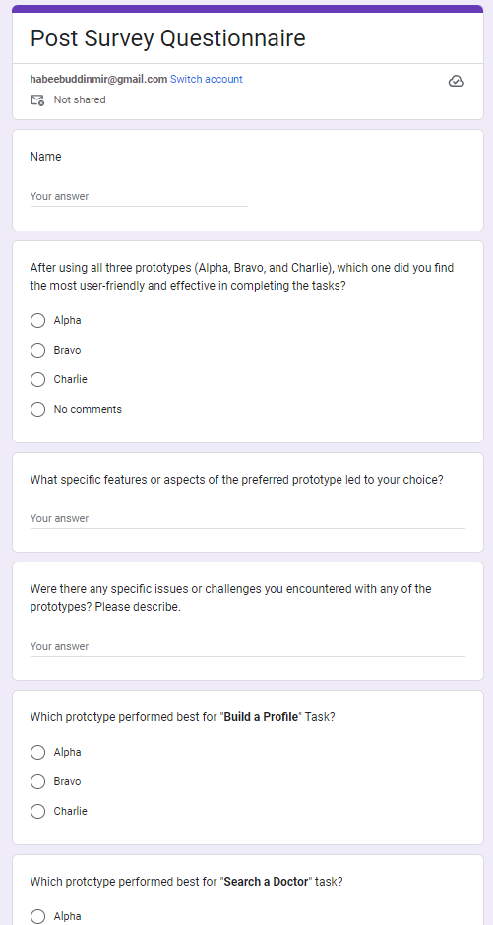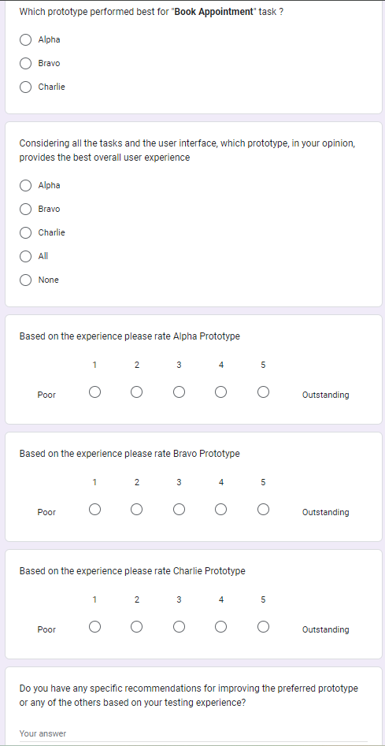

**Form Responses (Graphs):**

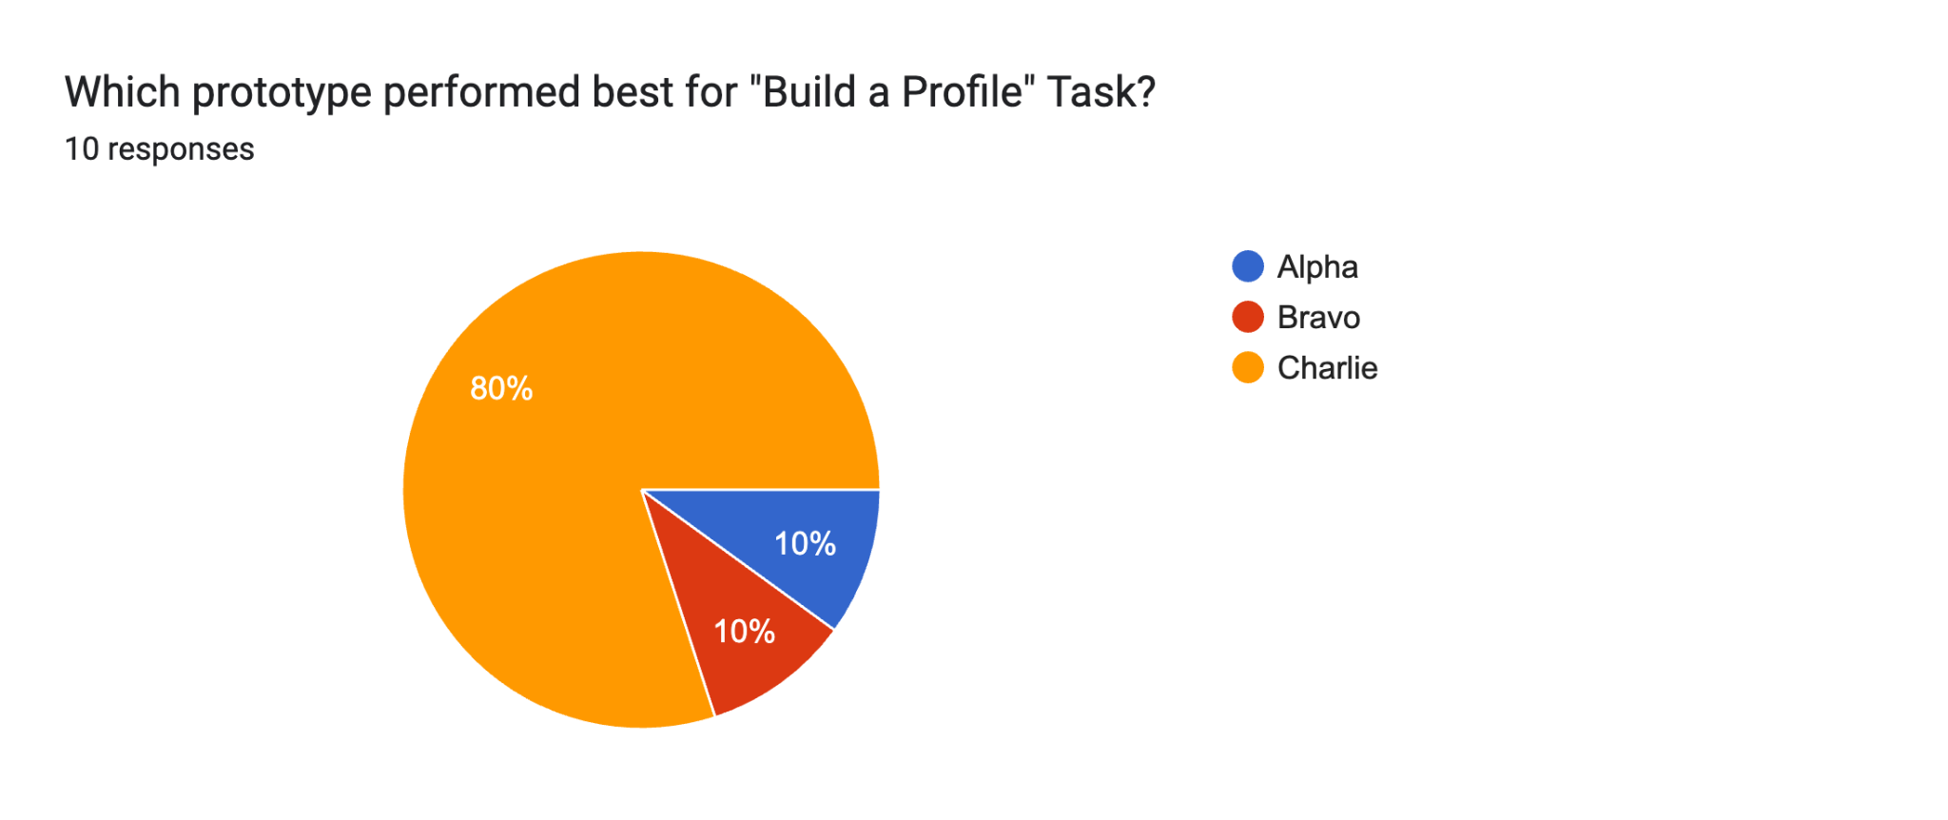

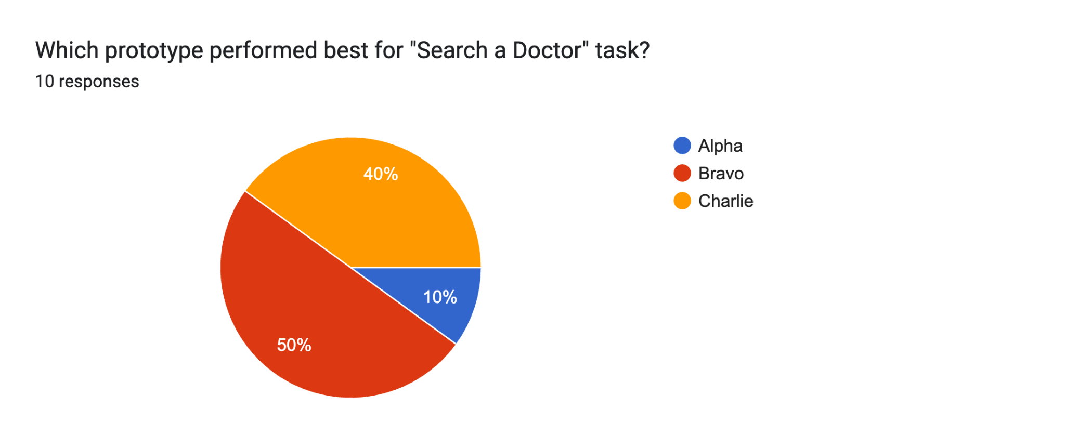

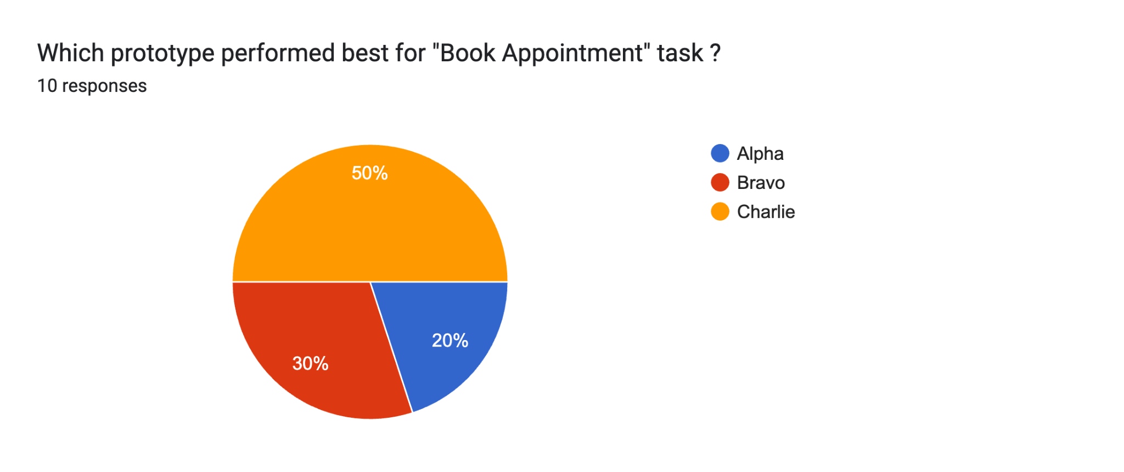

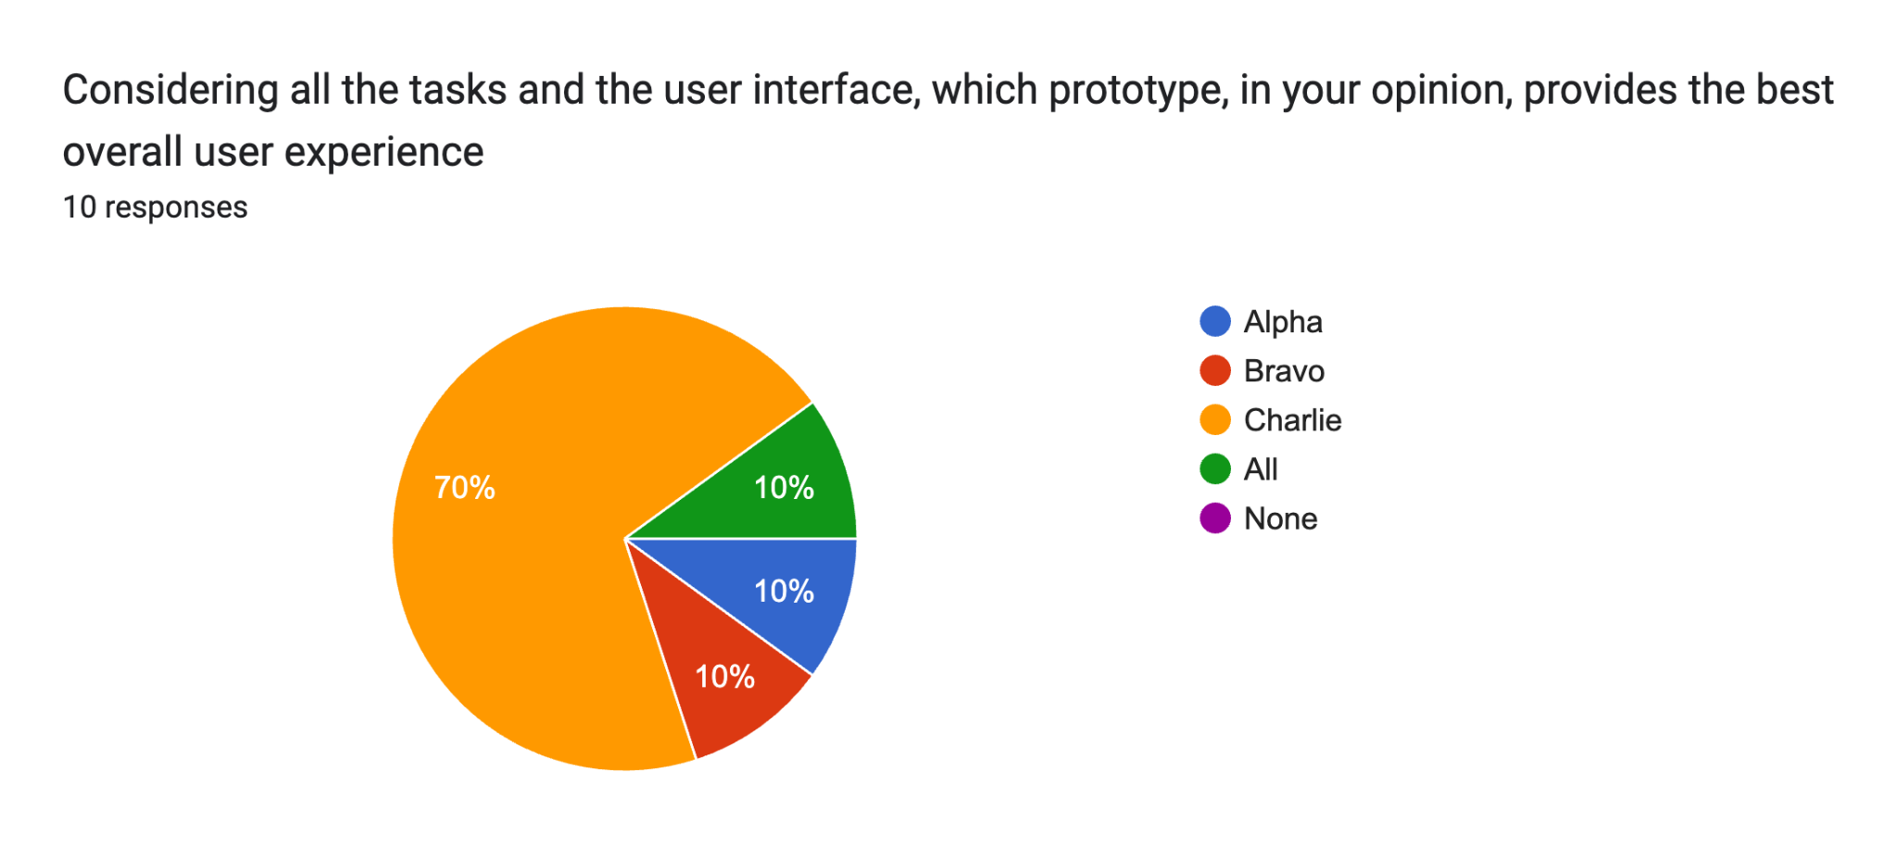

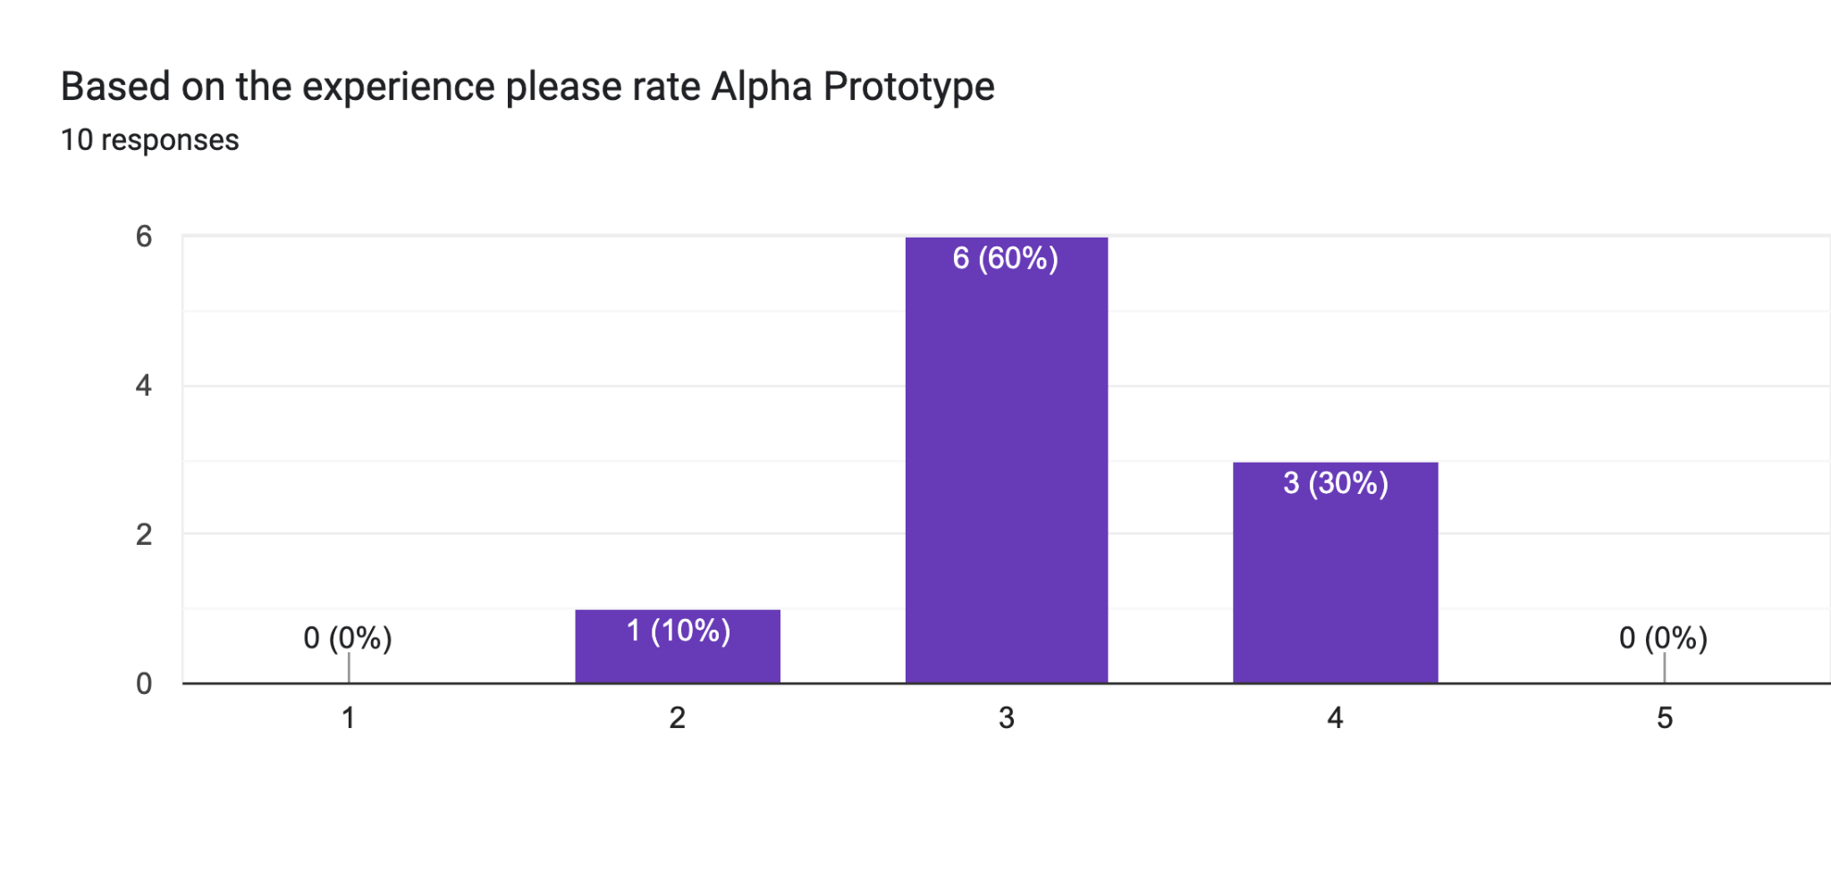

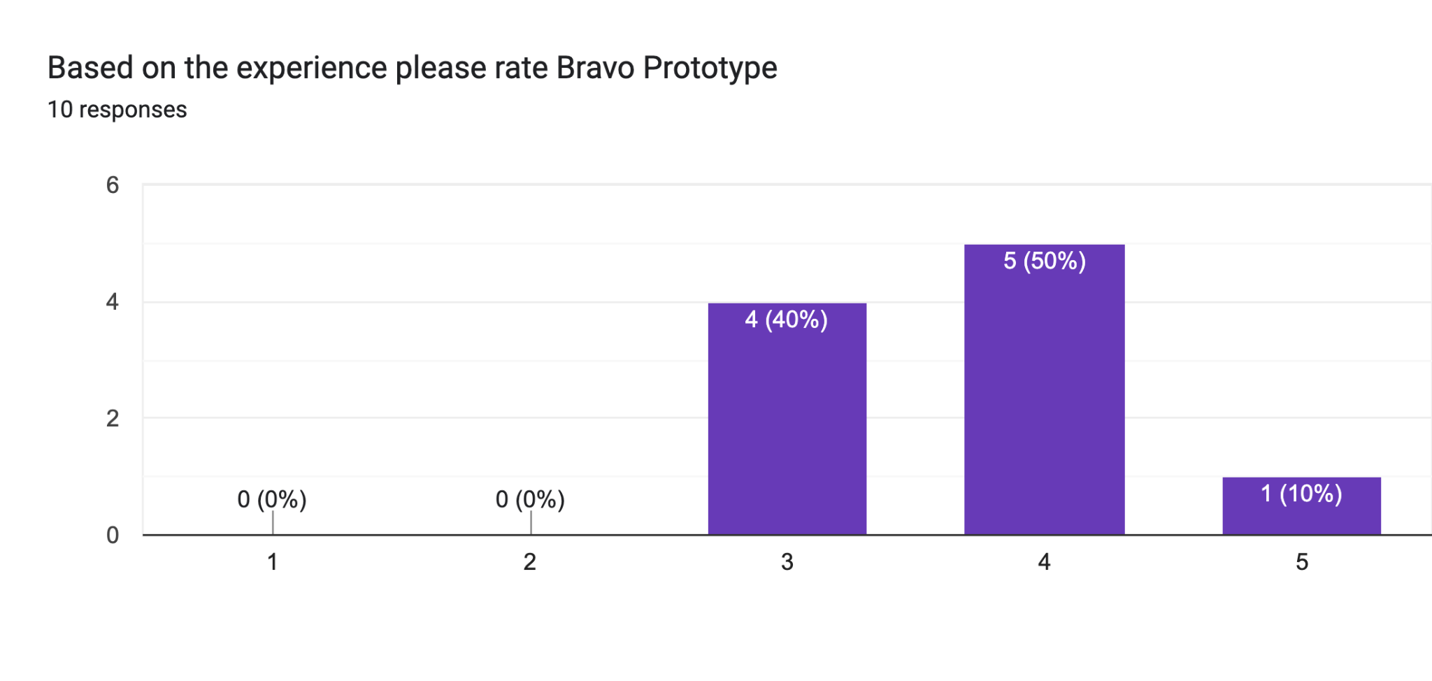

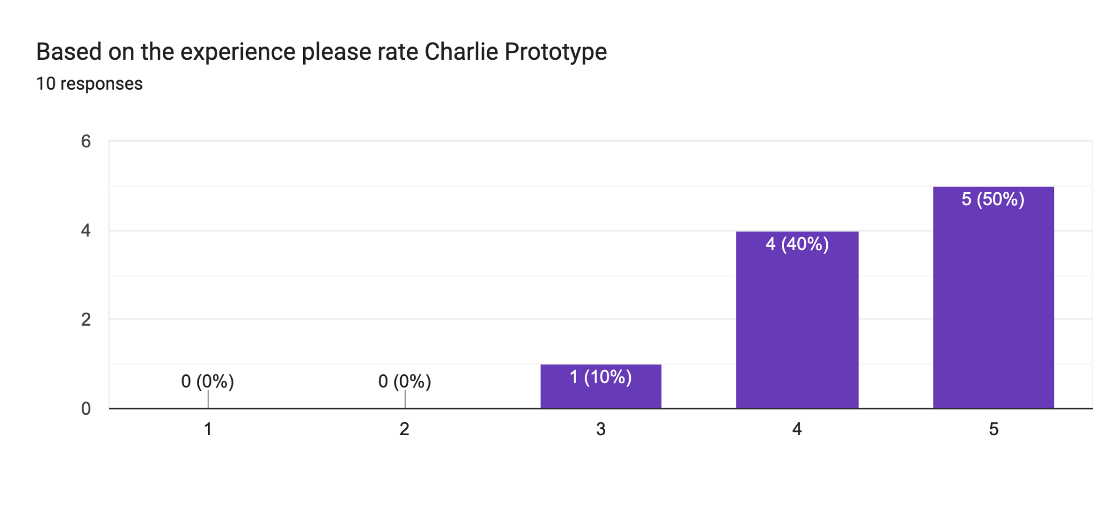**Form responses (Sheet):**

| **Name** | **Which prototype did you find the most user-friendly and effective?** | **What specific features or aspects of the preferred prototype led to your choice?** | **Were there any specific issues or challenges you encountered with any of the prototypes? Please describe.** |
| --- | --- | --- | --- |
| Nazma | Charlie | The Navigation was quite simple | Unsure |
| Ashok | Charlie | Book Appointment feature is quite good | Bravo and charlie are not having back button, include back button |
| Sam | Charlie | Simplicity | Nothing |
| Janvi | Alpha | Simple and easy navigation | no |
| Omer | Bravo | Book appointment and doctor search | Filtering and home page |
| Wajeeh | Charlie | Font and icon theme | Lack of navigation buttons and shortcuts |
| Nikhila | Charlie | Build a profile | No |
| Yusra | Bravo | Well arranged sections of pages | Lack of filtering options |
| Abrar | Charlie | Easy to understand and follow through | Doesn't have an option to skip profile building and complete later while booking |
| Ishaq | Charlie | The helpful pre appointment checklist and search filters | I would love to see a home page |

**6.2.5 Counterbalancing**

| **User** | **Round 1** | **Round 2** | **Round 3** |
| --- | --- | --- | --- |
| Nazma | PA:T1, PB:T2, PC:T3 | PA:T2, PB:T3, PC:T1 | PA:T3, PB:T1, PC:T2 |
| Ashok | PA:T2, PB:T3, PC:T1 | PA:T3, PB:T1, PC:T2 | PA:T1, PB:T2, PC:T3 |
| Sam | PA:T3, PB:T1, PC:T2 | PA:T1, PB:T2, PC:T3 | PA:T2, PB:T3, PC:T1 |
| Janvi | PA:T1, PB:T2, PC:T3 | PA:T2, PB:T3, PC:T1 | PA:T3, PB:T1, PC:T2 |
| Omer | PA:T2, PB:T3, PC:T1 | PA:T3, PB:T1, PC:T2 | PA:T1, PB:T2, PC:T3 |
| Wajeeh | PA:T3, PB:T1, PC:T2 | PA:T1, PB:T2, PC:T3 | PA:T2, PB:T3, PC:T1 |
| Nikhila | PA:T1, PB:T2, PC:T3 | PA:T2, PB:T3, PC:T1 | PA:T3, PB:T1, PC:T2 |
| Yusra | PA:T2, PB:T3, PC:T1 | PA:T3, PB:T1, PC:T2 | PA:T1, PB:T2, PC:T3 |
| Abrar | PA:T3, PB:T1, PC:T2 | PA:T1, PB:T2, PC:T3 | PA:T2, PB:T3, PC:T1 |
| Ishaq | PA:T1, PB:T2, PC:T3 | PA:T2, PB:T3, PC:T1 | PA:T3, PB:T1, PC:T2 |

**6.3 USABILITY TESTING**

**6.3.1 USABILITY TESTING SESSION PROTOCOL**

**Objective:**

To conduct high fidelity testing of CareConnect and identify areas of improvement.

**Participants:**

U1: 5 from ‘Young aged (18-39) and high technical proficiency’

U2: 5 from ‘Old aged (40+) and low technical proficiency’

**Facilitators:**

| **NU ID** | **Team Member Name** | **Contribution** |
| --- | --- | --- |
| 002713929 | Habeebuddin Mir | 3x Facilitator, 4x observer and note-taker |
| 002778147 | Maseerah Khatoon | 3x Facilitator, 3x observer and note-taker |
| 002796856 | Shaiz Akhtar | 4x Facilitator, 3x observer and note-taker |

**Tools and Methodology:**

i) Data Collection Excel Sheet to record Metrics

ii) Free form notes to record observational notes

iii) Multiple cameras to record sessions

iv) Figma application to redesign and test prototype

**Task Scenarios:**

**Task 1:** You are signing up for the first time on a Healthcare App. You need an email id and password. After the sign up, you have to sign in, navigate to the Build profile section, and answer a series of questions to build your medical and lifestyle profile.

**Task 2:** Once a user is signed in, they navigate to the explore section, to search for either a doctor or a speciality. Once they find a suitable match, they can view the doctor’s profile in detail.

**Task 3:** When a user finds a doctor’s profile satisfactory, they can find the ‘Book Appointment’ button which leads them to the booking screens. After completing a series of steps, which involves choosing their desired dates and time, a user is able to secure an appointment. They should then try canceling the appointment.

**Session Overview:**

**i) Informational Briefing-** Provide a brief overview of the session. Introducing the CareConnect application. Explain the purpose of the usability test and emphasize that the focus is on the product, not the participant's abilities.

**ii) Demographic Survey-** Present users with an online form to collect their demographic data and their technical proficiencies.

**iii) Prototype Testing-** At this stage, users are presented with the CareConnect prototype and asked to complete a series of tasks defined in section 5. This session involves recording performance of users in controlled settings. Users are observed and timed. Data is recorded on video, and observations are made in free form notes. The data is used to calculate performance times and to identify and explain errors and guidances a user might have required during the session.

**iv) Debrief and Post-Test Questionnaire-** Discuss any challenges or surprises encountered during the session. Gather feedback on the overall experience. Ask about specific pain points and areas of satisfaction.

**Post Session Task:**

i) Compile notes and observations

ii) Analyze data to identify common themes and issues

iii) Generate a usability report outlining findings and recommendations

iv) Redesign Prototype based on usability report conclusion

**6.3.2 USABILITY TESTING FREE FROM NOTES IMAGES**

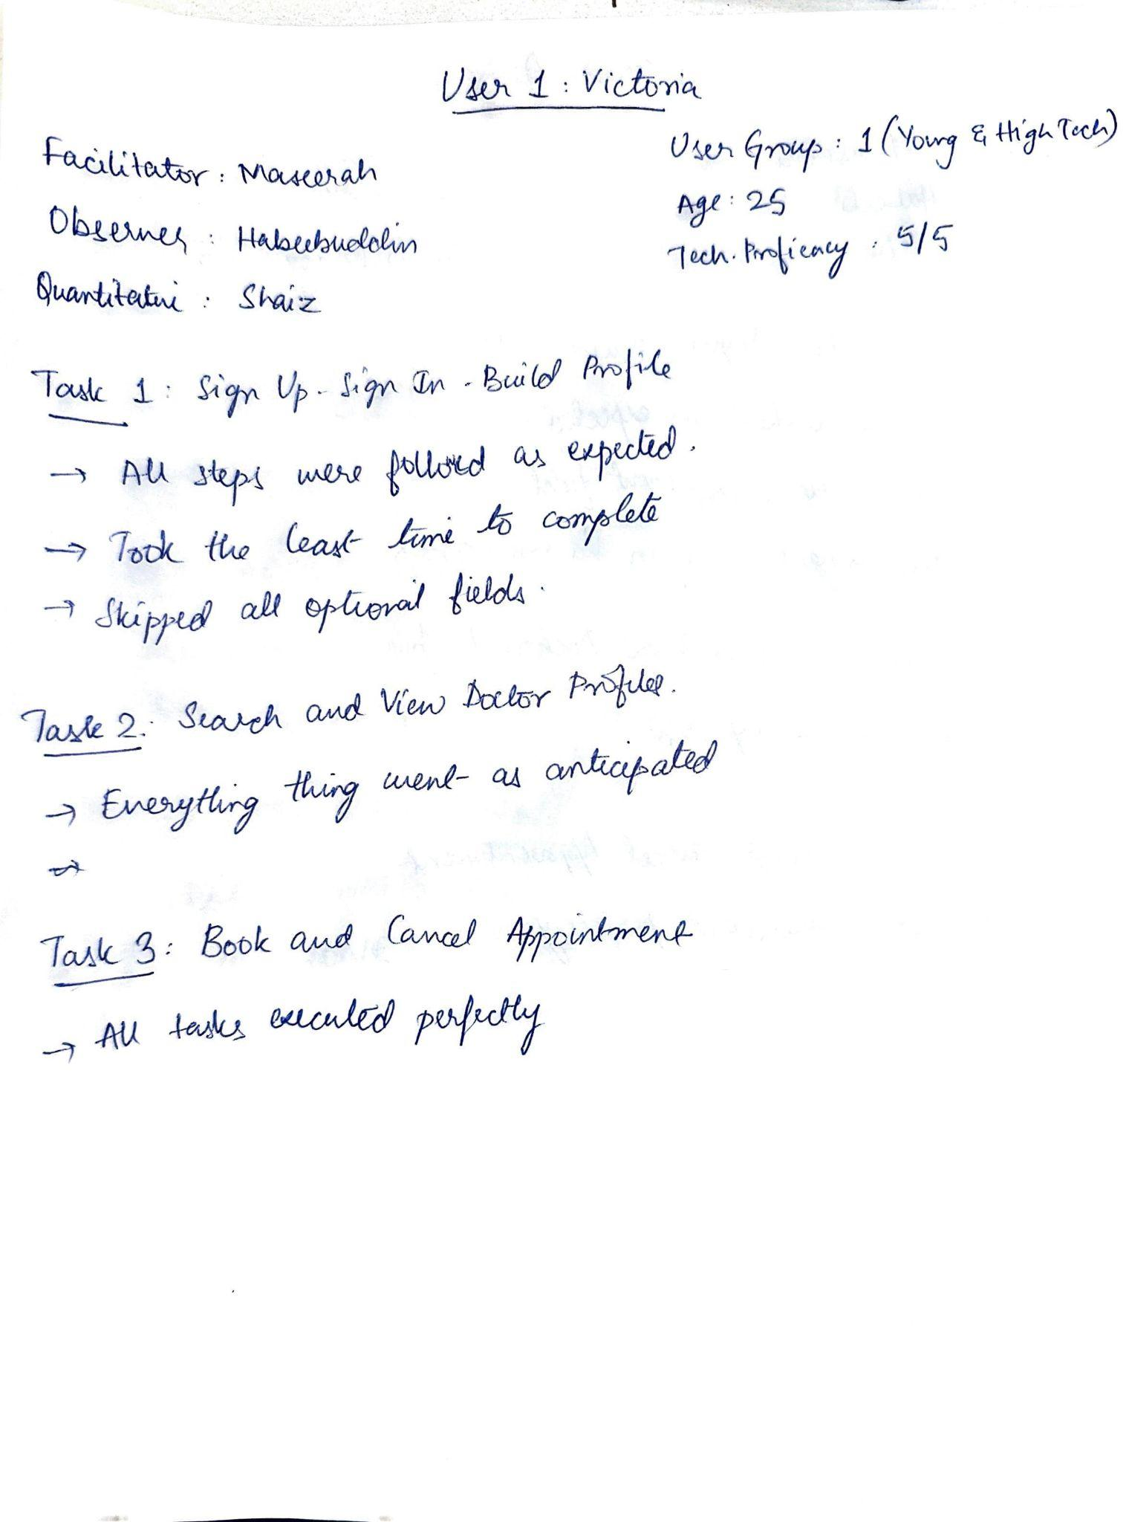

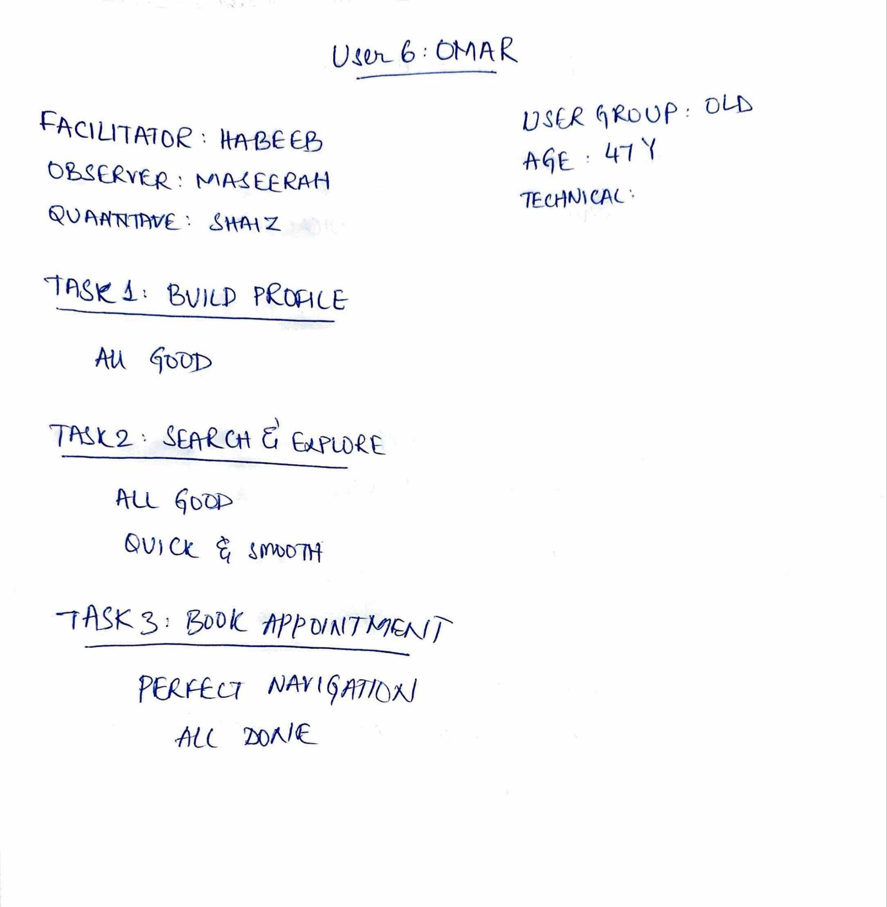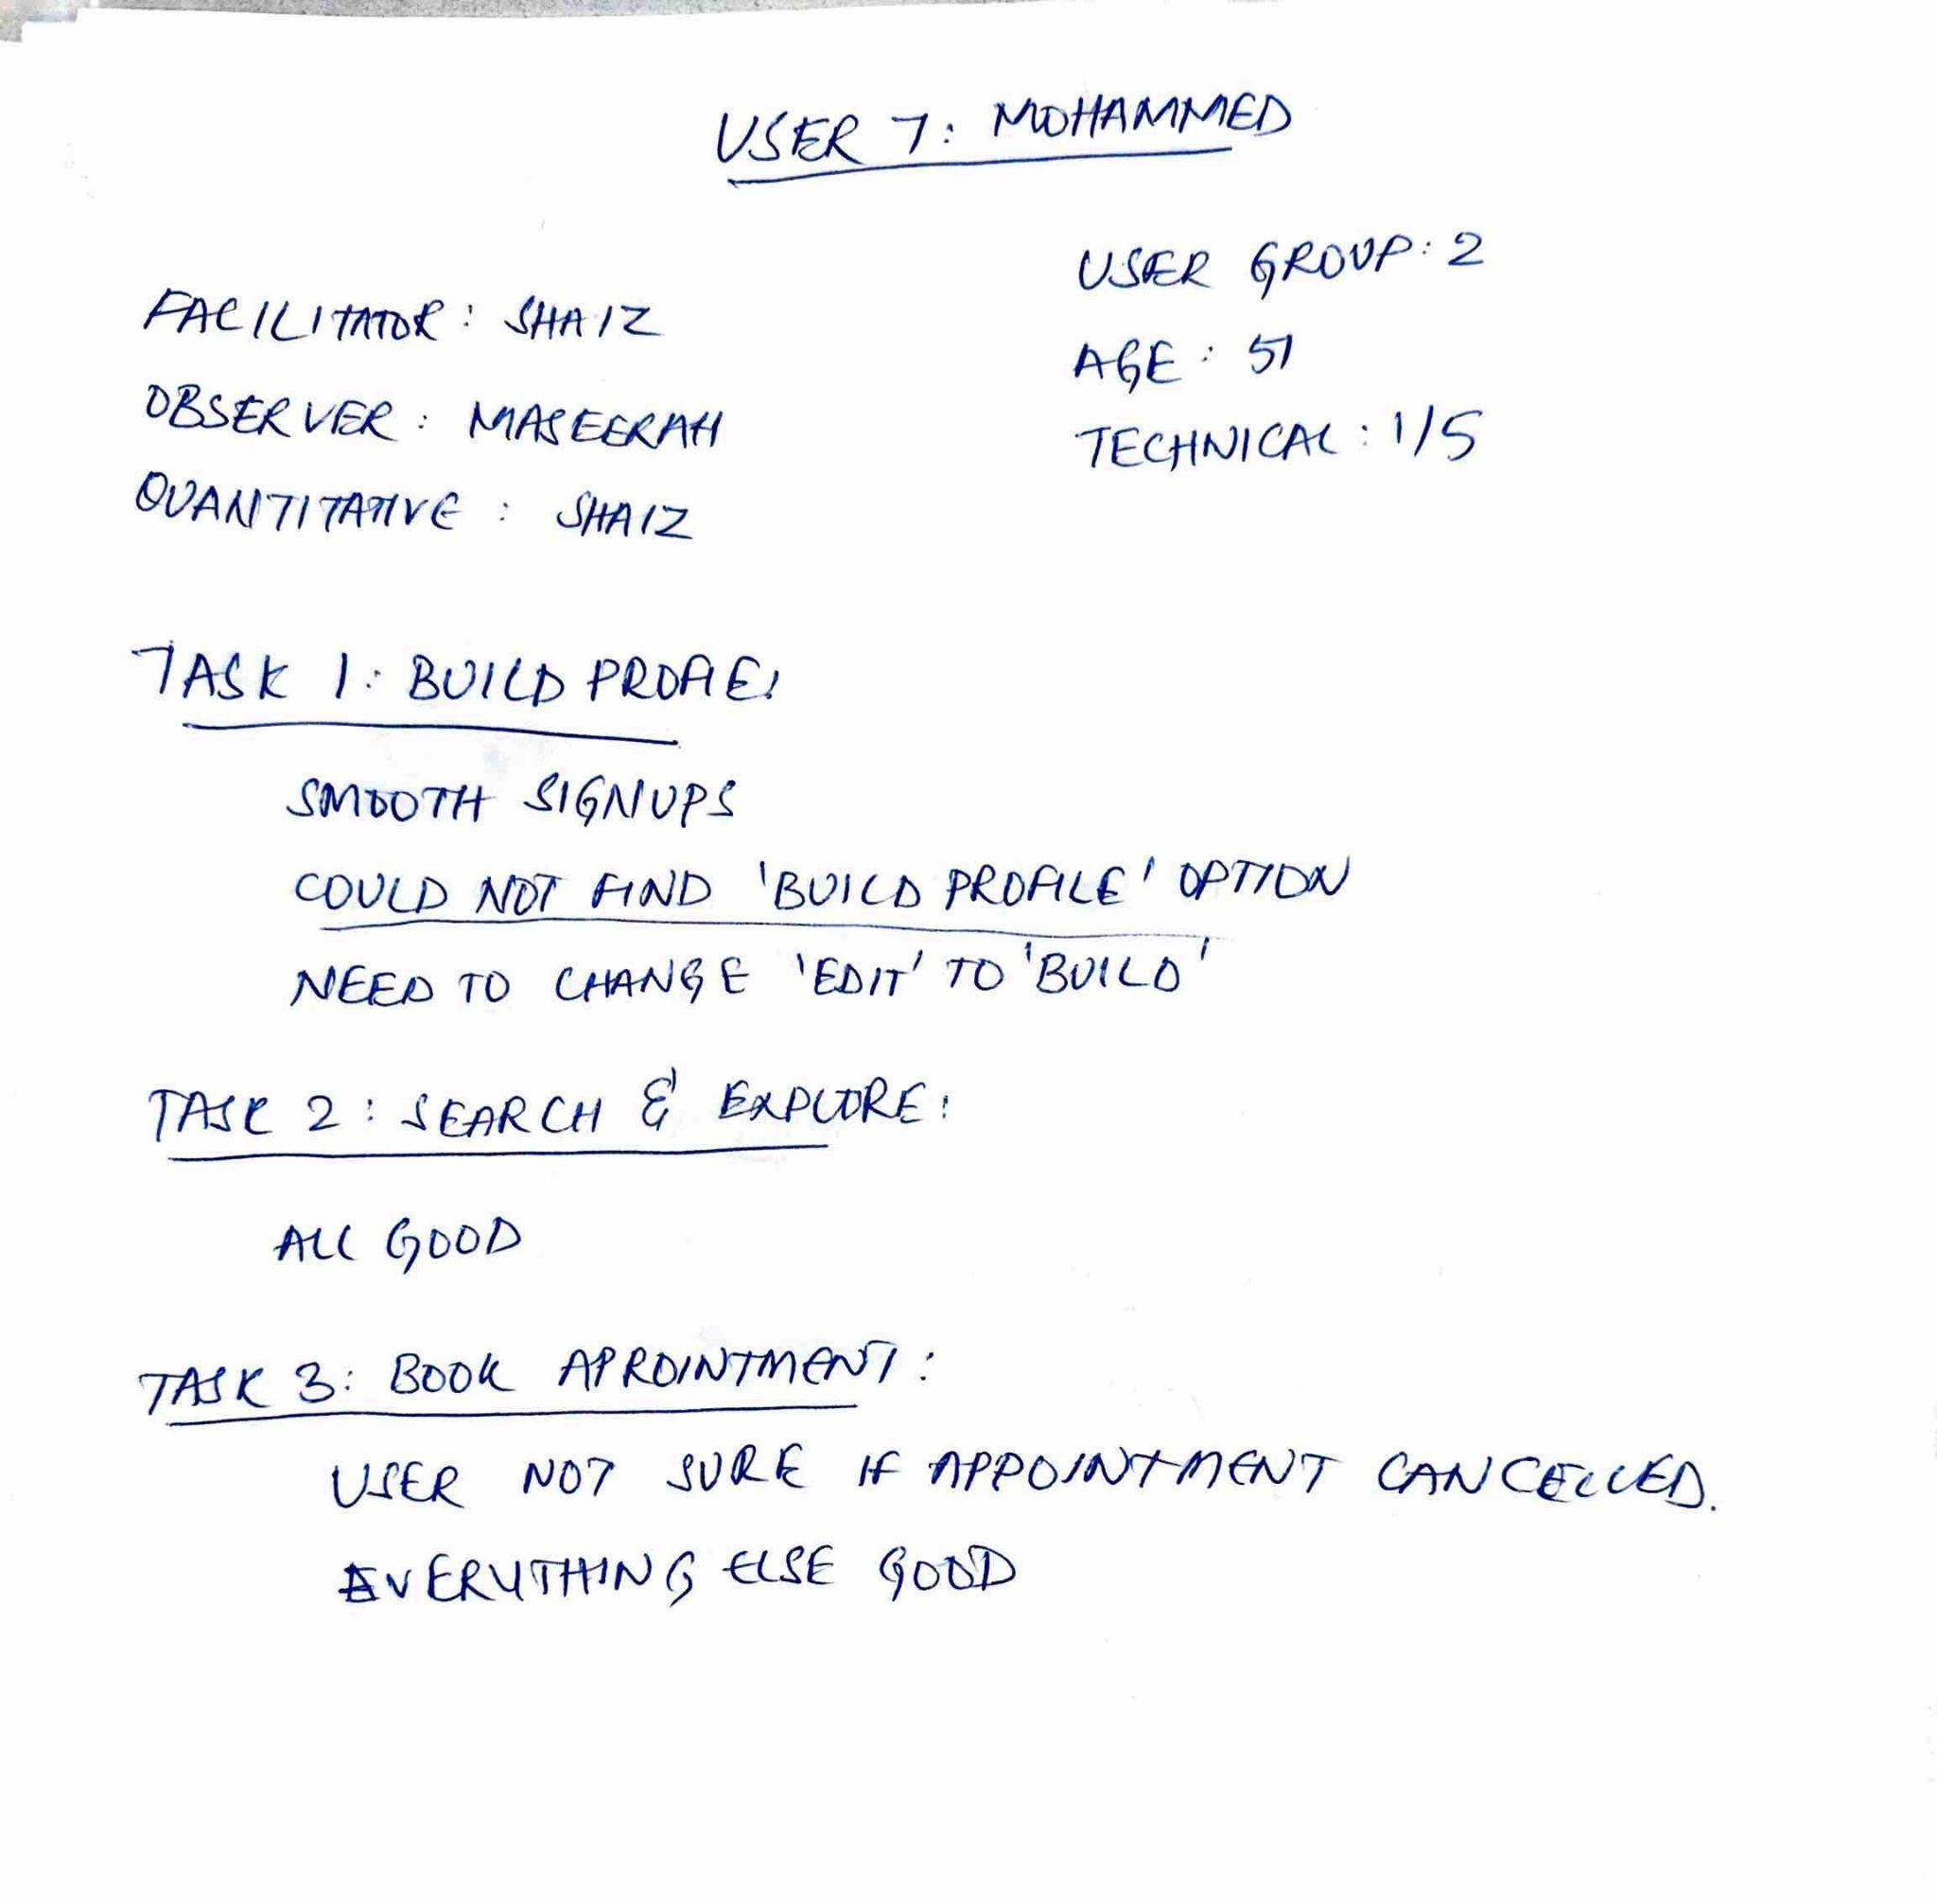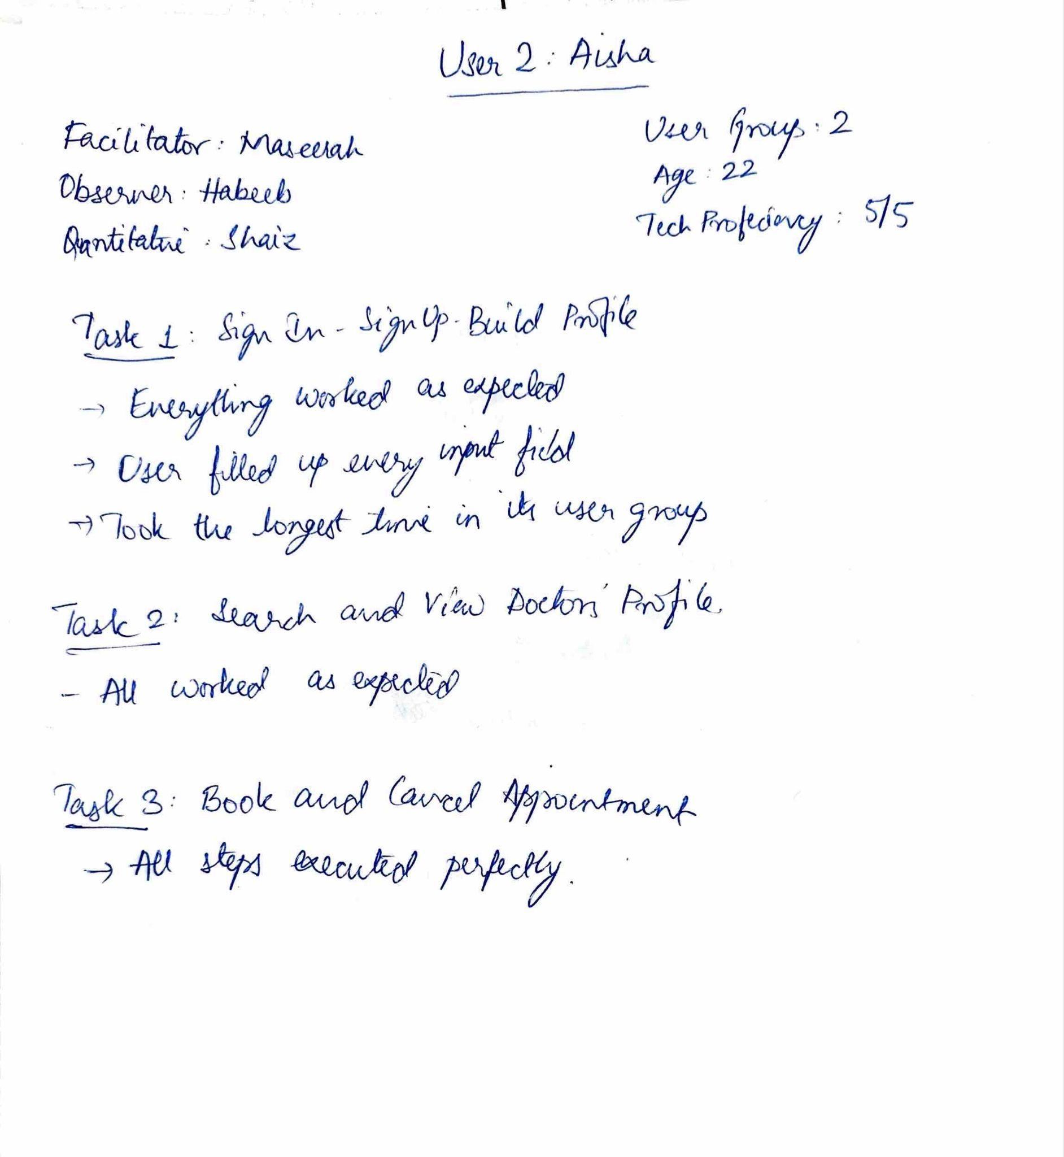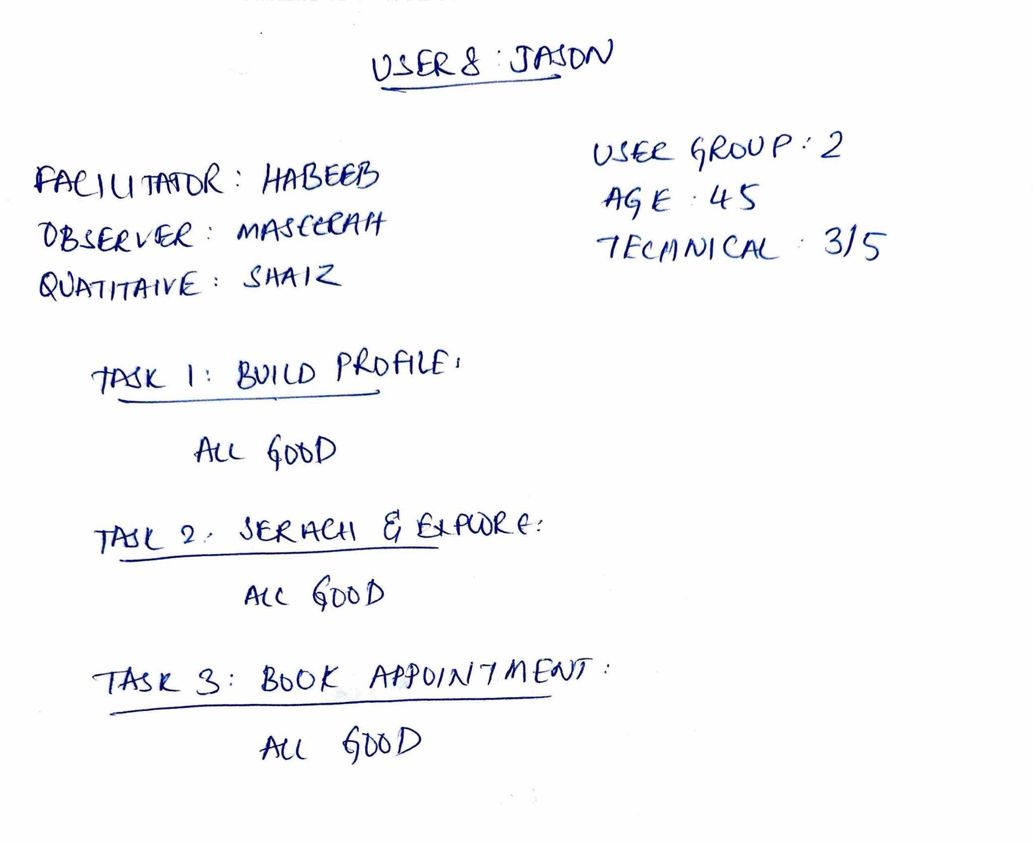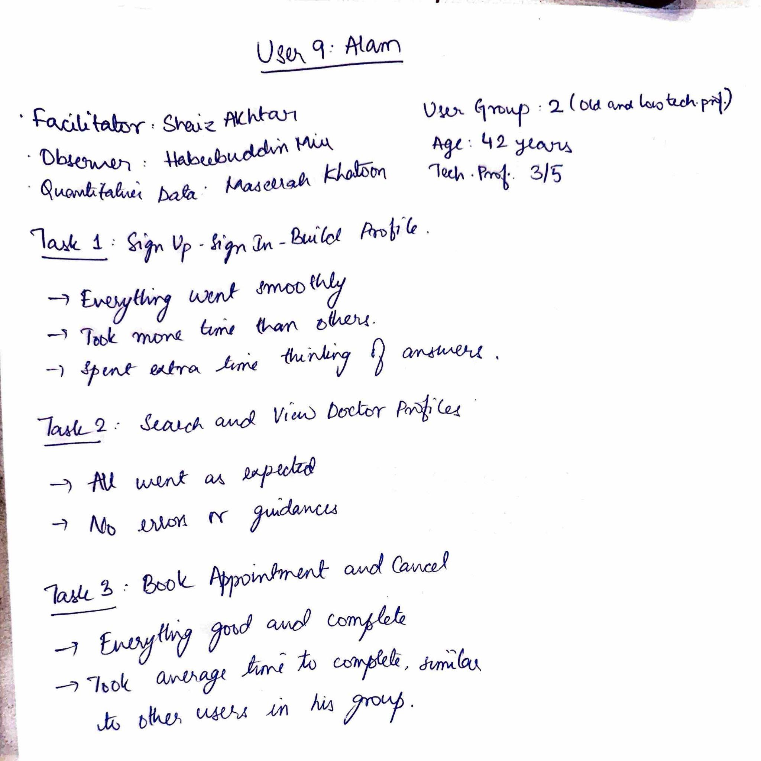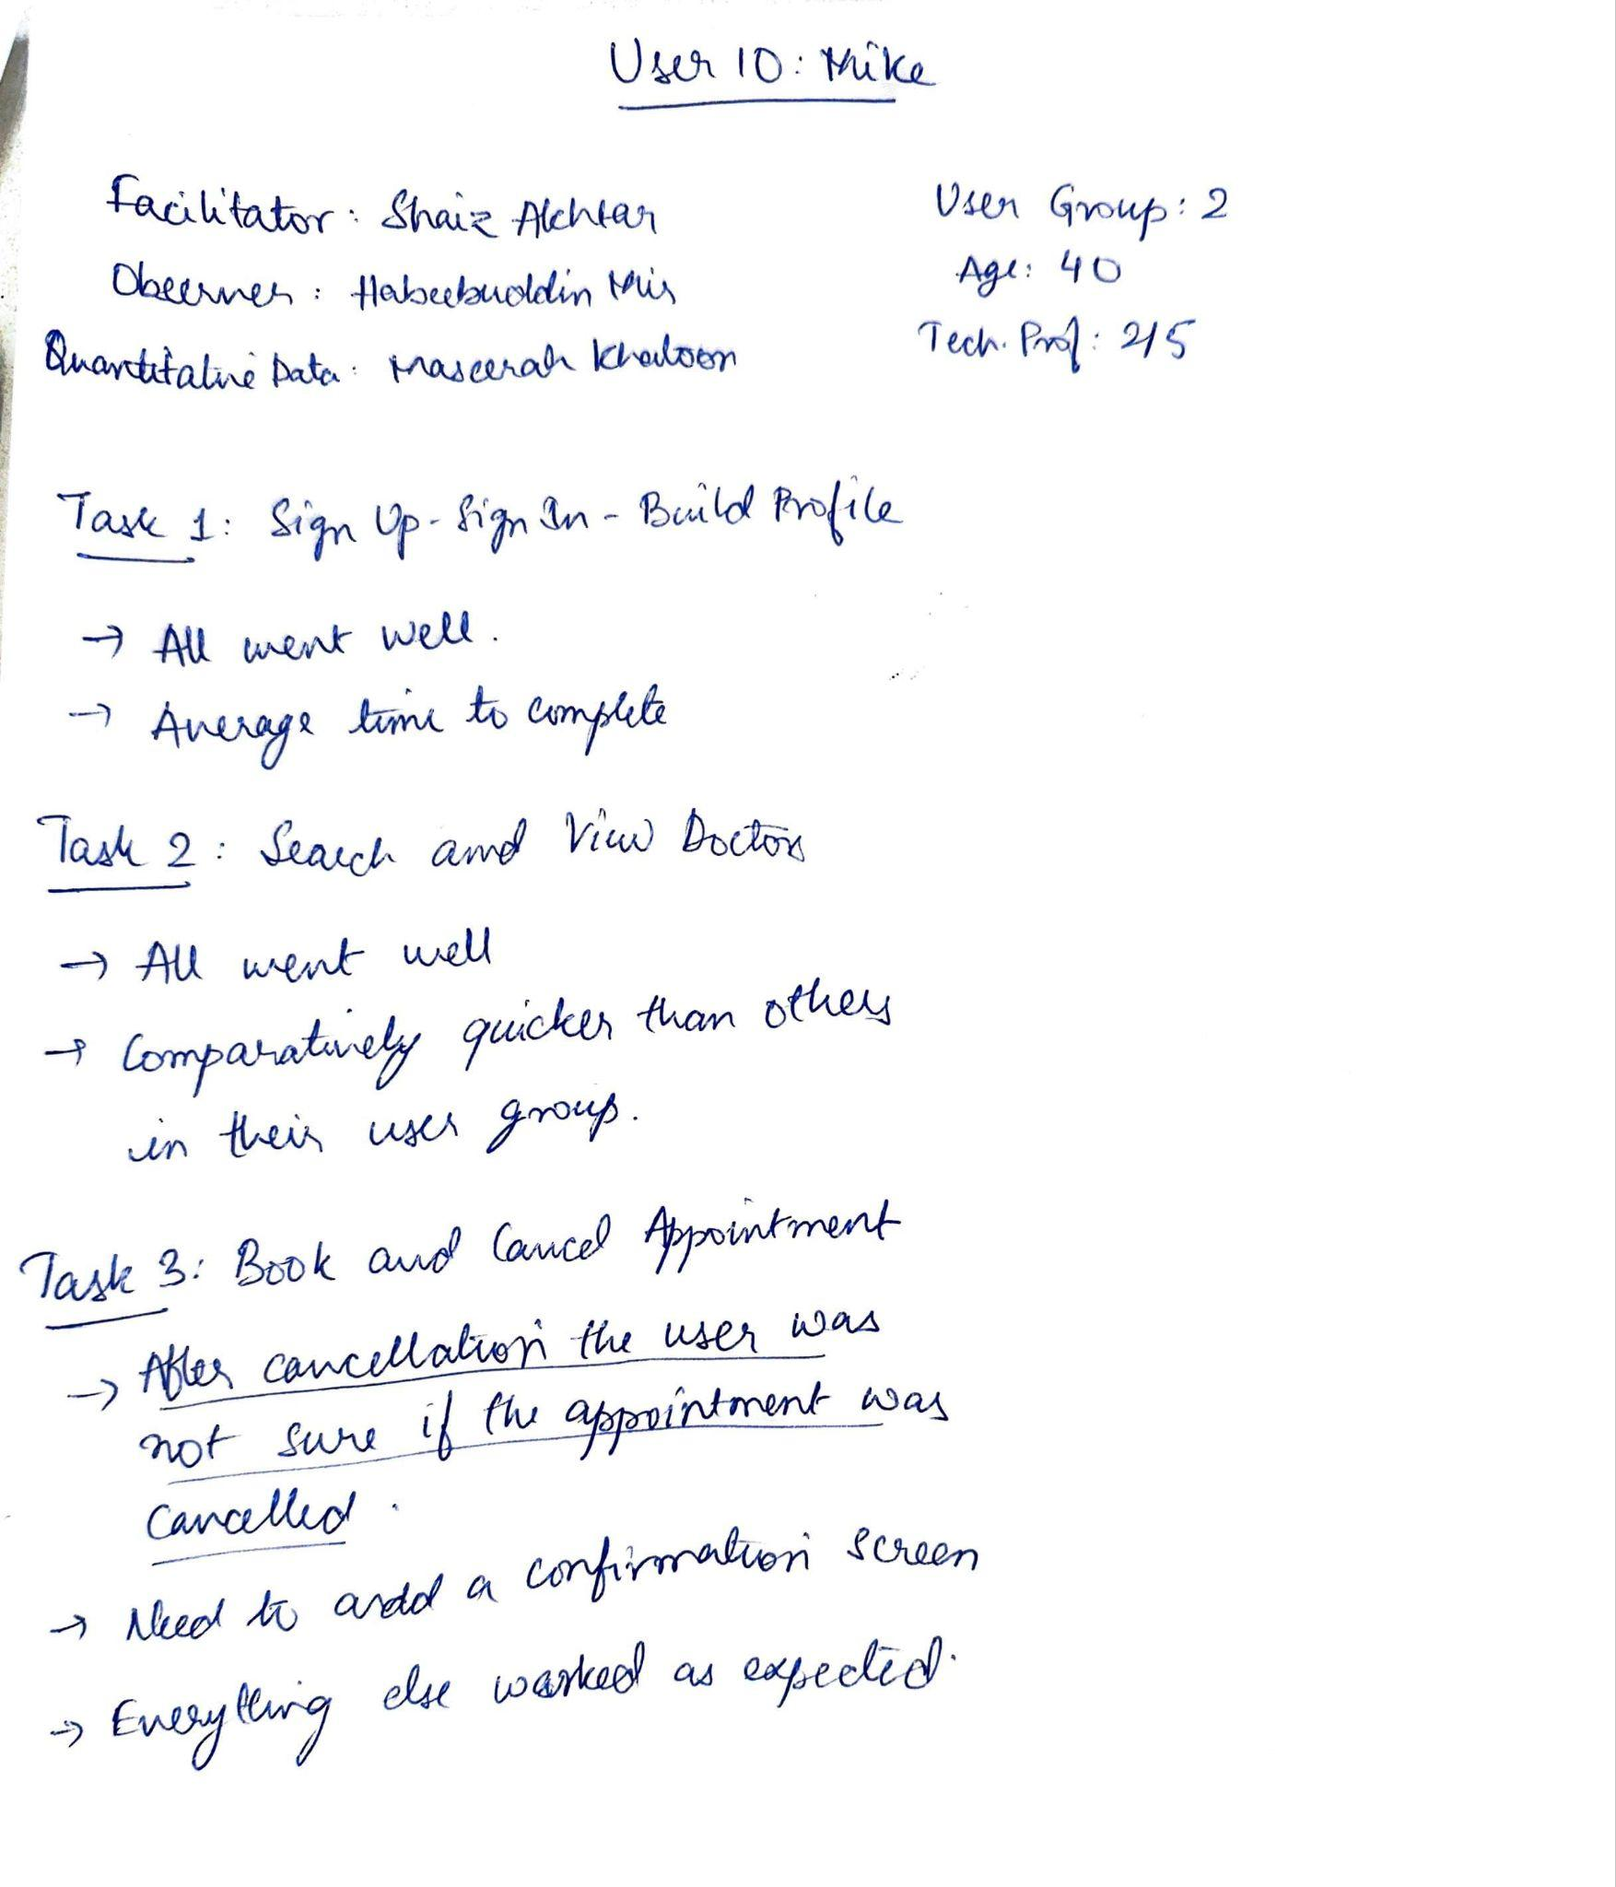

**6.3.3 USABILITY TESTING DATA COLLECTION SHEET**

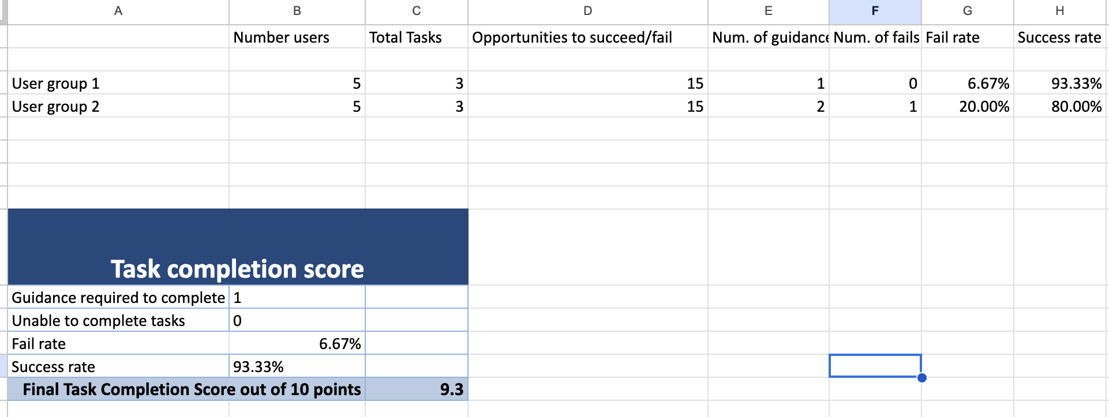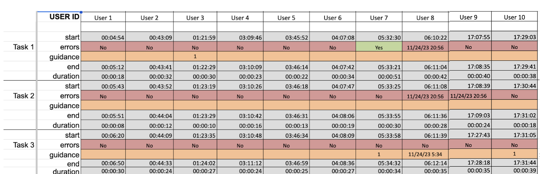

**6.4 FINAL PROTOTYPE AFTER USABILITY TESTING**











**6.5 CLASS PRESENTATION SLIDES**

